d-vtx pxl1 pxl2 ist1 ssd tpc end kBlack
Radius Thickness PointResOn PointResOnZ DetRes DetResZ Density Efficiency
0.230 0.0100 1126 1201 27 778 0.21 0.98
0.140 0.0100 220 788 17 1728 0.57 0.99
0.080 0.0028 137 845 9 9 4.08 0.97
0.025 0.0028 68 175 9 9 40.47 0.97

The hit densities on PXL1 & PXL2 are 40.4662 & 4.08349 per cm**2.
The single track pointing resolution at 755 MeV is
37.3696 microns in R-Phi and 41.6097 microns in Z.
The single track efficiency (all layers combined) is 90.877 percent.
The table does not include the TPC & SSD acceptance which is assumed
to be 75 percent for both detectors combined.

d-vtx pxl1 pxl2 ssd tpc end kBlue

Radius Thickness PointResOn PointResOnZ DetRes DetResZ Density Efficiency
0.230 0.0100 1126 1201 27 778 0.21 0.98
0.080 0.0028 365 912 9 9 4.08 0.92
0.025 0.0028 67 133 9 9 40.47 0.98

The hit densities on PXL1 & PXL2 are 40.4662 & 4.08349 per cm**2.
The single track pointing resolution at 755 MeV is
37.3889 microns in R-Phi and 41.6036 microns in Z.
The single track efficiency (all layers combined) is 88.1835 percent.
The table does not include the TPC & SSD acceptance which is assumed
to be 75 percent for both detectors combined.

d-vtx pxl1 pxl2 ist1 tpc end kRed

Radius Thickness PointResOn PointResOnZ DetRes DetResZ Density Efficiency
0.140 0.0100 1378 1378 17 1728 0.57 0.90
0.080 0.0028 143 1181 9 9 4.08 0.96
0.025 0.0028 68 156 9 9 40.47 0.97

The hit densities on PXL1 & PXL2 are 40.4662 & 4.08349 per cm**2.
The single track pointing resolution at 755 MeV is
37.3672 microns in R-Phi and 41.6078 microns in Z.
The single track efficiency (all layers combined) is 84.1291 percent.
The table does not include the TPC & SSD acceptance which is assumed
to be 75 percent for both detectors combined.

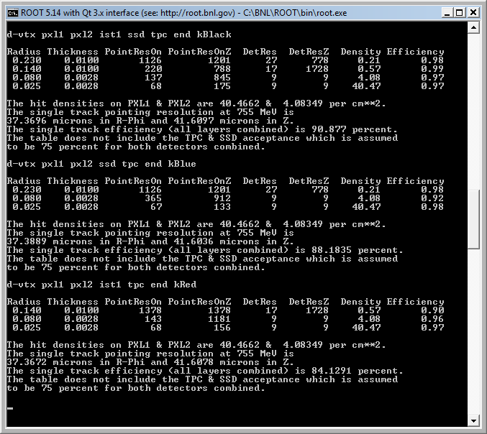

#define ParticleMass 1.865 // Mass of the test particle in GeV/c**2
#define Luminosity 5.e27 // Luminosity of the beam
#define Sigma 20.0 // Size of the interaction diamond (cm)
#define dNdEtaMinB 170 // Multiplicity per unit Eta
#define dNdEtaCent 700 // Multiplicity per unit Eta
#define CrossSectionMinB 10 // minB Cross section for event under study
#define CrossSectionUPC 3460 // UPC Cross section for event under study
#define AcceptanceOfTpcSSD 0.75 // Assumed geometric acceptance of TPC + SSD
#define IntegrationTime 0.200 // Integration time for PXL chips (ms)
#define UPCBackgroundMultiplier 1.0 // Increase multiplicity in detector
#define OtherBackground 0.0 // Increase multiplicity in detector
#define SiScaleFactor 0.288 // For scaling Si pad sizes.
#define EfficiencySearchFlag 1 // Define search method. ChiSquare = 1
#define RIDICULOUS 99999.99 // A ridiculously large resolution (cm)
#define BFIELD 0.5 // Tesla (test data taken at 0.25 Tesla)
#define AvgRapidity 0.5 // Avg rapidity, MCS calc is a function eta
#define PionMass 0.140 // Mass of the Pion
#define KaonMass 0.494 // Mass of the Kaon
#define D0Mass 1.865 // Mass of the D0

// Most likely Detector parameters you may want to tune are in the block starting here:

#define VtxResolution 0.3000 // cm Test data wants 3 mm vertex constraint
#define VtxResolutionZ 0.3000 // cm Test data wants 3 mm vertex constraint
#define NewVtxResolution 0.0300 // cm NewVertex to study effect of a refit
#define NewVtxResolutionZ 0.0300 // cm NewVertex to study effect of a refit
#define RefitVtxResolution 0.0030 // cm Refit Vertex to study effect of HiRes
#define RefitVtxResolutionZ 0.0030 // cm Refit Vertex to study effect of HiRes

#define BeamPipe1Resolution RIDICULOUS // Beampipe is not active as a detector

#define Pxl1Resolution 0.0030 // cm 30 x 30 micron pixels
#define Pxl1ResolutionZ 0.0030 // cm 30 x 30 micron pixels

#define Pxl2Resolution 0.0030 // cm 30 x 30 micron pixels
#define Pxl2ResolutionZ 0.0030 // cm 30 x 30 micron pixels

#define BeamPipe2Resolution RIDICULOUS // Beampipe is not active as a detector

#define Ist1Resolution 0.0060 // cm 60 x 4.0 microns x cm
#define Ist1ResolutionZ 0.6000 // cm 60 x 4.0 microns x cm

#define Ist1PrimeResolution 0.6000 // cm 1.92 mm x 1.20 mm pads
#define Ist1PrimeResolutionZ 0.0060 // cm 1.92 mm x 1.20 mm pads

#define SsdResolution 0.0095 // cm 95 x 4200 microns double sided
#define SsdResolutionZ 0.2700 // cm 95 x 4200 microns double sided

#define IFCResolution RIDICULOUS // IFC is not active as a detector

#define TpcResolution 0.0600 // cm 600 x 1500 microns
#define TpcResolutionZ 0.1500 // cm 600 x 1500 microns

#define VtxThickness 0.0000 // % Radiation Lengths
#define BeamPipe1Thickness 0.0018 // % Radiation Lengths (as in 0.01 == 1%)
#define Pxl1Thickness 0.0028 // % Radiation Lengths (0.0028 new 0.0036 old)
#define Pxl2Thickness 0.0028 // % Radiation Lengths (0.0028 new 0.0036 old)
#define BeamPipe2Thickness 0.0000 // % Radiation Lengths
#define Ist1Thickness 0.01 // % Radiation Lengths
#define Ist1PrimeThickness 0.01 // % Radiation Lengths
#define Ist2Thickness 0.0075 // % Radiation Lengths
#define Ist2PrimeThickness 0.0075 // % Radiation Lengths
#define SsdThickness 0.0100 // % Radiation Lengths
#define IFCThickness 0.0052 // % Radiation Lengths
#define TpcAvgThickness 0.00026 // % Radiation Lengths
#define VtxRadius 0.0 // cm
#define BeamPipe1Radius 2.05 // cm (2.05 new 1.50 old)
#define Pxl1Radius 2.5 // cm (2.5 new 1.55 old) JT Test
#define Pxl2Radius 8.0 // cm (7.0 new 5.00 old 8.0 proposed ) JT Test
#define BeamPipe2Radius 11.5 // cm (8.55 new 6.05 old 11.5 proposed) JT Test
#define Ist1Radius 14.0 // cm (12.0 IST, 10.8 SVT, option 9.5 IST)
#define Ist1PrimeRadius 14.1 // cm (12.1 IST1Prime)
#define Ist2Radius 17.0 // cm (17.0 IST, 14.5 SVT)
#define Ist2PrimeRadius 17.1 // cm (17.1 IST2Prime)
#define SsdRadius 23.0 // cm
#define IFCRadius 47.25 // cm Middle-Radius of the IFC
#define TpcInnerRadialPitch1 4.8 // cm
#define TpcInnerRadialPitch8 5.2 // cm
#define TpcOuterRadialPitch 2.0 // cm
#define TpcInnerPadWidth 0.285 // cm
#define TpcOuterPadWidth 0.620 // cm
#define InnerRows1 8
#define InnerRows8 5
#define InnerRows (InnerRows1+InnerRows8)
#define OuterRows 32
#define TpcRows (InnerRows1 + InnerRows8 + OuterRows)
#define RowOneRadius 60.0 // cm
#define RowEightRadius 93.6 // cm
#define RowFourteenRadius 127.195 // cm

