STAR Upgrades

Introduction
The first several years of RHIC operation have produced compelling evidence for a new state of matter formed in the collisions of heavy ions at high energy. These observations have given important insight into the nature of the matter being produced but they have also given rise to many intriguing questions. The physics goals outlined in the first section of this document lead to a set of key measurements that can be addressed at RHIC in the mid-term. Work on answering these questions is already underway in STAR, however to complete many of the challenging measurements, upgrades to the STAR detector are needed.
The STAR collaboration has planned a series of upgrades for the near and intermediate term to address these important questions. Implementation of these upgrades which are described briefly below will also allow efficient utilization of the increased luminosity expected from RHIC II.

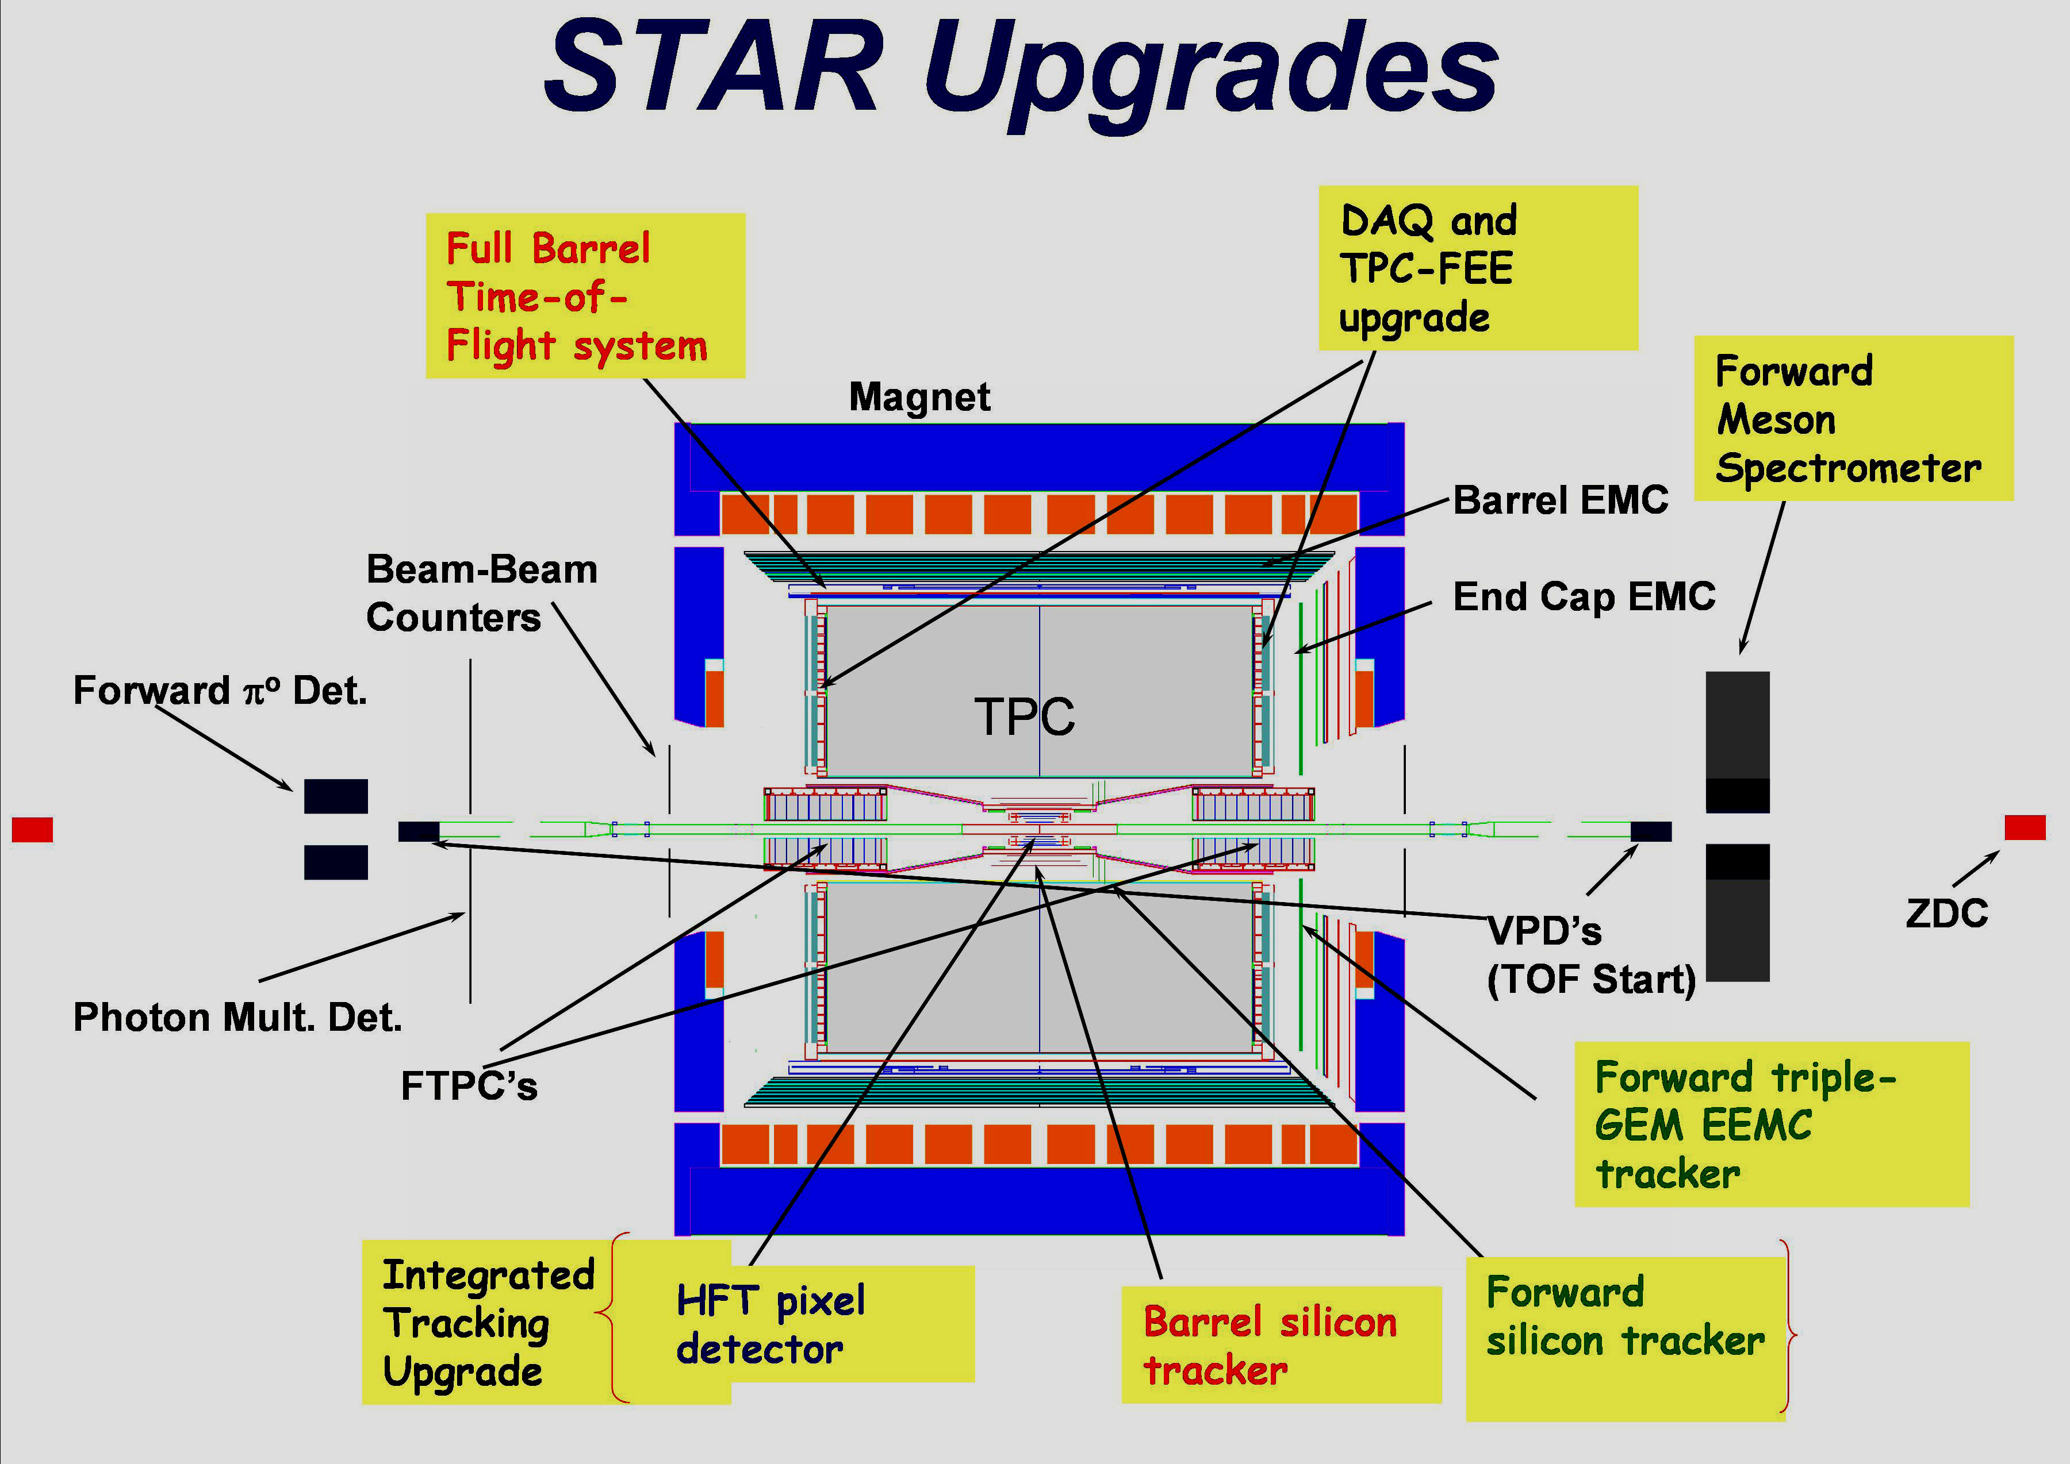
Figure 1. Location of planned upgrades (highlighted text) in the STAR detector.

The location of the various upgrades in the STAR detector is shown in Figure 1. The new systems are highlighted and include: the Forward Meson Spectrometer (FMS); a full barrel Time of Flight detector (TOF); an upgrade to the data acquisition system (DAQ-1000); a tracking upgrade including a barrel section with two inner layers of silicon pixel sensors (HFT) and three layers of silicon strip detectors (IST), and a forward tracker with four layers of silicon strip detectors and a GEM based chamber just inside the end cap calorimeter (FST/FGT). The physics motivation and details for each of these are presented below.

Forward Meson Spectrometer (FMS)
Addition of this detector to STAR will allow observation and characterization of the parton model gluon density distributions in gold nuclei for 0.001<x<0.1. The greatly expanded coverage in the forward direction compared to the existing Forward Pi-zero Detector (FPD) will also allow measurements to resolve longstanding questions about the origin of very large transverse spin asymmetries for forward πº production in p↑ + p → πº + X reactions initiated by transversely polarized proton beams.

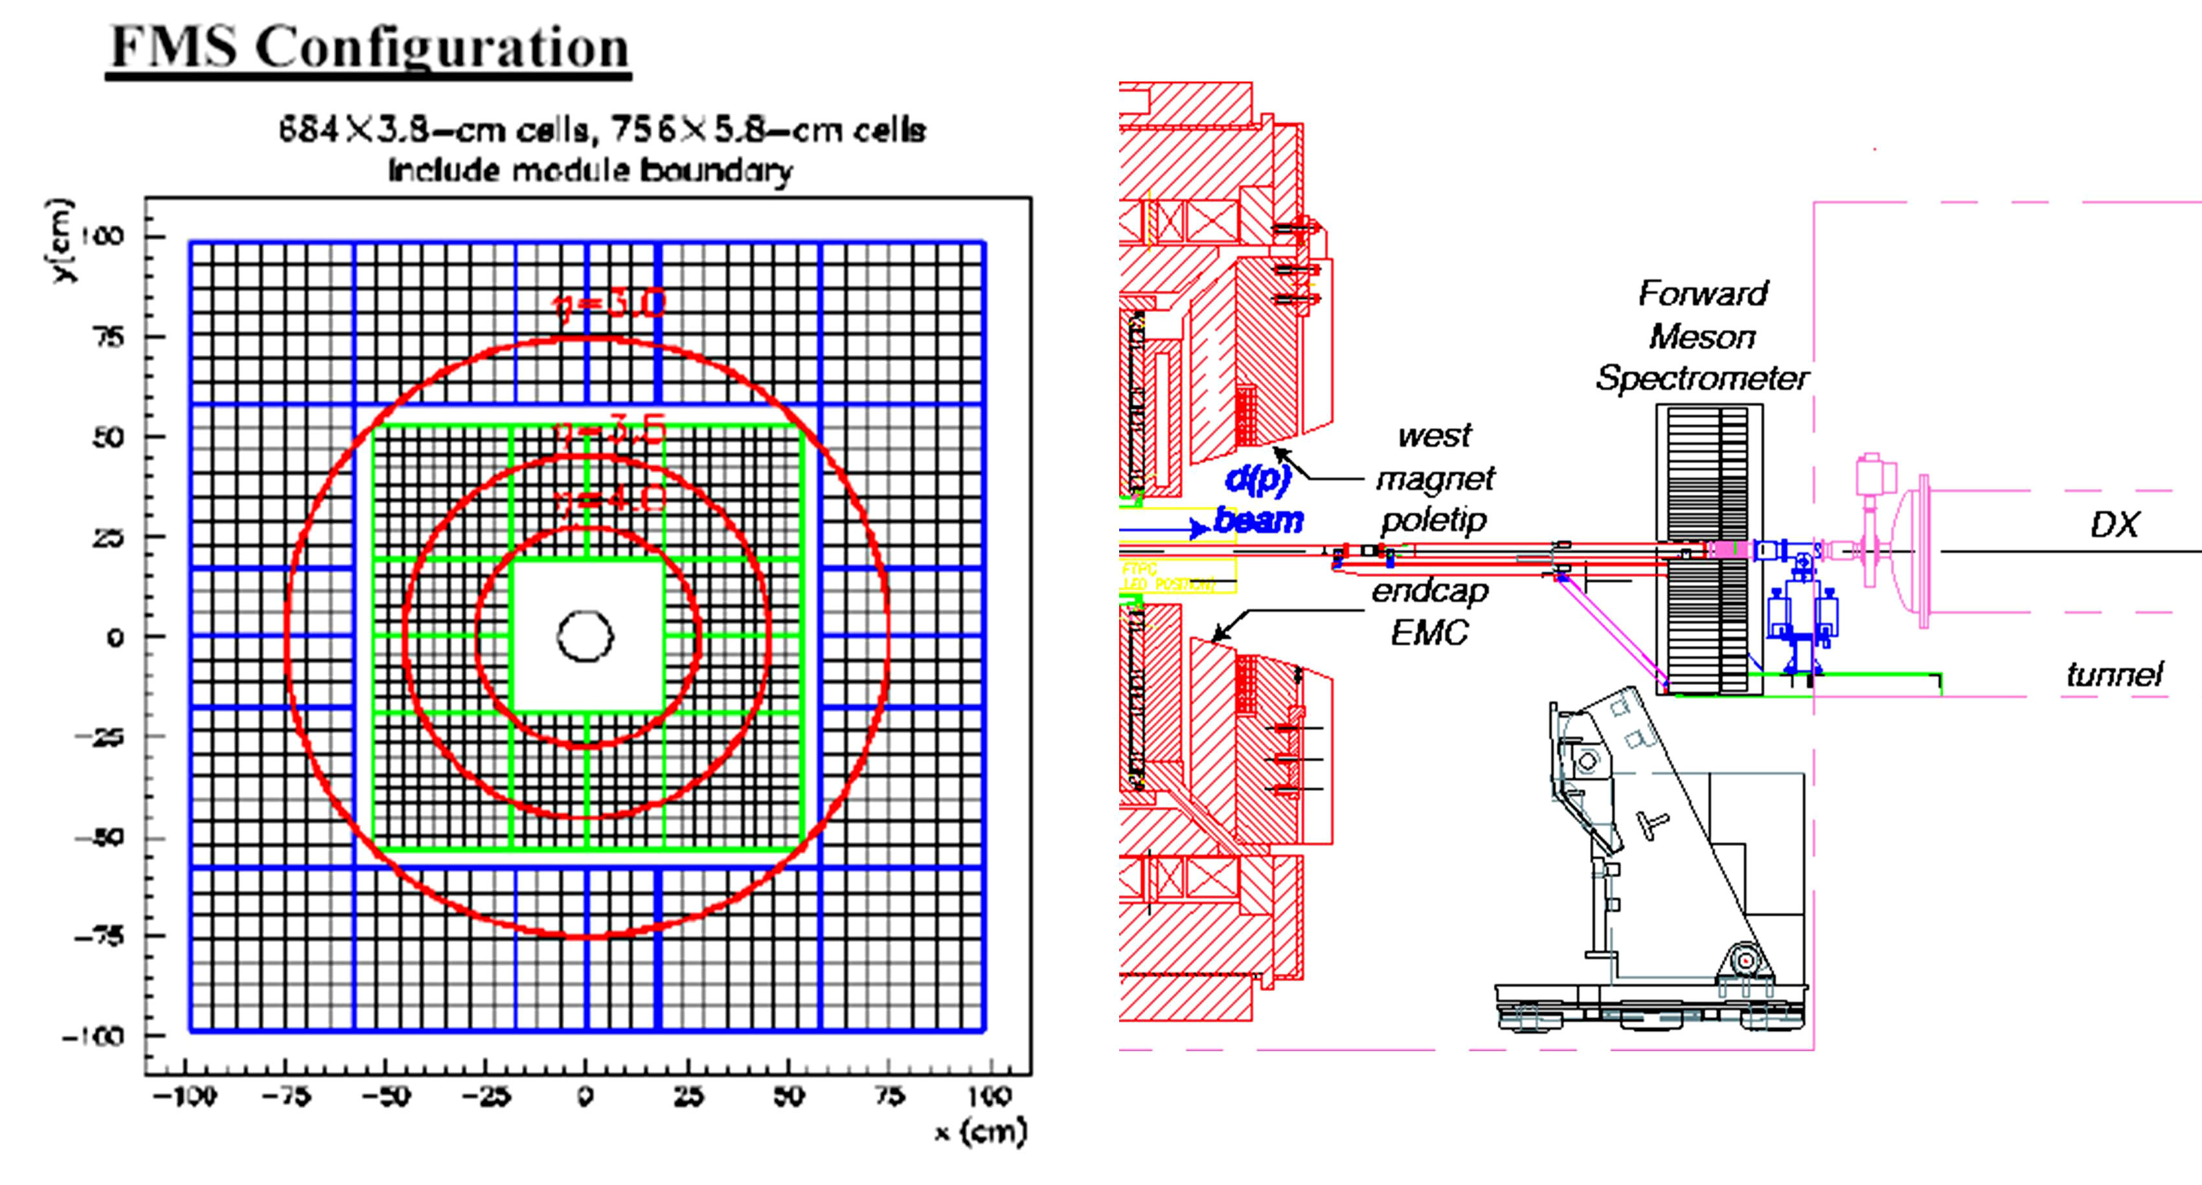

Figure 2. Forward Meson Spectrometer. Left, configuration of lead glass blocks. Right, west side of detector hall showing the FMS at the tunnel exit.
The detector, shown in Figure 2, is a 2m x 2m array of 1440 lead-glass blocks which will cover the full azimuth for 2.5<η<4.0 and is large enough to have reasonable efficiency for heavier meson decays to γ’s (Kº, Dº). It makes use of existing lead glass blocks, phototubes and bases which allows installation on a short timescale for a modest cost. The platform to support the array is in place at the tunnel exit on the west side of STAR. A technically driven schedule would allow completion of the FMS by 2007. The actual completion date depends on availability of funds to complete the readout. The FMS together with the existing end-cap and barrel electromagnetic calorimeters will give STAR almost complete electromagnetic calorimeter coverage with trigger capability for -1<η<4 and -π<ϕ<π.

Data Acquisition Upgrade (DAQ-1000)
A series of improvements to the STAR data acquisition system over the past several years has brought the capability from the original design rate of 1Hz recorded events to 50-100Hz. To acquire the very large data sample needed for precision measurements and untriggered rare process studies such as symmetry restoration/breaking and γγ HBT, an upgrade has been initiated with the goal of achieving a recorded event rate of at least 1kHz. The rare-trigger data sets will also benefit from the upgrade since the pipelined architecture being implemented will virtually eliminate the front end dead time, thus approximately doubling the luminosity seen by rare triggers. Also, adequate data sets for species or energy scans will be achievable in much less running time, thus making such scans more feasible in limited running time.

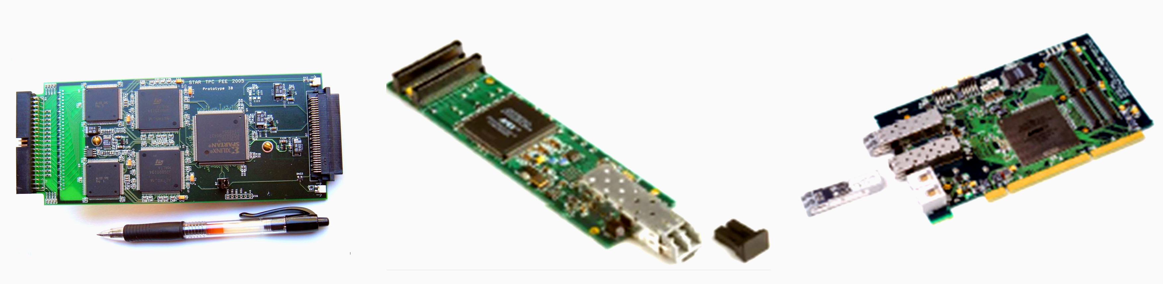
Figure 3. New TPC FEE board using ALICE PASA and ALTRO chips (left), and the data sender and receiver cards (center, right).
The upgrade will make use of circuits developed for ALICE, specifically the PASA (pre-amp/shaper-amp) and ALTRO (digitizer, filter, buffer) chips. These chips will be used on boards which will fit in the same footprint as the existing TPC FEE cards (Figure 3). The fiber transmitter and receiver cards developed for ALICE will also be used. These cards will pipe the data directly to general purpose PC’s via a fiber to PCI interface. In addition to the increased physics capabilities from the DAQ upgrade, the replacement of the TPC front end electronics, specifically the RDO boards that collect data from the FEE boards, will make space for a precision tracking chamber between the TPC end planes and the end-cap calorimeter that is part of the forward tracking upgrade described below. Replacing the TPC front end electronics also assures that this system will be maintainable for the next decade or more.
A small patch of the new TPC readout will be installed for pulser, laser and cosmic ray tests early in 2006 to gain experience with the new system. For the FY2007 run, two TPC sectors will be instrumented with the new system and the FY2008 run the complete system will be installed. New detectors currently being installed or planned will be compatible with the new DAQ. The readout for the other existing detectors which will remain in place for the RHIC II era can be adapted to the new high speed DAQ with minor changes.

Barrel Time of Flight (TOF)
A time of flight system covering the full outer barrel of the TPC is planned for construction and installation in STAR over the next three years. The system uses the Multi-gap Resistive Plate Chamber (MRPC) technology developed at CERN and will consist of 3840 MRPC modules with 23,000 channels of readout. The readout is based on the HPTDC digitizer chip developed at CERN. The modules will cover the TPC outer barrel (-1<η<1, -π<φ<π) and will be mounted in 120 trays which will replace the existing CTB (Central Trigger Barrel scintillation counter) trays.
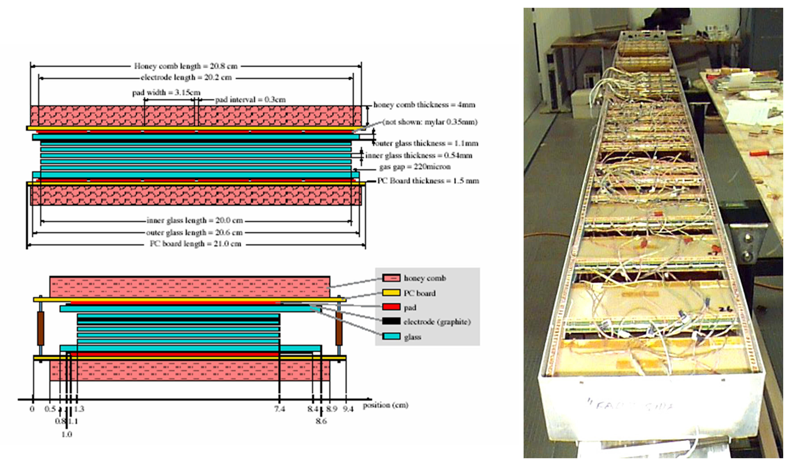
Figure 4. Cross sections through MRPC module showing dimensions (left) and a prototype tray of modules (right).

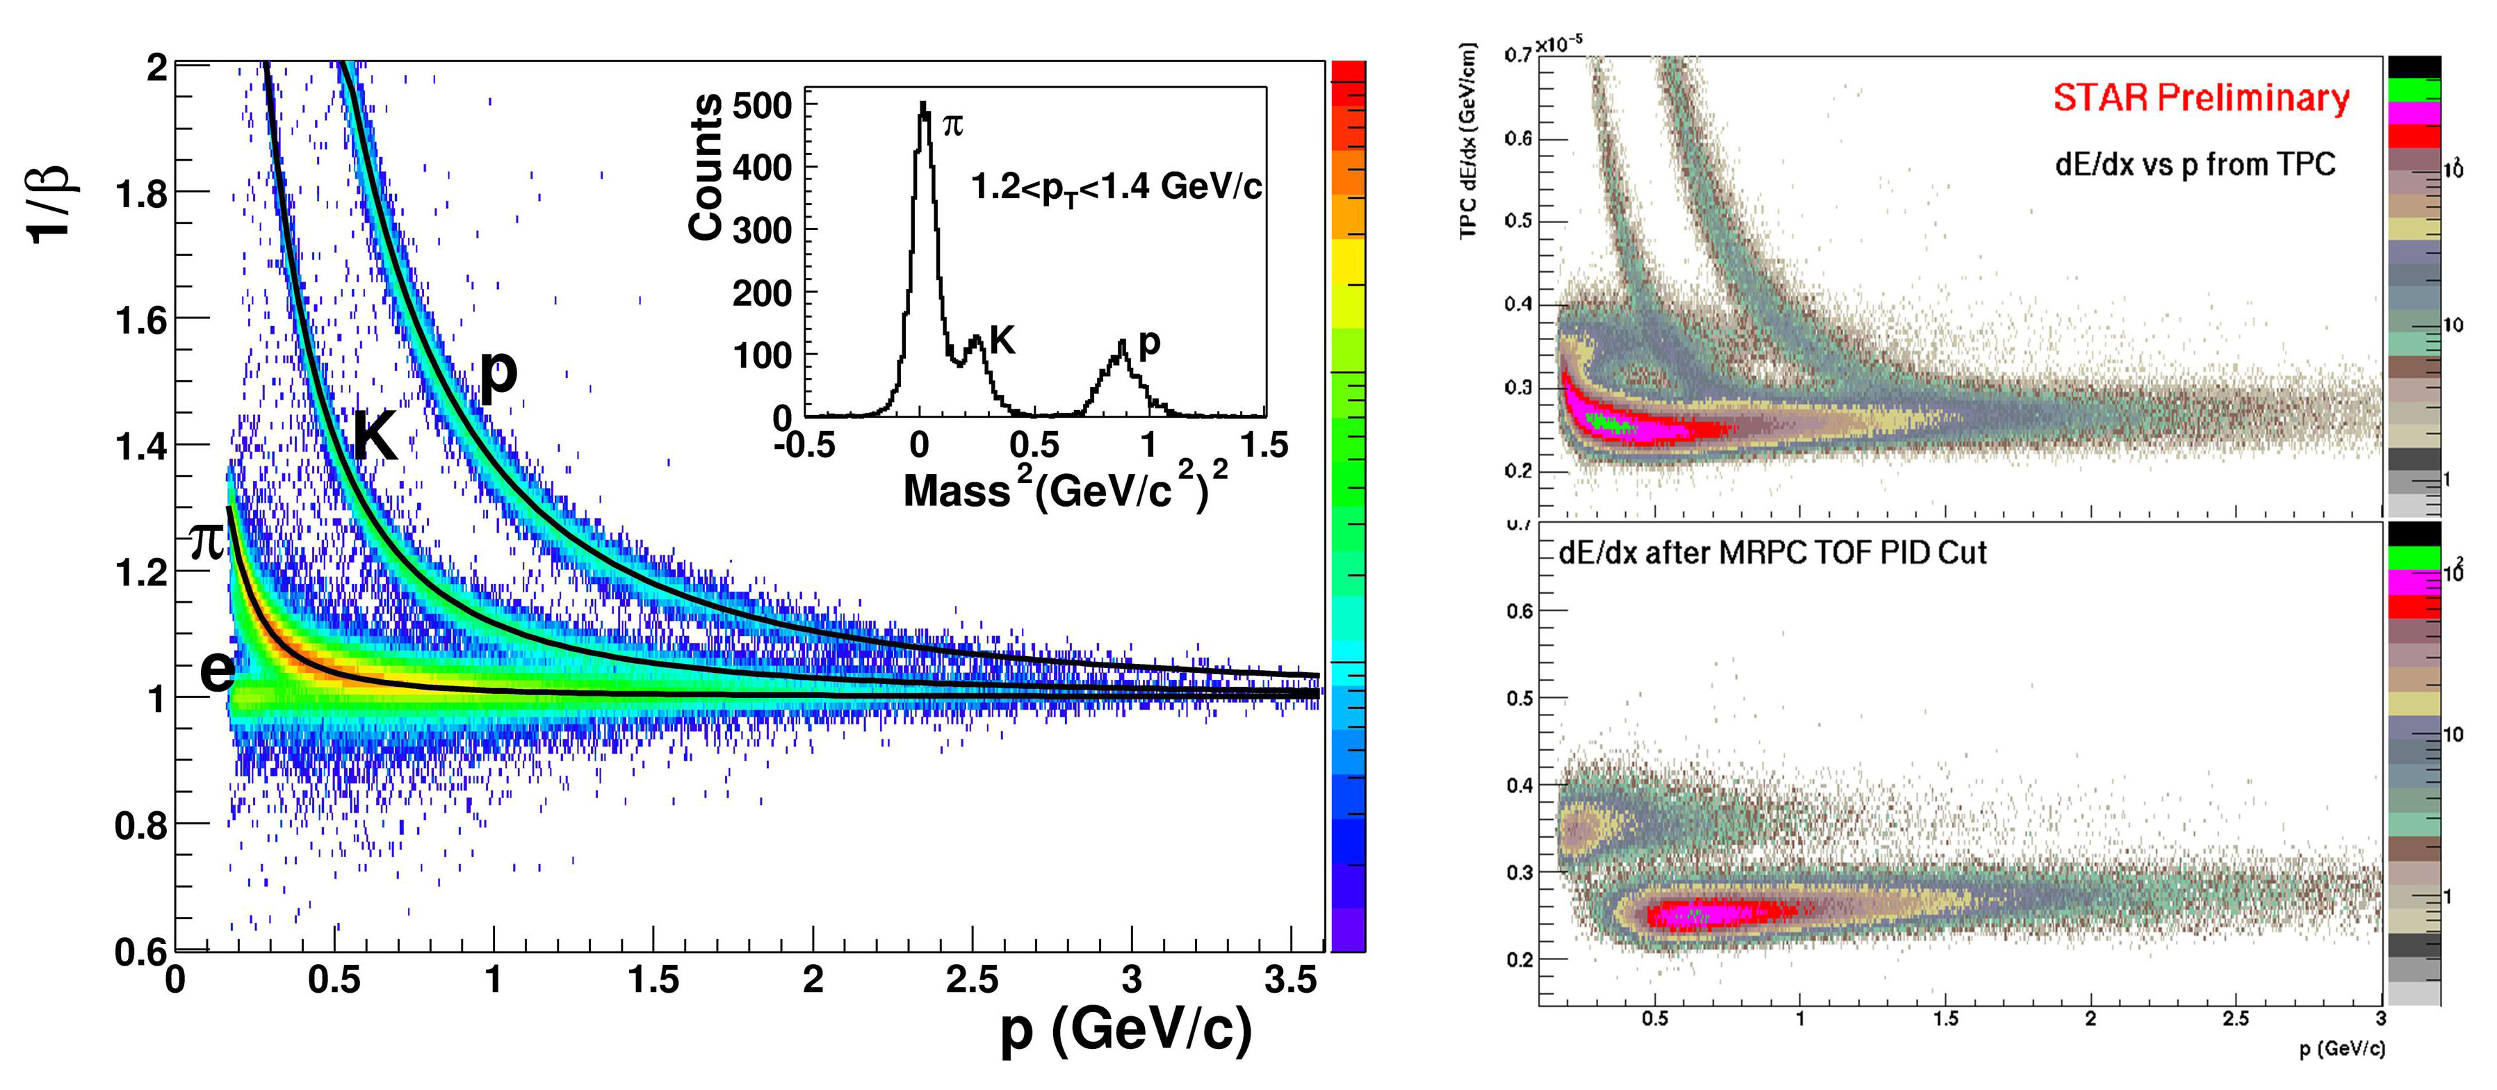
Figure 5. Time of flight from TOF (1/β) vs. momentum from the TPC (left). Right top, dE/dx in the TPC for all tracks; right bottom, dE/dx in the TPC for tracks with velocity measured in TOF to be consistent with β=1.
Figure 4 shows cross sections of a module and a prototype tray. At a radius of 2.1m with a timing resolution of 100ps, the TOF system will more than double the p_{T} range of PID in STAR from that achieved using only energy loss measured in the TPC. A prototype tray has been installed in STAR for the last three RHIC runs. This has provided invaluable engineering experience in developing the electronics and mechanical infrastructure and has also proven the capability of the technology by producing published physics results.,
In addition to doubling the momentum range over which π,k, and p can be identified (Figure 5), when the TOF measurement is combined with the TPC dE/dx measurement, electrons can be cleanly identified from the lowest momentum measured (~200MeV/c) up to a few GeV/c (Figure 5, right). This capability complements the STAR electromagnetic calorimeter which works well for momenta above ~2GeV/c and provides the capability in STAR to measure the soft lepton and di-lepton spectra.
The TOF system will bring significant new physics capability to STAR. When combined with the TPC dE/dx, the TOF will allow or significantly enhance the ability to study the following:
- Identified hadron spectra
  - freeze-out dynamics using resonance measurements
  - hadronization mechanism
  - Fluctuations and correlations of strange particles and baryons
- Identified particle correlations
  - Chemical and kinetic properties of in-medium jet associated spectra
- Lepton program
  - In-medium Vector Meson Properties
  - Heavy Flavor
  - Soft di-lepton spectrum
The presence of a high granularity fast detector covering the TPC barrel will also allow pile-up events in the TPC to be filtered out in the analysis. This is especially important for the collision rates that are expected in p-p collisions at the highest luminosity.
The TOF detector is a joint US-China project with a collaboration of Chinese institutions providing the MRPC modules and the US providing the readout electronics and mechanical infrastructure. The US project is scheduled for funding in FY06 and is planned to be completed by FY09. Since the system is completely modular at the tray level, partial and increasing coverage will be available during the construction period.

Inner Tracking Upgrade
In order to address the physics of thermalization at RHIC one must analyze the open charm-hardon distributions. It is therefore necessary to cleanly identify charm hadrons. Indeed this important question is also closely related to heavy quark energy loss and its thermalization in the hot and dense medium created in heavy ion collisions at RHIC. The recent results from both STAR and PHENIX on the suppression and flow of non-photonic electrons are intriguing however without an identified sample of charm the questions of contribution from semi-leptonic open-beauty decays and systematic errors on background subtraction make a clear interpretation of these results difficult. Measurement of the yields of various charm species will also allow a study of the charm hadro-chemistry. Efficient topological reconstruction of open charm decays requires tracking “point-back” resolution to the primary collision vertex of ~50μm or better. Further, the beam pipe and innermost layers of detector must be very thin and as close to the beam as possible to allow measurement of particles at low transverse momentum which comprise the bulk of the cross section. This will minimize the systematic errors in extrapolating the measured yield to the total yield. A thin beam pipe and inner detector layers are also key elements in efficiently vetoing photon conversion electrons which in combination with the electron identification from the TPC, TOF and electromagnetic calorimeter will enable measurement of the soft lepton and di-lepton spectra.

To achieve this STAR is developing a tracking upgrade for the central rapidity region (-1<η<1). The essential elements under consideration for this upgrade are a new thin, small-radius beam pipe (0.5mm thick, 14 mm radius), two layers of thinned (50μm) CMOS pixel detectors at average radii of 1.5 and 4.5 cm (HFT) and three layers of conventional silicon strip detectors at average radii of 10, 15 and 20 cm (IST) (see Figure 6). The existing layer of double-sided silicon strip sensors at a radius of 25 cm (SSD) will be kept. Also key to the new detectors is an integrated mechanical structure that will allow all relative alignment to be measured with high precision “on the bench” and the detectors to be easily mounted/demounted at STAR with repeatable precise positioning.
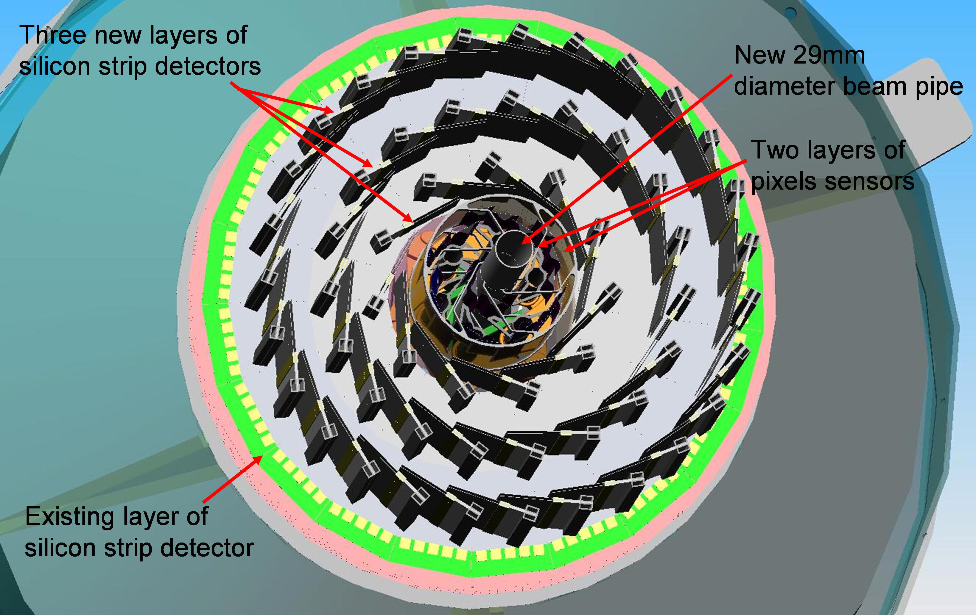
Figure 6. End view of small radius beam pipe (1.4 cm radius), two layers of pixel sensor, three new layers of silicon strip sensors, and the existing layer of silicon strip sensor.

Figure 7 shows the details of the two pixel layers. The inner two layers (HFT) will use new CMOS pixel sensor technology with the following properties:
- High Resolution
  - 100,000,000 pixels
  - 30 μm x 30 μm
  - 10 μm resolution
- Thin – with low Multiple Coulomb Scattering
  - 50 μm thinned Si
  - 0.36% radiation length
  - 0.5 mm thick Beam Pipe
  - CMOS technology (Industry Standard)
- 24 Ladders
  - 10 chips, 2 cm wide by 20 cm long
  - 100 mW/cm2 power budget
  - air cooled

Figure 7. Layout of the HFT inner pixel sensors.

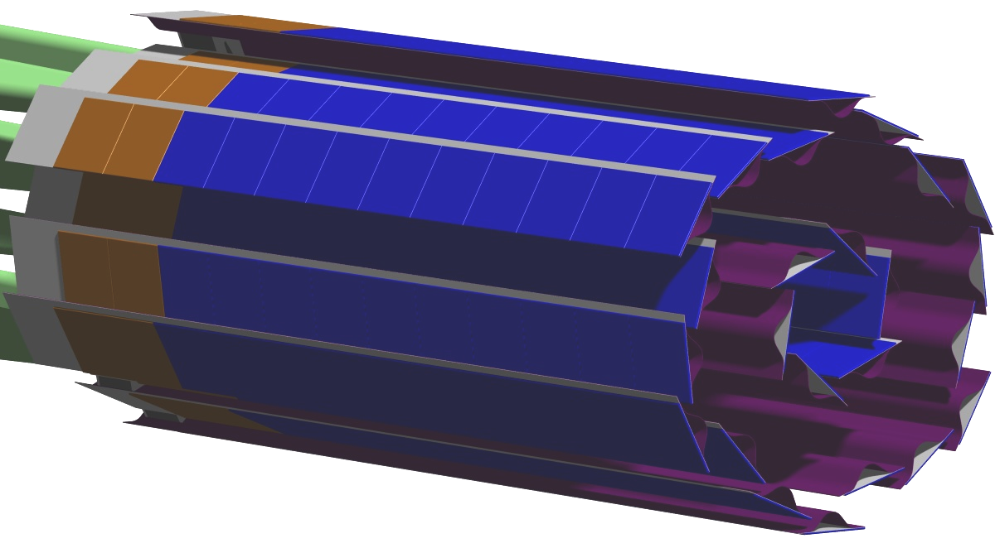
The three new layers of conventional silicon strip sensors (IST) will allow connecting tracks from the TPC and SSD to hits in the pixel layers. These layers will replace the existing three layers of silicon drift detector (SVT). It will be necessary to replace the SVT since when RHIC II becomes operational, the SVT will be over 10 years old, its readout is too slow to be compatible with the upgraded DAQ, and it has a large amount of infrastructure (cables and cooling) in the region 1<η<2 where precision tracking for determining the charge sign of the leptons from W± decay (see Forward Tracking Upgrade, below) is planned.
The HFT uses new technology, so to produce devices which meet the requirements in STAR a significant R&D program is underway with collaboration from UC Irvine, Lawrence Berkeley National Laboratory and IRES, Strasbourg. It is expected that this effort could produce a prototype device to be installed in STAR by FY09. This device would allow in situ demonstration of the technology, demonstrate that a tracking device can operate only 2 cm from the RHIC beams, demonstrate the mechanical concepts for alignment are sound and allow vetting of the required tracking software with real data. The final devices and the silicon strip layers would be installed in the following 2-3 years. Vetting and optimization of the design with simulations is in progress and proposals for these projects are in preparation.

Forward Tracking Upgrade
The production of W bosons provides an ideal tool to study the spin-flavor structure of the proton. W bosons are produced in () collisions and can be detected through their leptonic decay. Forward scattered , tagged in the STAR end cap electromagnetic calorimeter (), off the incoming polarized proton beam moving toward (away) from the STAR EEMC, yield a purity for coming from () quarks of about (). The discrimination of () quark combinations requires distinguishing between high charged leptons through their opposite charge sign which in turn requires precise tracking information. This forms the main motivation for the forward tracking upgrade (Figure 8).
The forward tracker will have silicon disks near the beam pipe in the forward direction based on conventional silicon strip technology and a GEM based chamber just in front of the end-cap calorimeter. Initial simulations show that this combination will unambiguously determine the sign of the track curvature over the required momentum range. Detailed simulations are in progress with a proposal to be completed this year.

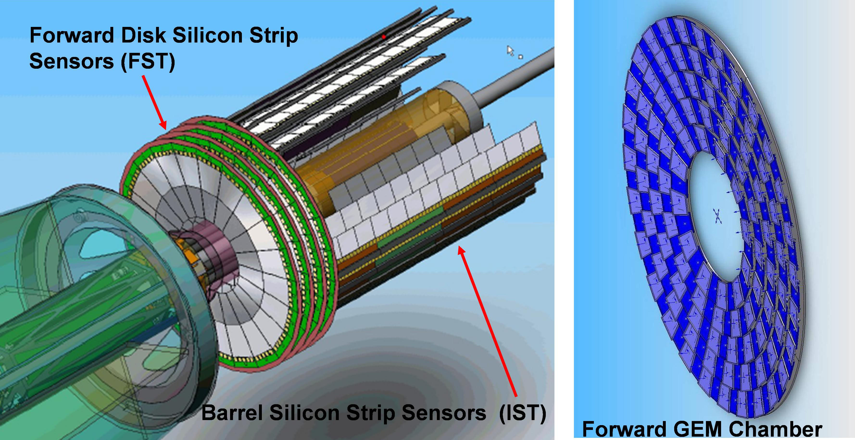

Figure 8. Forward Tracking. Left, Silicon strip disks; right, GEM chamber array. Note, the scales are very different. The silicon disks are 40cm in diameter, the GEM chamber array is 400cm in diameter.

TPC Performance at High Luminosity
The STAR collaboration has developed considerable experience and a large array of tools to correct track distortions in the TPC. The distortion of most concern for future operation at higher luminosity is due to space charge build up in the TPC gas volume. The charge build up in the TPC gas volume, which distorts the nominally purely longitudinal electric field, arises from the slow drift time of positive ions created by the flux of ionizing radiation through the TPC. It takes almost one second for a positive ion to traverse the full 2m drift distance. The charge buildup is proportional to the flux of charged particles through the TPC which will vary with luminosity and background and can vary on a short time scale. The tools used to correct these distortions include accurate modeling of the shape of the charge distribution, adequate scaler information to monitor the flux through the TPC and the ability to adjust the correction locally in time by using individual events. Details of the corrections can be found at: (URL for Gene’s talk). A powerful monitor of the quality of the corrections that is used in the short time scale corrections is the “signed distance of closest approach” (sDCA). This is simply the distance of closest approach of a track to the primary vertex (defined from a fit using all tracks) with a sign given by whether the primary vertex lies inside or outside the track’s curvature. The width of the sDCA distribution is a global monitor of tracking resolution. Figure 9 shows the mean (markers) and width (black bars) of the sDCA distribution as a function of luminosity after all corrections are applied for 200 GeV Au-Au collisions.
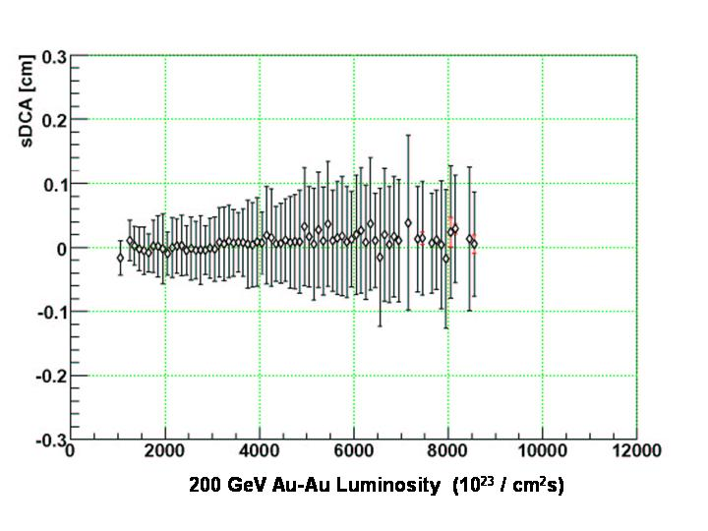
Figure 9 Signed DCA (sDCA) as a function of Luminosity for 200 GeV Au-Au collisions. The markers show the mean sDCA, the red bars the statistical error on the mean and the black bars the RMS of the event by event fitted sDCA mean. The latter is a monitor of the quality of the distortion corrections.

There is some increase in the sDCA width from the lowest luminosity to ~5 x 10²⁶ /cm²sec however the width remains constant above this to the highest luminosity sampled (~8.5 x 10²⁶ /cm²sec). This indicates the corrections are understood and there should be no difficulty running at even higher luminosity. We note that the peak luminosity for RHIC (30 x 10²⁶ /cm²sec) after the near term RHIC improvements is expected to be reached in FY09 and is within a factor of 2-3 of the RHIC II luminosity. This will be achieved five years before the full RHIC II luminosity is expected which should allow adequate time for refining the corrections, improving monitoring of the flux in the TPC and developments of improvements to the TPC (different operating gas and or increased drift field) if these are required. A research effort using a spare TPC sector is being initiated now to characterize various operating gases.

Summary
The STAR collaboration has planned and is constructing a series of upgrades to the STAR detector which will provide the capability to make key measurements in the mid-term. These improvements to the detector capability will also allow efficient use of the RHIC II luminosity. Figure 10 shows the capability provided by the upgrades and existing detectors in azimuth and pseudorapidity.
Timelines for implementing the upgrades are shown in . The funding profile needed to support this schedule is shown in Table 2 below. The additional costs for operation and maintenance of the new systems is expected to be about $300k/year plus one FTE electronics technician. Additionally, once the high speed DAQ is operational, there is expected to be increased cost for archival data storage as shown in the section on RCF.

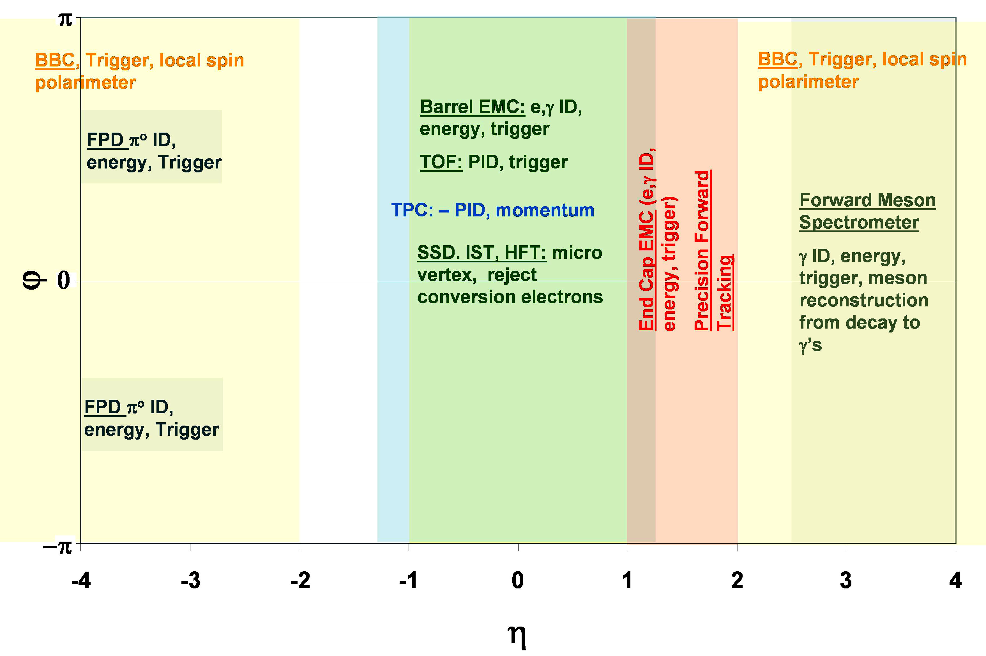
Figure 10. Coverage in azimuth and pseudorapidity of major STAR detectors and upgrades. The ZDC (Zero Degree Calorimeter covering full azimuth for η>6.5) is not shown.

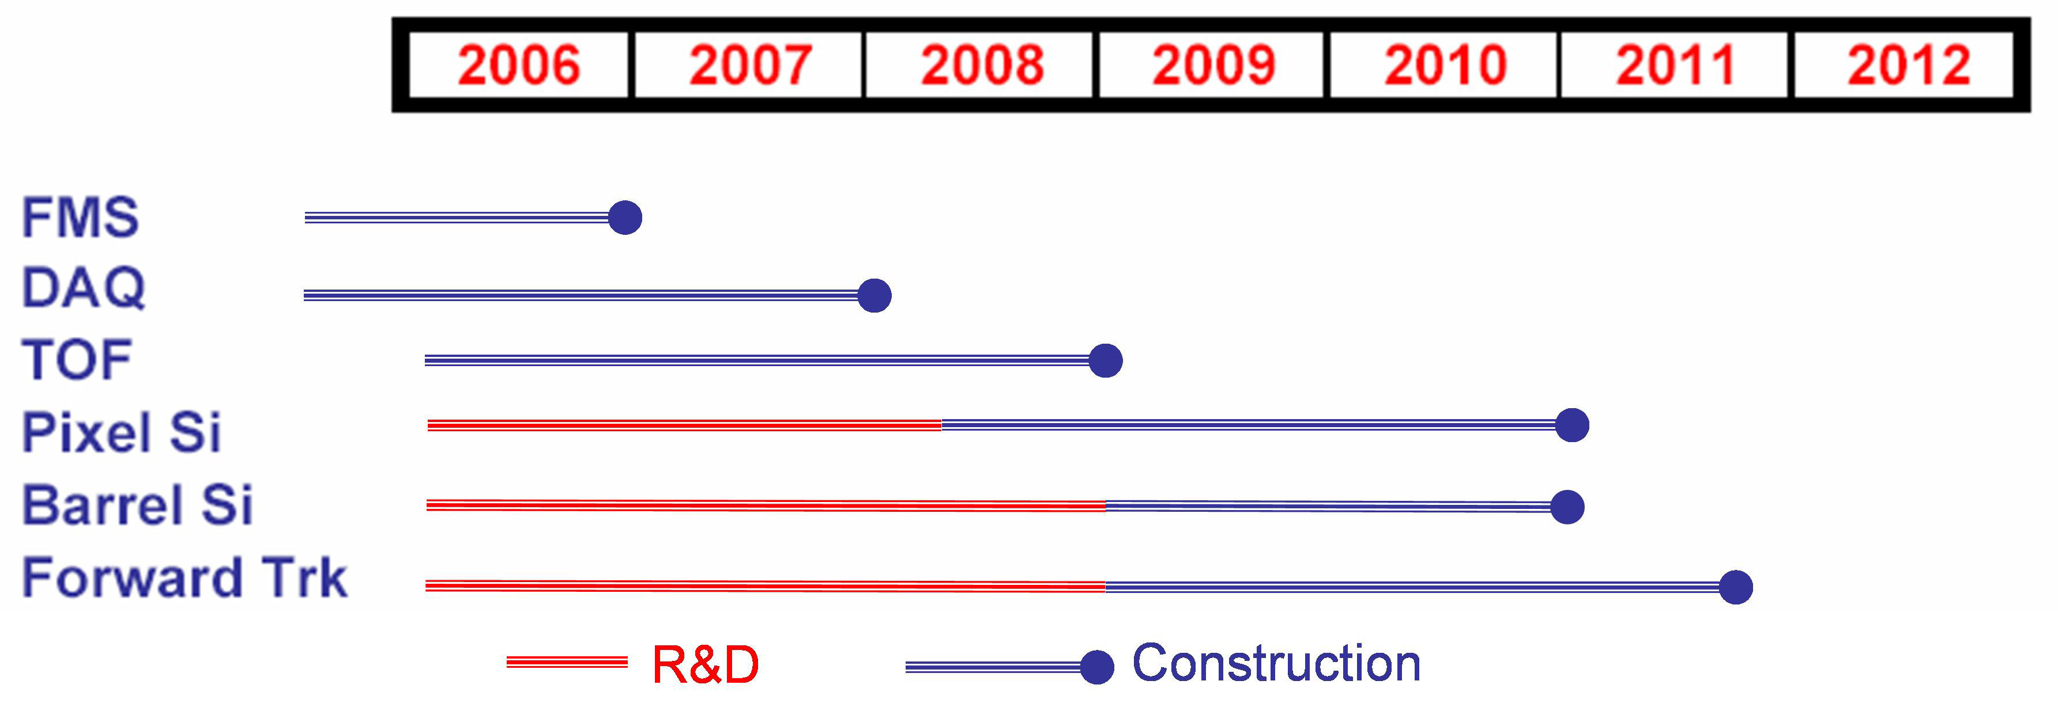

Figure 11. Timelines for implementing upgrades to the STAR detector.

J. Adams, et al, Phys. Lett. B 616 (2005) 8
J. Adams, et al, Phys. Rev. Lett. 94 (2005) 062301

