Mid-Term Strategic Plan: 2006-2011
For the Relativistic Heavy Ion Collider
At
Brookhaven national Laboratory
DRAFT 1/24/06

Prepared by
Brookhaven National Laboratory
With the
RHIC Scientific Community

For the
U.S. Department of Energy

February 14, 2006

Table of Contents

- Introduction

- The science case for the future of RHIC

  - Physics goals for the mid-term

- The mid-term run plan: 2006 – 2011

3.1 Collider performance projections for the Mid-Term

- Collider upgrades and development: 2006 – 2011

- PHENIX and STAR upgrades

  - Overview of PHENIX upgrade plans

  - Overview of STAR upgrade plans

  - Summary and status of detector upgrades

- Upgrade costs and schedules: R&D and construction

- The RHIC Computing Facility

  - Computational resource planning for the mid-term period

  - Resource utilization

  - RCF Staffing

  - RCF physical infrastructure

- An integrated strategic plan

Apppendix I: Mid-Term Plan working group

1 Introduction

The aim of the mid-term strategy is to map out an achievable, aggressive program of detector upgrades and facility utilization that will maximize the scientific impact of the RHIC program in the years 2009 and beyond, when RHIC will start to compete with the LHC heavy ion program. This Mid-Term Plan is being developed in response to two recommendations of the July 2005 DOE Science and Technology Review of RHIC:

- Develop a mid-term strategic plan which includes the implementation of necessary detector upgrades in the context of scientific priorities, expected machine performance, and the expected turn-on of the Large Hadron Collider (LHC). This plan should be cognizant of the DOE needs for formulating federal budgets and requirements for project management. The plan should be submitted to DOE by January 2006.

- Update the RCF five-year plan to consistently reflect the needs of a five-year run plan in the context of projected detector upgrades and accelerator performance. This plan should be complete and submitted to DOE by January 2006. This report may be combined with the mid-term strategic plan provided the RCF plan is a prominent component.

To be specific with regard to the first charge, we take the “mid-term” period to be the years 2006-2011. In addressing this strategy, we have kept in mind the long range planning for RHIC. In this regard, under favorable budget circumstances, the mid-term phase leads directly into operation of the collider at high luminosity with e-cooling. The strategy is based on achieving high-luminosity configurations of STAR and PHENIX, as well as providing computing resources via the RHIC Computing Facility (RCF) to deal with the corresponding increases in data volume and analysis requirements of the experiments. Thus, the Mid-Term Strategy serves to illuminate the technically driven schedule and scope of RHIC II.

This document updates the long-term planning presented in the report entitled “Twenty-Year Planning Study for the Relativistic Heavy Ion Collider Facility at Brookhaven National Laboratory” (BNL-71881-2003), submitted to DOE December 31, 2003. The plans presented here include the detailed planning for the RHIC Spin program presented in the “Research Plan for Spin Physics at RHIC”, presented to DOE on February 11, 2005.

The science case for the future of RHIC
[Material for this section will be provided by the RHIC II Science white paper writing committee.]

  - Physics goals for the mid-term

Note: This is still in outline form, as given in the Interim Report. It needs to be fleshed out in the context of the overall science case, to be given above.

The mid-term strategy outlined here calls for a balance of beam-on running time with investment in accelerator and detector upgrades necessary for crucial measurements of the new form of QCD matter now being investigated at RHIC, and a full realization of the RHIC spin capability.

Heavy Ion measurements:
Detector and facility upgrades to address these measurements are shown in italics. The upgrades are discussed below.
- Electron-pair mass spectrum (DOE performance milestone for 2010)
PHENIX Hadron Blind Detector for Dalitz pair rejection
- Open charm measurements in AA
High resolution vertex detection
- Charmonium spectroscopy (DOE performance milestone for 2010)
High luminosity; precision vertex; improved particle ID
- Jet Tomography
High luminosity; High-rate DAQ; improved particle ID
- Monojets in d-Au: Gluon densities at low x in cold nuclei (DOE performance milestone for 2012)
Particle detection at forward rapidity

Spin measurements:
- Complete initial ΔG/G measurement (DOE performance milestone for 2008)
No upgrades needed
- Transversity measurement
Forward particle measurement
- W measurements at 500 GeV (DOE performance milestone for 2013)

Forward tracking in PHENIX and STAR

The Mid-Term Run Plan : 2006 – 2011

In Table 3-1 we summarize the data samples collected in all of the RHIC runs to date. These first runs were characterized by a wide range of operating modes, varying both the collision species and energies; a rapid development of machine capability, leading to performance at the design luminosity after the first three runs; and a rich harvest of physics discoveries, opening up the fundamentally new realms of research described above for high energy heavy ion and spin physics.
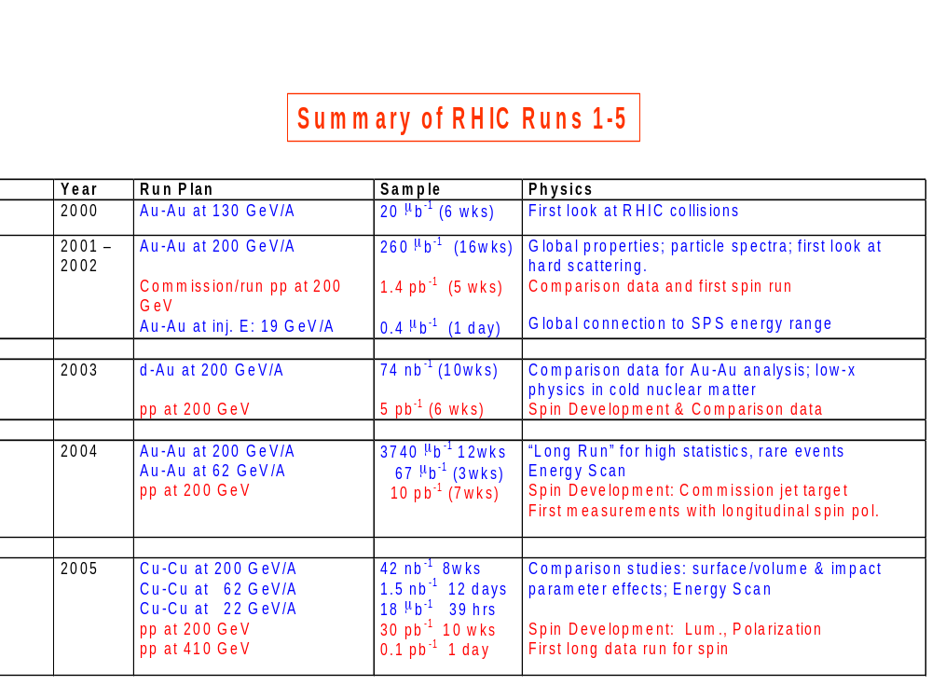
Table 3-1: Summary of RHIC runs 1-5. The column labeled “Sample” shows delivered luminosity, summed over all experiments.

Following the successful series of RHIC runs from 2000 through 2005, the two small experiments, BRAHMS and PHOBOS, have achieved their goals for data collection. The PHOBOS detector is now being decommissioned. The BRAHMS detector is still in place, and the collaboration has requested a short (2-3 week) p-p run at 62 GeV to provide reference spectra for the heavy ion program, and to make a measurement of the asymmetry parameter A_{N} for charged pions in polarized p-p collisions at this energy.

The primary goals for the run plan during the mid-term period are focused on the programs of the two large experiments, PHENIX and STAR, to address the scientific questions described above. The critical goals to be achieved during this period are:
- To follow up on the watershed results of the first RHIC runs by making definitive measurements of the nature and essential properties of the quark gluon plasma, utilizing upgraded detector capabilities as they become available, along with continuously improving machine luminosity, and setting the stage for the RHIC II luminosity upgrade.
- To obtain spin-polarized p-p data samples of sufficient sensitivity to address the core physics questions of the RHIC spin program, including direct determination of the spin-dependent gluon structure functions, with data samples at 200 GeV and 500 GeV as outlined in the 2005 “Research Plan for Spin Physics at RHIC”.

Both PHENIX and STAR have provided Multi-Year Beam Use proposals to BNL, updated annually for review by the Laboratory’s HENP Program Advisory Committee. Although the detailed requests for beam use differ between the two experiments, each proposes annual runs with significant data samples for both heavy ion and spin-polarized p-p collisions, calling for an annual operations cycle of approximately 30 weeks of cryogenic operation (“cryo-weeks”). Such a plan is consistent with the findings of the 2003 Twenty Year Planning Study for RHIC, addressing new physics issues with increased sensitivity to rare processes via much larger data samples than were possible in the early runs.

The goal of approximately 30 cryo-weeks per year is equivalent to the running time that was supported with the FY 2005 operations budget for RHIC. This represents an appropriate baseline for operations support of RHIC over the mid-term period. However, the cost of electric power to carry out this level of operations will increase markedly due to a change in the Laboratory’s contractual agreement with the New York State Power Authority. For the FY 2005 run, the cost of power was $55/MWhr, with a total power cost for the run of $10M. The power cost rate is now variable, and driven by market prices. The present rate is ~$100/MWhr. Allowing for some savings in the base energy use, the power cost of a 30 week run at this rate would be $17M. The difference is $7M. At the present power cost, the FY 2005 operations budget (adjusted for inflation) would allow only ~12 cryo-weeks.

While the Laboratory continues its efforts to mitigate this increase in power costs, our planning basis for the Mid-Term Strategy assumes an operations budget for RHIC at a constant level of effort based on FY 2005, with incremental support to cover the additional power costs to allow a 30 week annual run.

  - Collider performance projections for the Mid-Term

Key accelerator performance guidance for determining the scientific productivity of a particular RHIC operations scenario is given in the document “RHIC Collider Projections (FY2006 – FY2008)”, by T. Roser et al., July 2005. (This document can be found on the web at www.bnl.gov/henp/). In broad outline, it provides the following constraints on the utilization of RHIC during a single cryogenic run:
- Cool-down and warm-up of the RHIC magnet rings require a total of 2 ½ weeks.
- Each mode of running requires 3 weeks of machine set-up and ramp-up to stable physics operation. (A change in collision energy, after stable operation is achieved with a particular beam species pair, requires only ~2-3 days.)
- Both minimum and maximum luminosity projections are given. The minimum values assume little improvement over presently-established performance. The maximum values assume steady improvement in performance, requiring long periods of sustained running in a given mode.

For the luminosity and polarization projections we assume a long polarized proton run in FY2006. During that time the AGS cold snake will be further commissioned for both polarization and bunch intensity improvements of polarized protons. We expect to reach the Enhanced Luminosity and polarizations goals in FY2008. Until RHIC II is commissioned we expect only small improvements after FY2008. The projected luminosities for Au-Au are presented in Table 3-2 and Figure 3-1. The projected luminosities and polarizations for p-p are given in Table 3-3 and Figure 3-2. Proton luminosity projections are for 100 GeV beam energy, and need to be multiplied by 2.5 for operation at 250 GeV beam energy.

Fiscal year |  | 2001A | 2002A | 2004A | 2007E | 2008E
No of bunches | … | 55 | 55 | 45 | 90 | 111
Ions/bunch, initial | 10⁹ | 0.3 | 0.6 | 1.1 | 1.1 | 1.1
Average beam current/ring | mA | 16 | 33 | 49 | 98 | 121
β∗ | m | 2 | 1.0 | 1.0 | 0.9 | 0.9
Peak luminosity | 10²⁶ cm⁻²s⁻¹ | 0.3 | 5 | 15 | 48 | 60
Average store luminosity | 10²⁶ cm⁻²s⁻¹ | 0.2 | 1.5 | 5.0 | 12.1 | 14.9
Time in store | % |  | 25 | 53 | 58 | 60
Maximum luminosity/week | μb⁻¹ | 3 | 25 | 160 | 424 | 540
Minimum luminosity/week | μb⁻¹ |  |  |  | 160 | 160
Maximum integrated luminosity | μb⁻¹ | 7 | 89 | 1370 | 4450 | 5670
Minimum integrated luminosity | μb⁻¹ |  |  |  | 1680 | 1680

Table 3-2: Projected RHIC Au-Au luminosties

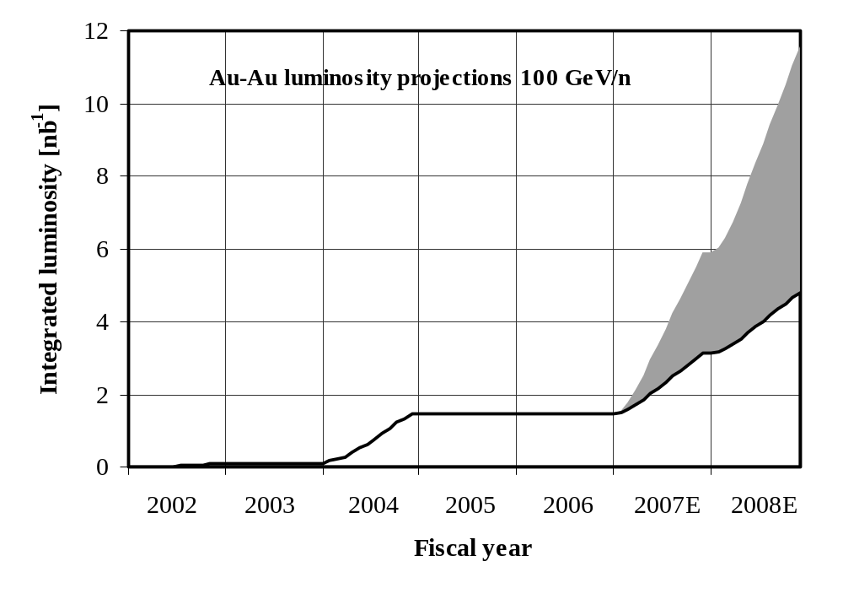
Projected
minimum
Projected
maximum
(d-Au)
(Cu-Cu) (only p-p)
Figure 3-1: Minimum and maximum projected integrated luminosity for Au-Au collisions.

Fiscal year |  | 2002A | 2003A | 2004A | 2005A | 2006E | 2007E | 2008E
No of bunches | … | 55 | 55 | 56 | 106 | 111 | 111 | 111
Ions/bunch, initial | 10¹¹ | 0.7 | 0.7 | 0.7 | 0.9 | 1.3 | 1.7 | 2.0
Average beam current/ring | mA | 48 | 48 | 52 | 119 | 180 | 236 | 278
β∗ | m | 3 | 1 | 1 | 1 | 1 | 1 | 1
Peak luminosity | 10³⁰ cm⁻²s⁻¹ | 2 | 6 | 6 | 10 | 37 | 64 | 89
Average store luminosity | 10³⁰ cm⁻²s⁻¹ | 1.5 | 3 | 4 | 6 | 25 | 43 | 60
Time in store | % | 30 | 41 | 41 | 56 | 58 | 59 | 60
Maximum luminosity/week | pb⁻¹ | 0.2 | 0.6 | 0.9 | 1.9 | 8.8 | 15.2 | 21.7
Minimum luminosity/week | pb⁻¹ |  |  |  |  | 1.9 | 1.9 | 1.9
Maximum integrated luminosity | pb⁻¹ | 0.5 | 1.6 | 3 | 13 | 72 | 131 | 179
Minimum integrated luminosity | pb⁻¹ |  |  |  |  | 16 | 16 | 16
AGS polarization at extraction | % | 35 | 45 | 50 | 55 | 65 | 70 | 80
RHIC store polarization, average | % | 15 | 35 | 46 | 47 | 60 | 65 | 70
Maximum LP⁴/week | nb⁻¹ | 0 | 9 | 40 | 90 | 1130 | 2720 | 5220
Minimum LP⁴/week | nb⁻¹ |  |  |  |  | 90 | 90 | 90

Table 3-3: Projected RHIC p-p luminosities and polarization

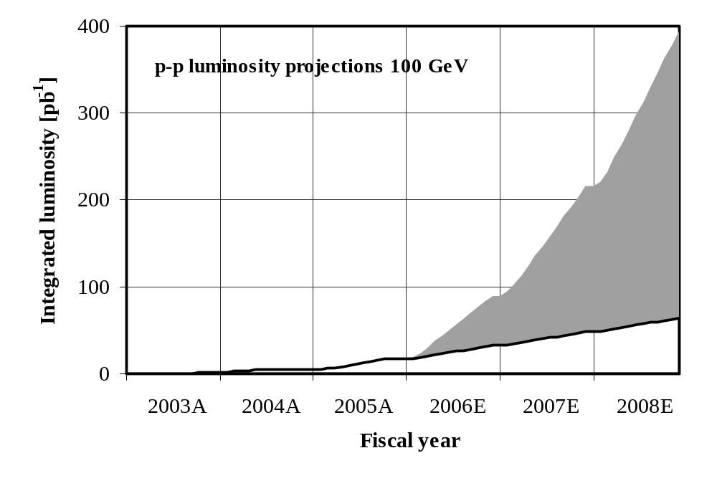
Projected
maximum
Projected
minimum
Figure 3-2: Minimum and maximum projected integrated luminosity for p-p collisions.

4 Collider upgrades and development: 2006-2011

In the quest for higher luminosity and polarization, more flexibility, and increased uptime, a number of upgrades are planned for the next few years:

- The evolution towards the Enhanced Luminosity and polarization goals
- The construction of the new ion injector EBIS
- The development and implementation of electron cooling for RHIC II
- Improvements to the aging infrastructure

1. The evolution towards the Enhanced Luminosity and polarization goals
In both Au-Au and p-p operation RHIC now exceeds the Design Luminosity. The RHIC Enhanced Luminosity goals consist of

L_{store ave} = 8×10²⁶ cm⁻²s⁻¹ for Au-Au at 100 GeV/n (4× design)

L_{store ave} = 6×10³¹ cm⁻²s⁻¹ for p-p at 100 GeV,
L_{store ave} = 1.5×10³² cm⁻²s⁻¹ for p-p at 250 GeV (16× design)
both with 70% polarization

To reach the luminosity goals requires the completion of the vacuum upgrades in RHIC, currently undertaken and expected to be finished by the end of 2006. For both the proton luminosity and polarization goals, the AGS cold snake needs to be fully commissioned. We expect to reach the Enhanced Luminosity goals by the end of 2008, provided that the machine runs a sufficiently long time in every year from FY2006 to FY2008. Should one of the modes not be run in any particular year, the performance development will be delayed.

2. The construction of the new ion injector EBIS
The new Electron-Beam Ion Source EBIS replaces the 35-year old Tandem electrostatic accelerators. Without EBIS the Tandems would require multi-million dollar reliability upgrade. With EBIS the ion injector operation is expected to be simpler and more reliable, at reduced operating costs. With EBIS new species can be offered such as uranium and polarized He-3. EBIS has received CD-1. Technically driven, it can proceed to CD-2 at the end of FY2006, and construction can begin at the beginning of FY2007 (CD-3). Commissioning can then begin in FY2009. The total DOE cost of the project is $17.1M, with an additional $5M from NASA.

3. The development and implementation of electron cooling for RHIC II
The enabling technology for RHIC II is electron cooling. For the first time electron cooling will be attempted at a high-energy collider, aiming at a ten-fold increase of the average heavy ion luminosity. This will make RHIC the first collider in which the dominant total beam loss comes from the physical interactions that the experiments study. For polarized protons a luminosity increase of a factor 2-3 is expected, from cooling the beams at injection down to an emittance that can be sustained under the limiting effects of the beam-beam interaction. Only small improvements to the polarization are anticipated.

Electron cooling at RHIC is based on a high-intensity, low emittance superconducting electron gun, and an Energy-Recovery Linac (ERL), also superconducting. Both critical components are under development and will be tested in scaled down ERL in building 912. The test ERL will accelerate electron beam of the required intensity and emittance to about half the required energy. The test ERL is expected to be completed buy the end of 2007. It is partially supported by funds from the U.S. Navy.

During 2006 we expect to establish feasibility of the RHIC II electron cooling upgrade, based on benchmarked simulations, and an assessment of the ability to reach the parameters needed in the critical components. With this milestone, CD-0 could be established in the same year, and technically constrained, CD-1, CD-2, and CD-3 decisions could follow, spaced approximately one year apart. With construction starting in FY2009, electron cooling could be commissioned in RHIC in FY2012.

4. Improvements to the aging infrastructure
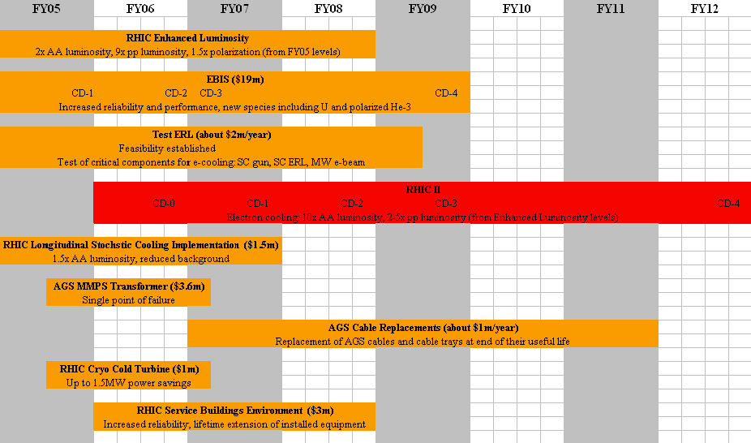
The more than 40-year old injector complex, and increasingly parts of RHIC, require the replacement of obsolete components to maintain reliability and performance. These upgrades will be undertaken with Accelerator Improvement Project (AIP) funds. The most important immediate upgrade is the replacement of the AGS Main Magnet Power Supply Transformer, a single point of failure equipment at the end of its useful life. Cable and cable tray replacements in the AGS are necessary for several years at a cost of approximately $1m/year. In RHIC, an upgrade of the refrigeration system will lead to a power reduction of up to 1.5MW in steady state operation. To increase RHIC’s reliability and to protect the installed equipment from unfavorable environmental conditions that shorten its lifetime, an improvement of the RHIC service buildings is needed. Electronics hardware in all parts of the RHIC complex can become obsolete, and parts unavailable, after a few years to a decade, making replacement necessary.

The most important of the planned upgrades are shown in Figure 4-1.

Figure 4-1: Planned upgrades in the RHIC complex through 2012

5 PHENIX and STAR Upgrades

Each of the experiments has a planned suite of upgrades to address the physics topics described in Section 2. We give here an overview of each experiment’s plans, followed by a brief listing of specific upgrade projects, noting the status of each. We have divided them into “short term” and “mid-term” upgrades. The short term upgrades are projects that either already underway, or expected to proceed in FY 2006. The mid-term upgrades are projects that are far enough along in the planning/development/proposal stage that they could be implemented as DOE construction projects and completed during the time window of this strategic plan.

It is important to note that a large fraction of each of the PHENIX and STAR collaborations is actively collaborating on the detector upgrades: ~ 30 universities and research labs in PHENIX, and ~28 institutions in STAR. A number of new institutions have joined both collaborations with strong expressions of interest in the physics associated with the upgrade detectors.

Overview of PHENIX Upgrade Plans

The PHENIX experiment has developed a plan to incrementally upgrade its detector subsystems over the next five to seven years. The upgrades are designed to allow PHENIX to pursue the spectrum of compelling physics topics as RHIC evolves from the relativistic heavy ion discovery phase to the realm of exploration and characterization of strongly-coupled dense partonic matter. In addition, the upgrade program will enable PHENIX to significantly expand the systematic exploration of the sources of nucleon spin and to begin a comprehensive program of p(d)+A physics at RHIC. All detector upgrades are optimized for the increase in RHIC luminosity from electron cooling. The upgrade physics program will reach its full potential once the RHIC luminosity upgrade becomes available.

Key physics measurements of the PHENIX Upgrade Program include:

- Precision study of heavy quark production (charm and beauty) in A+A, p(d)+A and polarized p+p
- Detailed measurement of the electron pair continuum in the low mass (ρ to φ ) and intermediate mass range (φ to J/ψ) in all collision systems.
- Jet tomography for γ+jet, direct photon and πº measurements over a pseudo-rapidity and azimuthal range increased by an order of magnitude.
- ΔG/G with charm, beauty and γ+jet correlations in p+p
- Δq/q for sea quarks determined through W-polarization in p+p
- Transversity and transverse spin components of proton spin
- Gluon shadowing and gluon saturation (Color Glass Condensate) in p(d)+A over a large x range (10⁻¹ to 10⁻³)
- Measurement of ϒ at mid-rapidity. Improved S/B for J/ψ, ψ' and ϒ in A+A, p(d)+A and p+p.

Details of the PHENIX upgrade subsystems are shown in Table 2. The upgrade detectors include a Hadron Blind Detector composed of CsI-doped triple Gas Electron Multipliers (GEMs) in a proximity-focused Cerenkov counter (HBD), a four-layer silicon vertex barrel at mid-rapidity (VTX), a forward, four-layer, silicon vertex tracker (FVTX), Resistive Plate Chamber (RPC) tracking stations located in the Muon Spectrometer arms (MuTrig), and a compact tungsten-silicon calorimeters in the forward rapidity region (NCC). All the new subsystems complement the PHENIX baseline detector, and in all cases enhance or extend physics capabilities of the existing detector. All upgrade subsystems rely on technologies that were unavailable at the time of the construction of the PHENIX baseline detector.

Upgrade Subsystem | Detector type | Physics program | Collaborating Institutions 12/2005
Hadron Blind Detector | GEM-based Cerenkov | Low mass di-electrons | BNL, Columbia U, U Mass, RBRC, Stony Brook U, U Tokyo, WIS
Muon Trigger | Res Plate Chambers | Quark spin structure  W-polarization | ACU, Columbia U, ISU, Kyoto U, Peking U, RBRC, UCR, U Colorado, UIUC
Silicon Vertex Barrel | Silicon pixel + strips | γ+jet, heavy quark spec.  jet tomography | BNL, Ecole Polytech., FSU, ISU, KEK, Kyoto U, LANL, Niigata U, ORNL, RIKEN, Rikkyo U, Stony Brook U, UNM
Forward Silicon Vertex | Silicon mini-strips | γ+jet, heavy quark spec.  jet tomography, CGC | BNL, Charles U, Columbia U, Czech Tech U, Inst Phys Czech Acad Sci, ISU, LANL, NMSU, UNM
Nose Cone Calorimeter | Tungsten-silicon calorimeter | γ+jet, W-polarization  heavy quark spectroscopy,  jet tomography | BNL, Charles Univ, Columbia U, Czech Tech U, EWU-Korea, Inst Phys Czech Acad Sci, ISU, JINR-Dubna, Korea U, Moscow State, RIKEN, Stony Brook U, Tsukuba U, UCR, UIUC, Yonsei U
Data Acquisition | Electronics, computing | High luminosity, high rate | BNL, Columbia U, ISU

Table 5-1: Summary of the PHENIX mid-term Upgrade program

Future PHENIX Beam Use Proposals will be optimized to take advantage of the new physics available as the subdetectors in the Upgrade Program are commissioned and operated in PHENIX. Physics runs with substantial integrated luminosities for collisions of Au+Au, d+Au and p+p (both s ^{½} = 200 GeV and s ^{½} = 500 GeV) will be requested during the next five to seven years of RHIC operations. Collisions of U+U will be requested once EBIS is completed and the beams become available to RHIC. The goal is to have all PHENIX upgrade subsystems installed and commissioned with initial physics measurements completed by the time RHIC II luminosities become available circa 2012.

The PHENIX upgrade subsystems will join the PHENIX baseline detector, and previously completed High pT ( Aerogel + Time of Flight) and TRD upgrades, to enable the experiment to carry out a comprehensive physics program for the next decade and beyond. An active R&D program is underway for each of these upgrade subsystems and in certain cases, such as the HBD, construction of the final detector has begun. A team of PHENIX engineers, scientists and upgrade subsystem personnel has been working since Fall 2004 on infrastructure and installation planning for the upgrades. Progress on integration and facilities issues is advancing on a timeline consistent with the anticipated construction schedules of the upgrade subsystems.

5.2 Overview of STAR Upgrade Plans

The STAR Collaboration has planned and is constructing a series of upgrades to the STAR detector which will provide the capability to make key measurements in the mid-term period and beyond. Implementation of these upgrades will add significant new capability for the detector, increasing the sensitivity and acceptance, and enabling STAR to make effective use of the RHIC II luminosity for addressing the core scientific questions outlined in Section 2.

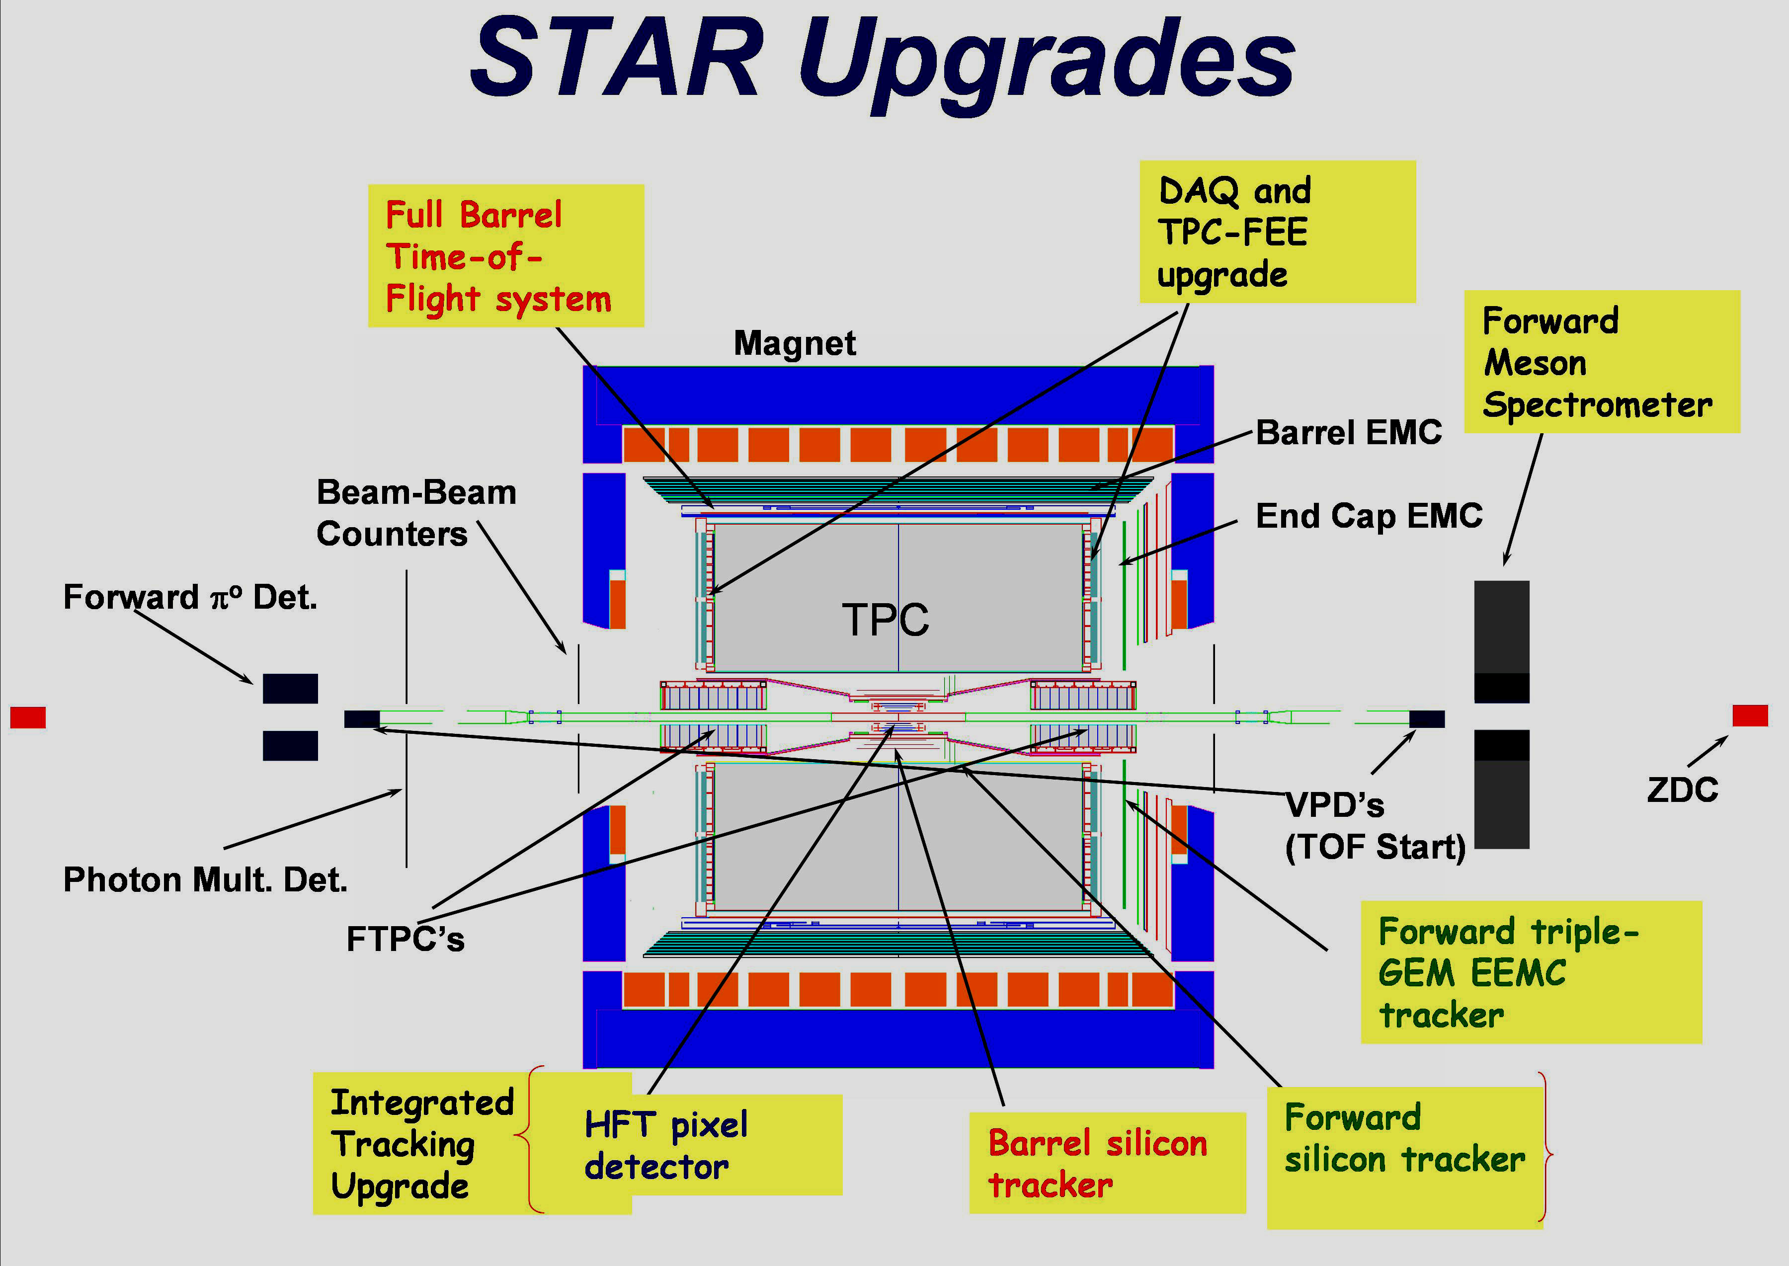
Figure 5-1. Location of planned upgrades (highlighted text) in the STAR detector.

The location of the various upgrades in the STAR detector is shown in Figure 5-1 The new systems are highlighted and include:
- An upgrade of TPC electronics and data acquisition (DAQ1000) to increase the event recording rate from the present level of 50-100Hz to 1000Hz.
BNL; U.T. Austin; LBNL
- A full barrel Time of Flight detector (TOF)
BNL; HuaZhong Normal U., Wuhan; IHEP, Beijing; IMP, Lanzhou; LBNL; MEPHI, Moscow; NASA-Goddard Space Flight Center; Rice Univ.; SINR, Shanghai; Tsinghua Univ., Beijing; UCLA; USTC, Hefei; U.T. Austin; U. Washington; Yale Univ.
- A Forward Meson Spectrometer (FMS), consisting of Pb glass array covering the pseudo-rapidity interval 2.5-4.0.
Penn State Univ.; BNL; UC Berkeley Space Sciences Inst.; IHEP, Protvino; Texas A&M Univ.
- A high-resolution silicon pixel Heavy Flavor Tracker (HFT).
BNL; U. Ca. Irvine; UCLA; Czech Republic Nuclear Physics Inst.; Strasbourg; MIT; LBNL; Ohio State Univ.
- An Intermediate Silicon Tracker (IST) consisting of three layers of silicon strips surrounding the HFT, and a Forward Tracking Upgrade consisting of three disks of silicon strip detectors and a GEM based detector designed to resolve the charge sign of leptonic W decays into the End Cap Electromagnetic Calorimeter.
Argonne Nat. Lab; BNL; IUCF; LBNL; MIT; Valparaiso Univ.; Yale Univ.; Univ. of Zagreb.

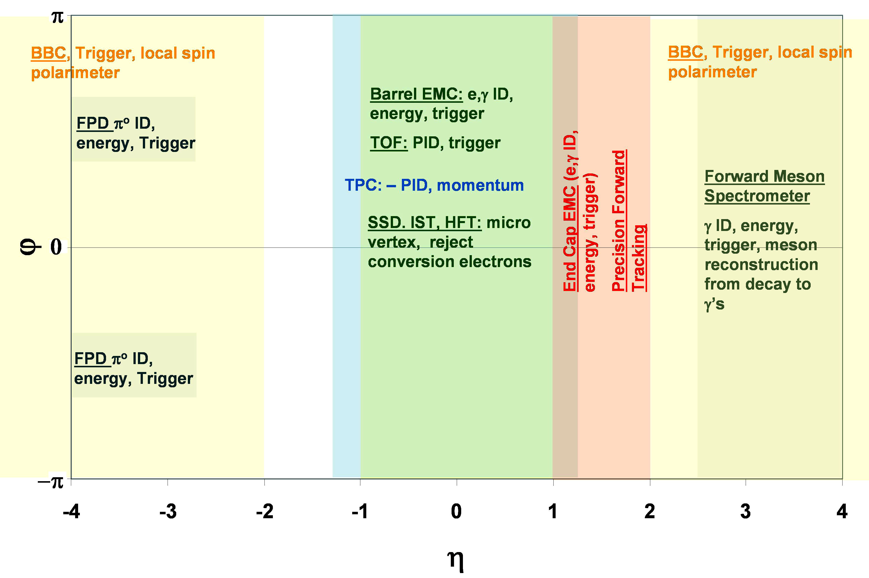
Figure 1-2. Coverage in azimuth and pseudorapidity of major STAR detectors and upgrades. The ZDC (Zero Degree Calorimeter covering full azimuth for η>6.5) is not shown.

Performance of the STAR TPC at high luminosity
The Time Projection Chamber is clearly central to the utility of the STAR detector, providing accurate momentum and dE/dx measurements for charged particles over full azimuth in the rapidity range –1 to +1. Clearly, a crucial consideration for upgrading STAR, in readiness for RHIC II luminosity, is the question of whether the TPC will continue to function effectively in this high-rate environment. The STAR collaboration has developed considerable experience and a large array of tools to correct track distortions in the TPC. The distortion of most concern for future operation at higher luminosity is due to space charge build up in the TPC gas volume. The charge build up in the TPC gas volume, which distorts the nominally purely longitudinal electric field, arises from the slow drift time of positive ions created by the flux of ionizing radiation through the TPC. It takes almost one second for a positive ion to traverse the full 2m drift distance. The charge buildup is proportional to the flux of charged particles through the TPC which will vary with luminosity and background and can vary on a short time scale. The tools used to correct these distortions include accurate modeling of the shape of the charge distribution, adequate scaler information to monitor the flux through the TPC and the ability to adjust the correction locally in time by using individual events. Details of the corrections can be found at: http://xxx.lanl.gov/abs/physics/0512157 . A powerful monitor of the quality of the corrections that is used in the short time scale corrections is the “signed distance of closest approach” (sDCA). This is simply the distance of closest approach of a track to the primary vertex (defined from a fit using all tracks) with a sign given by whether the primary vertex lies inside or outside the track’s curvature. The width of the sDCA distribution is a global monitor of tracking resolution. Figure 5-3 shows the mean (markers) and width (black bars) of the sDCA distribution as a function of luminosity after all corrections are applied for 200 GeV Au-Au collisions.
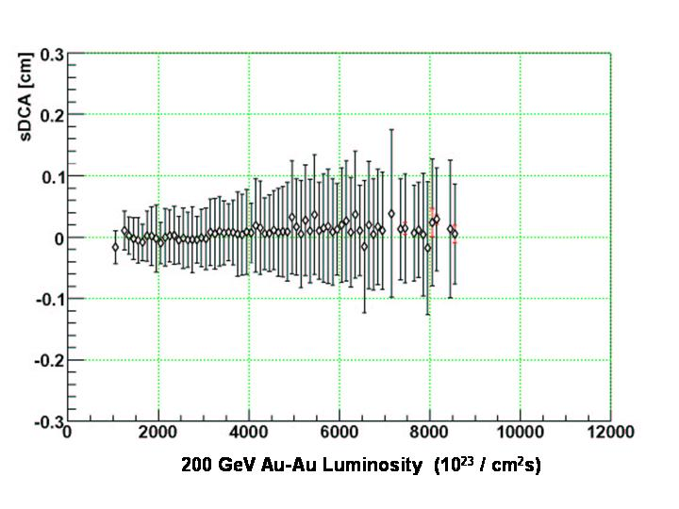
Figure 2 Signed DCA (sDCA) as a function of Luminosity for 200 GeV Au-Au collisions. The markers show the mean sDCA, the red bars the statistical error on the mean and the black bars the RMS of the event by event fitted sDCA mean. The latter is a monitor of the quality of the distortion corrections.

There is some increase in the sDCA width from the lowest luminosity to ~5 x 10²⁶ /cm²sec however the width remains constant above this to the highest luminosity sampled (~8.5 x 10²⁶ /cm²sec). This indicates the corrections are understood and there should be no difficulty running at even higher luminosity. We note that the peak luminosity for RHIC (30 x 10²⁶ /cm²sec) after the near term RHIC improvements is expected to be reached in FY09 and is within a factor of 2-3 of the RHIC II luminosity. This will be achieved five years before the full RHIC II luminosity is expected which should allow adequate time for refining the corrections, improving monitoring of the flux in the TPC and developments of improvements to the TPC (different operating gas and or increased drift field) if these are required. A research effort using a spare TPC sector is being initiated now to characterize various operating gases.

5.3 Summary and Status of Detector Upgrades

Short Term Upgrades:

PHENIX Hadron Blind Detector: The HBD will enable PHENIX to measure the low and intermediate mass electron pair continuum for all collision systems. The HBD is a windowless Cerenkov detector operated with pure CF4 in a proximity-focus configuration. The cylindrical detector, located in the central spectrometer magnet, consists of a 50 cm long radiator directly coupled to a triple-GEM which has CsI evaporated onto the top face surface of the GEM foil and a pad readout at the bottom of the GEM stack. The HBD’s ability to detect the electrons of Dalitz decays from πº ‘s and γ conversions will increase the S/B of the electron-pair continuum in the low mass region by two orders of magnitude. The project is being led by the Weitzmann Institute. The DOE cost is $1.5M, funded from RHIC operations capital ($1.0M of this was provided in FY 04-05). A full size prototype is installed for an engineering run in Run 6. The detector should be operational for Run 7.

PHENIX Muon Trigger: The fast muon trigger system (MuTrig) will be used to select events containing W bosons produced in polarized p+p collisions. The measurement of single longitudinal spin asymmetry A_{L} in W production makes it possible to determine the spin contributions of sea and valence quarks to the proton spin. The fast muon trigger system consists of three resistive plate chamber (RPC) stations installed in each of the PHENIX forward muon spectrometer arms. The MuTrig will have the same azimuthal and rapidity coverage as the existing PHENIX forward muon arms, and will use two-gap RPC technology developed for the CMS muon trigger at LHC. It is designed for a background reject of > 10⁴ which is sufficient for efficient operation at the anticipated 9 MHz collision rates at RHIC for polarized p+p running at s ^{½} = 500 GeV. This project is funded by the NSF, at a cost of ~$2M, and is led by the UIUC group. Construction is scheduled to begin in FY 2007, with completion in 2009.

STAR Time of Flight (TOF): A fast, fine-grain barrel array of multi-gap resistive plate chambers (MRPC) that will surround the STAR TPC. In addition to doubling the momentum range over which π,k, and p can be identified, when the TOF measurement is combined with the TPC dE/dx measurement, electrons can be cleanly identified from the lowest momentum measured (~200MeV/c) up to a few GeV/c. This capability complements the STAR electromagnetic calorimeter which works well for momenta above ~2GeV/c and provides the capability in STAR to measure the soft lepton and di-lepton spectra. The presence of a high granularity fast detector covering the TPC barrel will also allow pile-up events in the TPC to be filtered out in the analysis. This is especially important for the collision rates that are expected in p-p collisions at the highest luminosity. The TOF detector is a joint US-China project with a collaboration of Chinese institutions providing the MRPC modules and the US providing the readout electronics and mechanical infrastructure. This is a line-item (MIE) project with a DOE cost of $4.7M. It is funded in FY 2006, with completion in 2009.

STAR Forward Meson Spectrometer (FMS): A Pb glass array of ~1400 existing blocks, covering the η range from 1-4, over the full azimuth. Addition of this detector to STAR will allow observation and characterization of the parton model gluon density distributions in gold nuclei for 0.001<x<0.1. The greatly expanded coverage in the forward direction compared to the existing Forward Pi-zero Detector (FPD) will also allow measurements to resolve longstanding questions about the origin of very large transverse spin asymmetries for forward πº production in p↑ + p → πº + X reactions initiated by transversely polarized proton beams. The FMS is being funded from RHIC operations capital, at a cost of $600K. It is expected to be fully operational in FY 2007.

STAR DAQ1000: Replaces the front-end electronics of the STAR TPC with a fully pipelined system using the readout chip designed for the ALICE TPC. This will increase the readout rate from its present 100Hz to 1000 HZ, allowing very large data sets for untriggered rare processes, and virtually eliminating front-end dead time, thereby approximately doubling the luminosity seen by rare triggers. The project is funded from RHIC operations capital at a cost of $1.8M, it should be implemented by FY 2008.

The implementation of the DAQ1000 upgrade will result in a sharp increase in the raw data volume to be processed by STAR in subsequent heavy ion runs. This, in turn, will require an incremental investment in computing equipment for the RHIC Computing Facility. This increment is presently estimated to be $4.5M, spread over the period FY08 – FY10. The details are discussed in Sec. 7. This item is listed as “STAR Computing Upgrade” in the cost summary of Table 6-1.

Mid-Term Upgrades

PHENIX Si Barrel Vertex Detector: The VTX will allow precision measurements of heavy quark production (charm and beauty) in A+A, p(d)+A and polarized p+p collisions. It will enable γ + jet measurements over 2.4 units in pseudorapidity and almost 2π in azimuth. It will significantly increase the x-range for gluon shadowing and saturation measurements. The VTX is a four-layer silicon detector configured as concentric cylinders located in the PHENIX central spectrometer magnet and positioned immediately around a new 3 cm diameter beam pipe. The silicon sensors in the inner two layers are pixels (r = 2.5, 5.0 cm) and the outer two layers are strips (r = 10, 14 cm). The VTX barrel will cover |η| < 1.2. This is a joint U.S. and Japanese effort. The U.S. component is proposed as an MIE project with a DOE cost of $4.7M. It has been reviewed, and a management plan accepted by DOE. It is expected to be funded for a construction start in FY 2007, with completion in 2009.

PHENIX Si Forward Vertex Trackers: The FVTX extends the solid angle coverage of the VTX barrel. The FVTX will allow precision measurements of heavy-quark (charm and beauty) production in the forward and backward rapidity regions in A+A, p(d)+A, and polarized p+p collisions. It provides new coverage in the small Bjorken-x region where gluon saturation is thought to be important and significantly extends the range over which PHENIX can examine the gluon structure functions and their polarization. The FVTX will be composed of four silicon mini-strip planes in each of two endcaps matched to the muon arms. It will provide vertex tracking with a resolution of <200 μm over a large coverage in rapidity (1.2 < |η| < 2.2) with full azimuthal coverage. This would be a joint U.S. and Japanese effort. The proposed DOE cost will be ~$4.5M. There is not yet a formal proposal for this project.

PHENIX Nose Cone Calorimeter (NCC): The NCC is a compact tungsten-silicon sampling calorimeter (NCC) built to identify and make precision measurements of forward electromagnetic showers, provide jet identification, jet energy, γ/π⁰ and γ/hadron discrimination. The NCC has a circular geometrical coverage of a 50 cm radius at a distance of 40 cm from the nominal PHENIX collision point corresponding to a forward rapidity range from 0.9 to 3.5. Two calorimeter modules, one located on each of the pole faces of the PHENIX central spectrometer magnet, are built with an electromagnetic compartment, shallow hadronic compartment, a preshower section and a γ/π⁰ identifier.
The NCC is being developed by Russian and Japanese members of the PHENIX collaboration. A full technical design is in preparation. The estimated DOE cost is $4M

STAR Heavy Flavor Tracker (HFT): A silicon pixel inner tracking device with vertex point-back accuracy <50 μm, consisting of two layers of CMOS active pixel sensors, 10⁸ pixels, thin, 2 cm radius beampipe, with detector thickness ~ 50μm per layer. The HFT uses new technology. A significant R&D program is underway with collaboration from UC Irvine, Lawrence Berkeley National Laboratory and IRES, Strasbourg. It is expected that this effort could produce a prototype device to be installed in STAR by FY09. This device would allow in situ demonstration of the technology, demonstrate that a tracking device can operate only 2 cm from the RHIC beams, demonstrate the mechanical concepts for alignment are sound and allow vetting of the required tracking software with real data. The final devices would be installed in the following 2-3 years. This is an on-going development effort, with expectation that a project to construct a functioning detector for STAR could be undertaken in 2-3 years. The cost would be in the range $5-10M.

STAR Inner/Forward Tracking (integrated tracker): A silicon barrel consisting of 3 layers of Si strip detectors, replacing the present SVT, surrounding the HFT, and utilizing the existing SSD Si strip layer, provides a track pointing device for the HFT, connecting TPC tracks to the high precision inner layers, compatible with DAQ 1000. Forward tracking consists of 4 Si strip discs just forward of the Si barrel, and a GEM layer on the front face of the Forward EM Calorimeter. The forward tracking components provide precision tracking in the range 1 < η < 2, giving charge sign discrimination for leptonic decays of W bosons. The charge sign determination of forward scattered e±, tagged in the STAR end cap calorimeter in polarized p-p collisions is the main motivation for the forward tracking upgrade. Detailed simulations for the Integrated Tracker are in progress, and are expected to lead to a technical proposal during FY 2006. The estimated cost is ~$10M.

Upgrade costs and schedules

In Table 6-1 we summarize the estimated costs and schedules for these upgrades. Only the DOE costs are shown. Here, the estimates for the short-term upgrades are well-established. For the mid-term upgrades we have provided the current best estimates. The schedules shown for the mid-term upgrades include the time required for review of technical designs and management plans by BNL and DOE in advance of the budget preparation cycle for the proposed construction start. (Thus, for example, proposed project starts in FY 2008 must be reviewed by mid-FY 2006).

In discussing these projects in the context of the strategic plan, we have considered the resources required to implement them, including manpower; the costs and expected funding sources; the R&D requirements, including R&D costs; the incremental operations costs and computing resources once the upgrade becomes operational; and the timing of these upgrades with respect to possible physics operations scenarios for the facility. Thus, for example, the planning for the next high-statistics Au-Au run is coupled to the availability of detector upgrades to allow direct observation of open charm. These considerations are the subject of the “integrated plan” for upgrades that we discuss below.

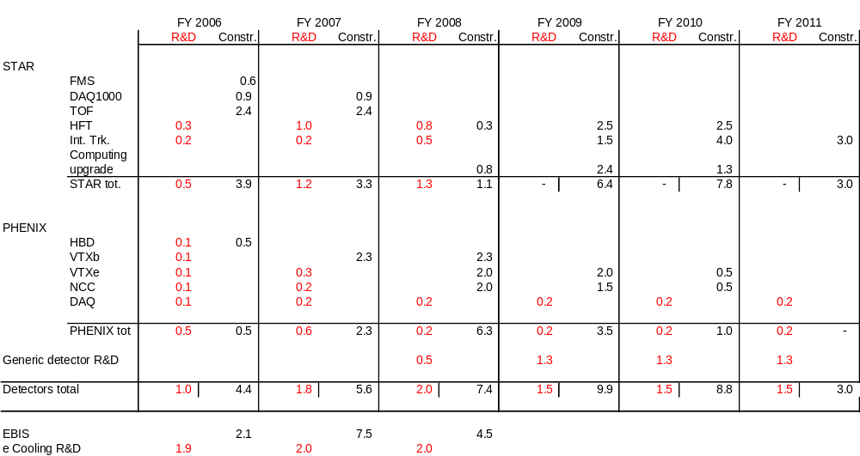

Table 6-1. Upgrade cost profiles (DOE costs): R&D and Construction

As R&D for the Mid-Term detector projects is completed, it is anticipated that development effort on detector technologies will continue, with an eye to future detector improvements as well as the design and development of detector systems for the eRHIC program. Hence, Table 6-1 includes a line for “generic detector R&D”, beginning in FY2008.

The total annual R&D and equipment fabrication costs for detectors in FY 2005 and 2006 is about $6M per year. In Table 6-1 one sees that this annual investment would rise to levels of $7-10M per year for the period 2007 – 2010 in order to implement these upgrades.

The effect of upgrades on facility operating costs

The annual cost of operating the RHIC detectors will increase incrementally as major new subsystems come on-line. This results mainly from the need for additional trained personnel on site at BNL to commission, maintain, de-bug, and repair these systems. Estimates from PHENIX and STAR of the added costs of material, travel, personnel, and computing due to these upgrades indicate that the total incremental operating costs for the two experiments, once these upgrades are in place, will be about $1M. This is roughly equivalent to the cost of operating an additional small experiment, on the scale of BRAHMS or PHOBOS.

When EBIS becomes operational, toward the end of the mid-term period, it will replace the 35-year-old Tandem Van de Graaf machines, which are relatively expensive to operate, with a modern, linac-based pre-injector. It is estimated that the implementation of EBIS will reduce the operating costs by about $2M per year, beginning in 2010.

RHIC Computing Facility

The RHIC Computing Facility (RCF) uses a scalable architecture consisting of three main components – a CPU farm, central and distributed disk, and a hierarchical mass storage system (HPSS) – interconnected with a Gigabit Ethernet network. The CPU farm is based on dual-CPU commodity hardware running the Linux operating system. Each annual CPU purchase brings in an identical set of machines, this minimizes the number of machine configurations and greatly reduces the effort required to maintain the systems.

The disk storage in the facility started as high quality, expensive RAID arrays. As the volume of data collected by the experiments quickly exceeded expectations and the cost of non-RAIDed disk came down, the experiments began shifting to distributed disk on the farm nodes for the bulk of their online data storage, leaving the centralized RAID disk for files requiring high availability or not redundantly stored in HPSS. With this strategy, the experiments are able to afford much more storage than they would if they used only centralized disk. At this point they have over twice as much distributed disk as they have centralized disk.

The HPSS hierarchical mass storage system stores the entire raw data set from the experiments as well as the data derived from the reconstruction and analysis passes through the Linux farm. After some initial problems with HPSS, which were addressed by IBM, HPSS has been quite stable. The rapid increase of the data rates from the experiments, well beyond the initial design profile of the HPSS system, did result in some reconfiguration of the system during the first part of Run-5. It is felt that as long as we continue to upgrade HPSS, we will be able to keep up with the data rates from the experiments.

  - Computational Resource Planning for the Mid-Term Period

The systems within the RCF and the experiment counting houses are connected via gigabit Ethernet including some trunked gigabit Ethernet paths. All individual machines are directly connected to large central switch chassis that initially were segregated by experiment. As the facility grew it became impossible to connect all of the nodes of one experiment on a separate switch and interswitch traffic has become significant; to the point where we will be upgrading these links to 10 gigabit connections in the near future.

The annual replacement of ~1/4 of the installed hardware within the facility by new, more performant, hardware at a cost of about $2M per year has generally been successful in ramping up facility capacity at a rate adequate to meet the increasing demands of successive RHIC runs. Working with the experimental groups, we have developed algorithms to estimate the required capacities for CPU, disk, and mass storage for anticipated RHIC running scenarios. During annual meetings, the experiments provide the input used by the algorithmic model. From their beam use plans, the experiments estimate the amount of raw data they will collect for each species in each year. Each experiment then provides factors for the maturity of their codes, the number of reconstruction passes they believe will be required and a “richness” factor for the data, which indicates improvement in the density of interesting events compared to the data set used as the reference of the model. The model then calculates the required resources per Terabyte of raw data by scaling the corresponding parameters used historically by each of the experiments. The current model uses the 2005 Cu-Cu values as the reference data set. Finally, using the historical and Moore’s Law projected costs for CPU, disk, etc., the model produces a profile of required and delivered capacity for each year and the associated cost to meet it.

Since the actual species and duration of each future running period is not well know prior to the relevant PAC meeting, the model is flexible and the changing expected run conditions can easily be entered into the model. An example of the output of the model is shown in Table 7-1, Table 7-2, and Table 7-3. The total data volumes given by the experiments are shown in the first line of Table 7-1. The increases in expected data volumes over the coming years are based on the projected schedule for detector upgrades (increased read-out data volume per event, and increased data acquisition rate for STAR) and projected increases in the machine luminosity. The following lines in Table 7-1 show the scaled capacities required to process the raw data based on FY ’05 Cu-Cu experience. The lower half of the table shows the required installed capacities in the facility consisting of the resources required to process the data for that run plus a fraction of the previous year’s requirement.

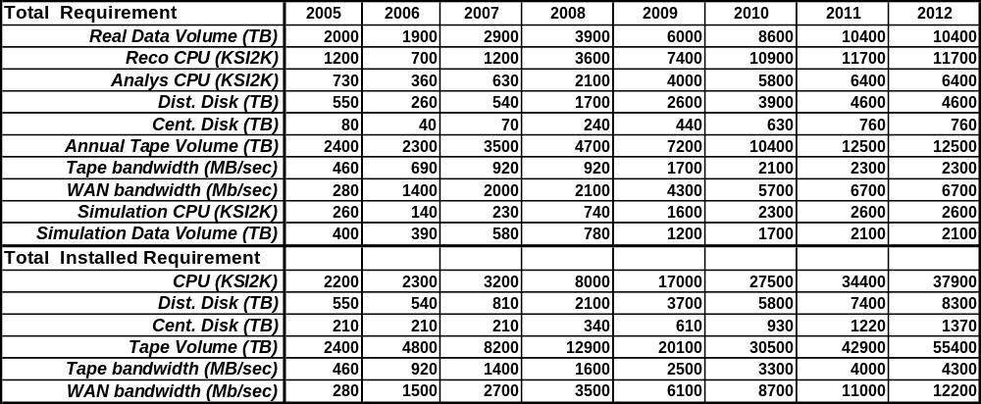
Table 0-1 Total computing requirement for each running scenario and the total RCF installed requirements

Table 7-2 shows the resulting detailed equipment cost profile for each year and Table 7-3 shows the estimated profile for the delivered capacity.

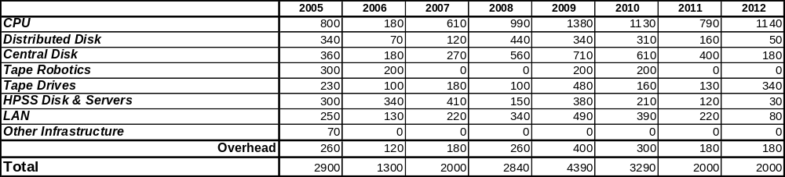
Table 0-2 Detailed RCF equipment cost profile (at year $K)
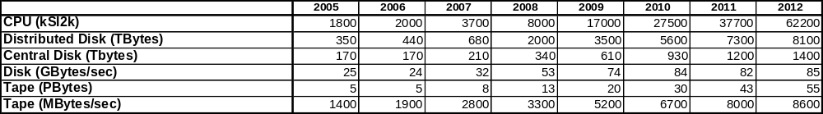
Table 0-3 Estimate of delivered capacity profile

The model shows that, given this particular set of Run scenarios, a significant increase in equipment funding over the nominal $2 M a year would be required between FY’08 and FY’10 in order to meet the expected requirements of the experiments. This sharp bump in the required investment in computing equipment, amounting to an estimated $4.5M increment over a 3-year period, is due to the dramatic increase in the expected data volume made possible by the STAR DAQ1000 upgrade. The rate of increase in expected data volume flattens out in the years beyond FY’09, and further impacts on the budget are moderated by Moore’s Law. The out years, of course, have the greatest uncertainly and the impact on the experiments data volume due to the proposed detector upgrades is not well known. Once the data volumes are better understood, the model can be rerun and the effect on the RCF plans and equipment costs can be estimated. In the meantime, in the discussion of upgrade costs in Sec. 6, we have included a line in the summary table (Table 6-1) for “STAR Computing Upgrade” to account for this $4.5M increment in FY08 – FY10.

CPU has historically been the primary driver of RCF equipment costs, and, to date, the predictability of Moore’s Law has been excellent for increasing CPU capacity through annual purchase of new hardware. Moreover, new Dual Core Processor technology promises a significant price/performance enhancement, as well as a reduction in Watts/performance. On the other hand, growth in data volume and data recording rates has outpaced early expectations, hence RCF is moving toward cheaper (more commodity-like) solutions for mass storage. The model takes this trend in mass storage into account.

  - Resource Utilization

RHIC Computing Facility CPU resources are assigned to particular experiments on the basis of long term anticipated needs. Within an experiment resources are then assigned for production reconstruction or for later stage individual or group level analysis. In the past, this allocation of resources resulted in some inefficiencies in the use of computational resources. This situation has now been corrected so that machines are no longer the exclusive province of particular groups. Assignments to particular experiments now relate to highest priority use of individual machines and are implemented by high priority queues in the Condor batch system. In addition to these high priority queues there are low priority queues on all machines which allow jobs of any experiment to migrate into and use computing resources assigned to another experiment when those resources become idle. If the assigned user of a machines begins submitting jobs, the jobs from the low priority queues are stopped so as not to interfere with this high priority use. In this way it is anticipated that utilization of the RHIC computing resources will be higher and more consistent across the ebbs and flows of use by individual experiments during the upcoming RHIC run. In addition, as a result of the fact that both RHIC and ATLAS are using the same version of the Red Hat operating system, it is now expected that low priority cross utilization of idle computing resource will also be possible between these two projects.

7.3 RCF Staffing

The issue of manpower is not addressed by the model. Presently the facility is at 19.5 FTEs with that effort distributed as shown in Table 7-4. This number fluctuates around 20 FTEs as we lose and replace people. We are currently in the process of recruiting to fill one additional position. The facility has, in general, been understaffed, but the collocation of the US ATLAS Computing Facility with the RCF has allowed for a sharing of expertise and effort among the manpower of the two facilities. This sharing of effort has benefited both facilities and has enabled both facilities to function at an effort level significantly below what would be required for either facility stand alone. Provided the US ATLAS facility remains collocated with the RHIC facility and the technologies used remain well aligned, it is not expected that an increase in manpower for the RHIC facility will be required over the next five years. However, an increase of two to three FTEs would allow for more aggressive involvement in new technologies resulting in more cost effective use of equipment funds as well as better support to the user community. A scenario that would require an increase in the manpower of the facility would be a dramatic change in the architecture of the facility. If it were decided that a dramatic shift in say storage or computer architecture were appropriate, then additional manpower would be required to allow for the transition to the new architecture while maintaining the current architecture until it could be phased out. Such a major architectural shift is not presently anticipated.

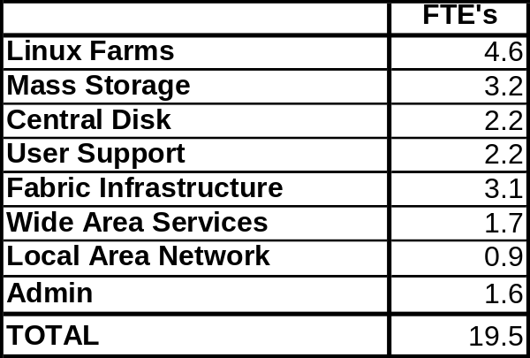
Table 0-4 Cuurent RHIC effort

7.4 RCF Physical Infrastructure

Finally, a very serious issue for RCF relates to physical infrastructure. The scale of computing has grown to the point where the physical hardware will soon outgrow the available floor space. More pressing is the fact that the facility has reached the limit of the power and cooling capacity of the building. Over the next one to two years, power and cooling can be added at the current location, but after that additional floor space as well as the accompanying power, air conditioning, fire detection/suppression, etc. will have to be provided. This problem is being studied at the Laboratory level. While it is not expected that the cost of providing this space and the associated power, cooling and fire detection/suppression equipment will be passed to the RHIC budget, the increasing power costs themselves are paid out of the RCF budget and will significantly impact it.

An Integrated Strategic Plan

Based on the details discussed in Sections 4 and 5, we believe that the mid-term accelerator and detector upgrades could proceed over the coming 5-6 years while carrying out a physics operations program of 20-30 weeks each year. In Figure 1 we show a time-line in which we have assumed a straw-man beam-use program that is consistent with the recent Beam Use Proposals from PHENIX and STAR, and is also consistent with the present C-A Dept. projections for beam performance over this period.

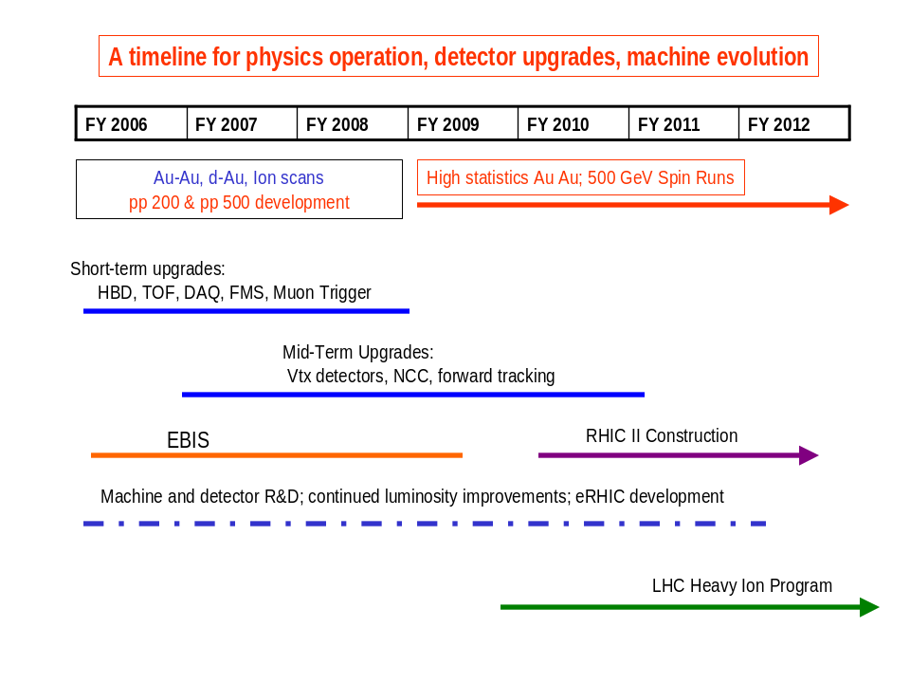
Figure 8-1: A Mid-Term timeline for physics operation and upgrades

A key element of this timeline is the readiness for high-statistics Au-Au runs from 2009 onward. This corresponds to the time when we expect the first results to emerge from the LHC heavy ion program. An important part of the strategy, reflected in the funding plan of Table 6-1, is to complete a complement of detector upgrades to enable measurements of open charm (and beauty), charmonium spectroscopy, and jet tomography in a high-statistics Au-Au run starting no later than 2009. Also in the mid-term time period, the forward tracking and calorimetry upgrades should enable the measurement of W± production in 500 GeV p-p collisions.

We have noted that the development of e-cooling is proceeding at a pace that should allow the initiation of a construction project to implement full-energy cooling of the RHIC beams, producing the RHIC II luminosity gains, with a construction start (CD-3) in 2010. With the completion of the proposed detector upgrades, both STAR and PHENIX will be capable of exploiting the RHIC II luminosity to carry on with the physics program described in Section 2 of this report.

Therefore, an important consequence of the mid-term strategy described here is the possibility to re-visit the planned scope of the RHIC II Project, which had previously been envisioned to include significant funding for detector upgrades. We suggest that with the implementation of this mid-term plan, a RHIC II Project can be more narrowly defined, strictly as a luminosity upgrade for the machine. At correspondingly lower cost, this major upgrade in machine performance could become operational at the end of the mid-term period, with two large detectors well equipped for RHIC II physics. The graphic in Figure 8-2 illustrates this plan in detail, showing the timeline for machine and detector upgrades along with the evolution of machine capability over the mid-term period, and the corresponding readiness to begin the key physics measurements.

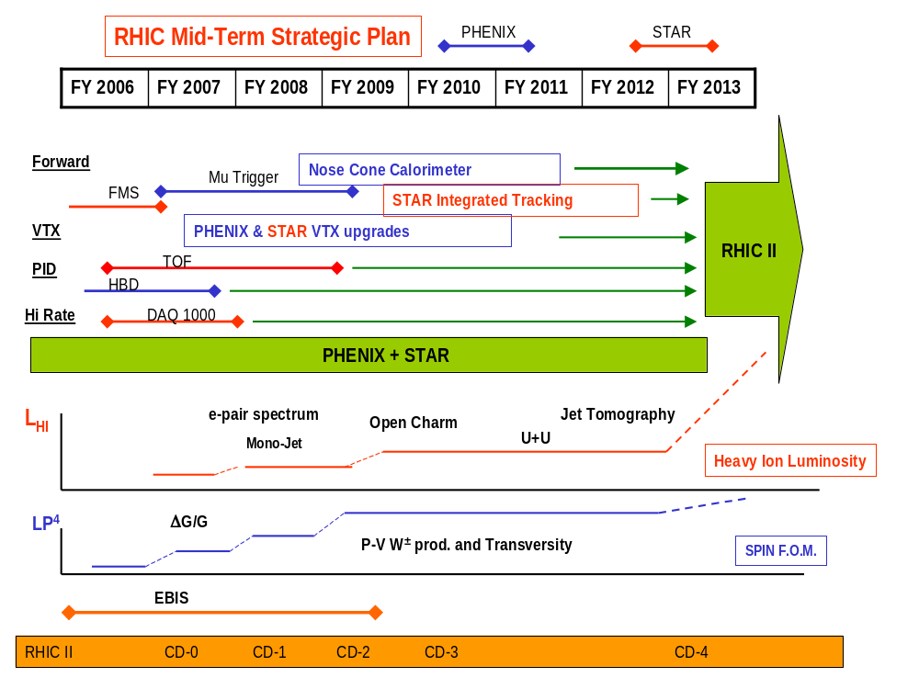

Figure 8-2: Graphic illustration of the Mid-Term Plan

Appendix I
Mid-Term Plan Working Group

The mid-term strategic plan is being developed by a working group established by Sam Aronson early in September. The group is broadly representative of the two major experiments, including both the heavy ion and spin interests. It includes the leadership of RCF and the accelerator team responsible for machine development and upgrades in the C-A department. The planning group includes two members of the BNL theory group, and two leaders of the BRAHMS and PHOBOS collaborations who provide their own perspective on the future program at RHIC and its relation to the LHC heavy ion program. In addition, the working group has included the computing leaders for PHENIX and STAR in its discussions of the RCF planning. The membership of the planning group was as follows:

T. Ludlam, convenor
S. Aronson, ex officio

PHENIX: A. Drees, E. O’Brien, W. Zajc, A. Deshpande
STAR: R. Majka, T. Hallman, B. Surrow
C-AD: P. Pile, W. Fischer, T. Roser
RCF: B. Gibbard, T. Throwe
Theory: D. Kharzeev, W. Vogelsang
RHIC Spin: G. Bunce
At Large: M. Baker, F. Videbaek
Consultants on Exp. Computing: J. Lauret, D. Morrison

Material presented at the working group meetings is available on the web at:
http://www.rhic.bnl.gov/midterm/
Formal presentations were heard from the PHENIX and STAR collaborations on their detector upgrade plans. Presentations were also heard from the Collider-Accelerator group on machine development and performance expectations, and from RCF on the current status and mid-term planning for the computing facility. In articulating the scientific questions that drive the mid-term planning, the working group received invaluable input from the RHIC II Science Working Groups and Writing Committee.

