M.S., L.G.
6/13/2011
Updated: 7/11/2011

Overview of latchup studies for the PXL detector
(DRAFT)

Introduction 1
A brief overview of SEL and SEU studies in early PXL sensor prototypes 2
On-going studies 3
Latchup rate measurements in the STAR environment 5
Test plans 9
Appendix A 10

Introduction

The PXL detector is a part of the HFT vertex detector upgrade for the STAR experiment at RHIC. This detector is composed of MAPS sensors fabricated in a commercial CMOS process with an epitaxial layer []. The first layer of MAPS in the PXL will be located at a 2.5 cm radius from the beam and, therefore, be exposed to a considerable radiation environment. One of the radiation induced effects to which CMOS devices can be prone is single event latchup (SEL).

During the R&D work on the PXL detector, we have performed a series of studies to evaluate the latchup sensitivity of the MAPS prototypes designed for the PXL detector. This document is intended as a short overview of that work, while detailed description and discussion of these studies can be found in the references.

NOTE:
In addition to latchup studies, the PXL R&D program integrates two approaches aimed at reducing and eliminating adverse consequences of SEL events.
- Digital circuitry of PXL sensors is being redesigned with increased transistor spacing to improve sensor’s resistance to latchup.
- The PXL detector power supply distribution is based on power supply modules servicing individual ladders and each of these modules comprises circuitry for latchup monitoring and automatic power cut-off when current consumption increases above a set threshold.

A brief overview of SEL and SEU studies in early PXL sensor prototypes

In our studies of SEL and SEU in MAPS for the PXL detector, we have investigated sensors with different architectures and complexity, including sensors with analog readout, digital readout, and on-chip memories. The measurements were performed at the TVDG Facility at BNL. In these studies, described in [, ] and summarized in Figure 1, we have
- estimated the onset energy for latchup, which corresponds to the ionizing energy of a few thousand of MIPs, for the more sensitive sensors,
- measured latchup cross-section curves for various LET values,
- observed the onset of SEU and SEL to be quite similar.

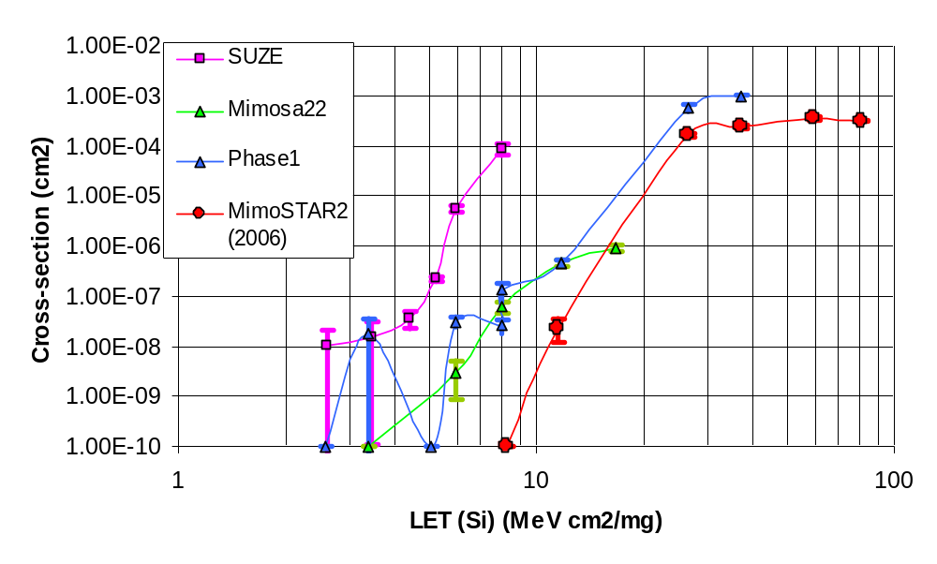
onset of SEU
Figure 1 Summary of latchup cross-section measurements on different MAPS prototypes: MimoSTAR2 – a small-size sensor with analog readout, Mimosa22 – small area sensor with binary readout, Phase-1 – full-reticle-size prototype with binary readout, SUZE – prototype of zero-suppression circuitry.

On-going studies
Recently, MAPS prototypes based on the same architecture as the PXL sensors became available and are currently being studied for latchup and SEU sensitivity. The prototype, Mimosa26, is half the size of the PXL sensor and its built-in memory is one third of that in the PXL sensor. A small digital chip dedicated to latchup studies was available for these tests as well.

In addition to Mimosa 26 studies, this set of tests has been extended to all IC components which are expected to be located on the sensor ladders or supporting mass termination boards (MTB), all of which will be exposed to radiation environment. This includes LVDS buffers, PLL, ADC, analog amplifiers, and a voltage regulator.

The measurements are performed at the BASE facility at the 88” cyclotron, LBNL. Some of the ion beams used for this study are not penetrating enough to allow for reliable measurements in encapsulated ICs. To address this limitation, we have tested the thickness of the packages by milling them until the silicon chip was exposed (see Figure 2 a). In most cases the encapsulation thickness was measured to be 10 or 15 mils (250 or 375 µm), with the maximum of ~120 mils for the voltage regulator. Due to limited availability of data on the package composition, we have assumed the density of the encapsulation to be approximately half of the density of silicon. In the latchup measurements we allowed the thickness of encapsulation to be 10 mils, therefore, some packages needed to be milled down to that particular thickness. The exception here was the regulator package, which could not be milled down without damaging internal bond wires. The chosen configuration should allow most of the test ions to penetrate at least several micrometers into the silicon chips.

The test PCB for this study has been designed to allow for concurrent exposure of all the devices under tests (Figure 2 b) to optimize setup in the vacuum chamber and the use of beam time.
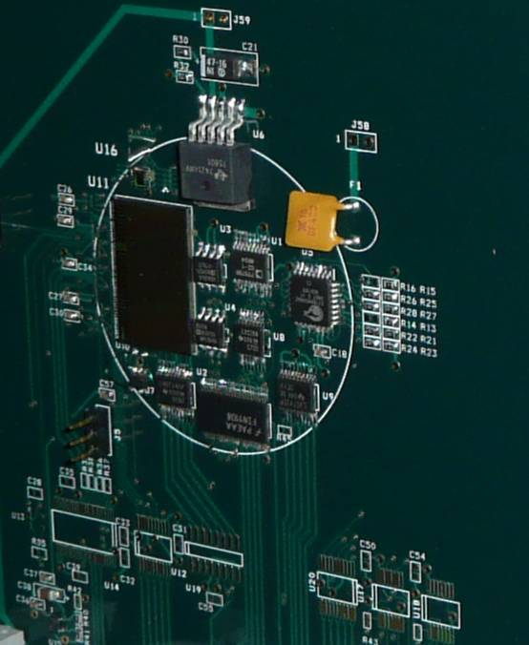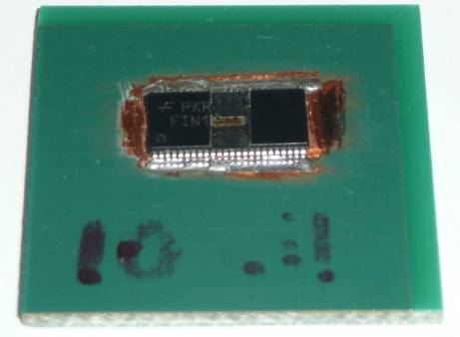
a)b)
Figure 2 Example of an LVDS buffer with part of packaging milled down to expose the silicon chip (a). Multiple DUTs mounted to a test PCB for concurrent latchup studies (b).

The raw data from initial measurements are shown in Figure 3. The only devices that exhibited latchup during this test were Mimosa 26 (mem, vdd, vda), LU test structure (std, 2um), and the ADC. Data points with single latchup occurrences are circled in red. The devices that latched frequently were Mimosa26 and the section of the LU test structure built with standard cells. We have observed only 2 other latchup events, one in the ADC and the other one in the LU_test structure with increased transistor spacing. The plot shows only raw data and detailed analysis is not available at the time of this writing.

The presented set of measurements appears to be in a fairly good agreement with earlier results (Figure 1). These measurements will be completed by additional latchup and SEU studies.

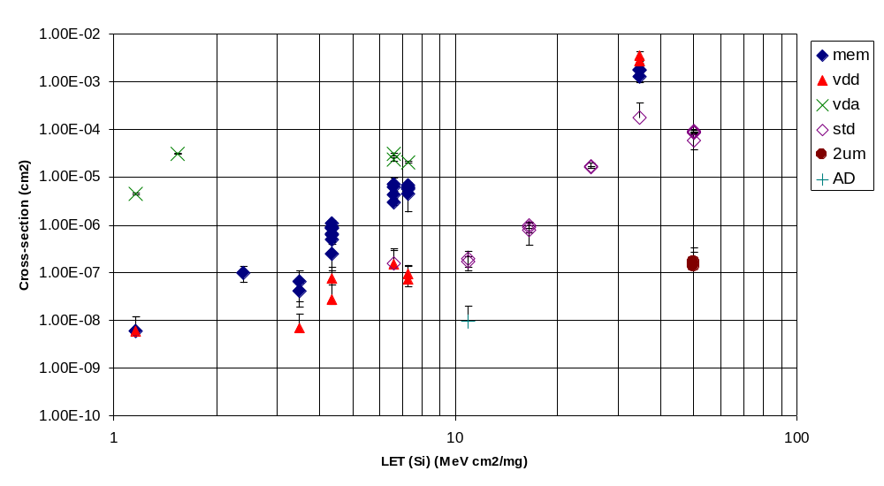
Single counts
Test results: Mimosa26, LU_test_structures, ADC
Preliminary results, raw data

Figure 3 Preliminary plot of raw data from the first series of latchup measurements on the Mimosa26 prototype, LU test structure, and MTB/ladder IC components.

Latchup rate measurements in the STAR environment

The heavy ion beams allowed us to study latchup rates in a well controlled environment. However, in the STAR experiment environment we don’t expect to see such heavy ions. The PXL detector will be exposed mostly to particles with charge one and additional, beam associated background. This suggests that the required amount of LET for latchup can not be generated based on the same energy loss mechanisms, mostly primary ionization. In STAR we expect that the latchup will be dominated by inelastic nuclear collisions in the silicon and, therefore, have lower cross-sections.

In the PXL R&D program, it has been of high importance to perform latchup measurements in the STAR environment. First and very limited observations were performed with a 3-plane telescope composed of the first-generation, small-scale sensor prototypes []. No latchup events were observed during that study.

To improve our understanding of the STAR environment, we have recently installed two Mimosa26 prototypes and a voltage regulator on the outside of the STAR TPC. These devices are being monitored for latchups during a part of this year’s RHIC run.

The test setup is shown in Figure 4. The test PCB allows for latchup measurements on the voltage regulator and VDD, VDA and memory power supply (VMEM) for both chips independently. The test PCB is mounted next to the beam pipe outside of the TPC volume, behind BBC counters (Figure 4). The choice of the location allowed for a very easy setup with no interference with regular STAR operations. The power supply is delivered by the same latchup monitoring power supply modules that will be used in the PXL detector.

Even though the sensors are mounted quite far from the interaction point, the measured latchup rate is an important parameter for the PXL detector. The latchup rate measurements can be combined with earlier radiation load studies (see Appendix A) to provide insight into latchup rates in the PXL detector.

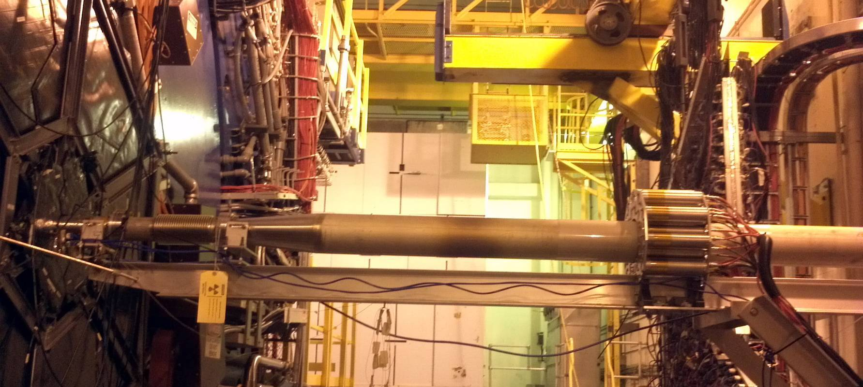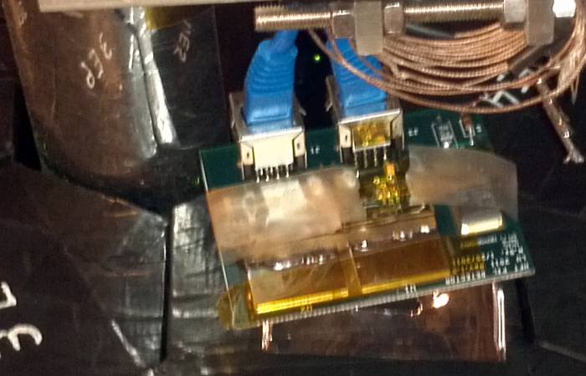
Figure 4 Location of the two Mimosa26 prototypes used for latchup studies in the STAR environment. The test PCB hosting two sensors and a separate voltage regulator is shown in the inset. The test PCB is mounted next to the beam pipe outside of the TPC volume, behind BBC counters.

Our latchup monitoring system went online on April 13, 2011. Up to date, we have registered 3 latchup-like events. The status of the STAR experiment at the time of each event is shown in Figure 5. All events happened during normal operations with steady beams.
Registered events:
- 17 April 2011, ~9:00 pm (EDT) MEM1
- 6 May 2011, ~1:08 am (EDT) VDD2
- 24 May 2011, ~10:03 am (EDT) VDD1
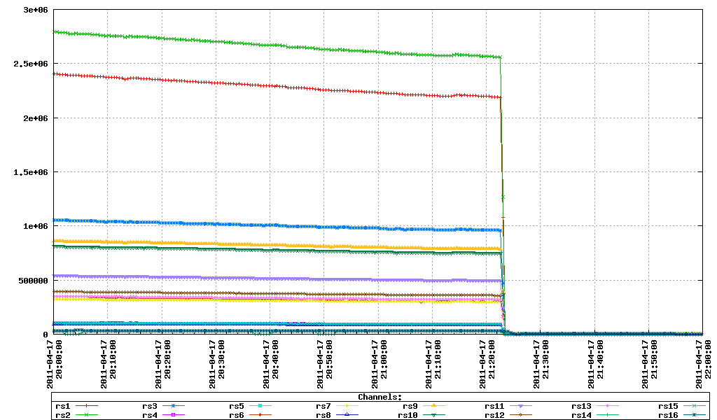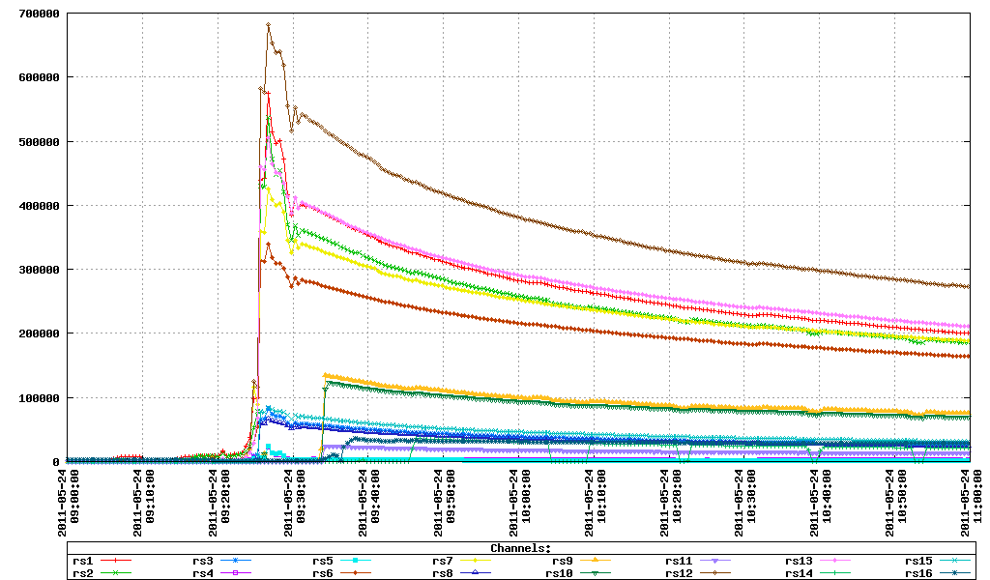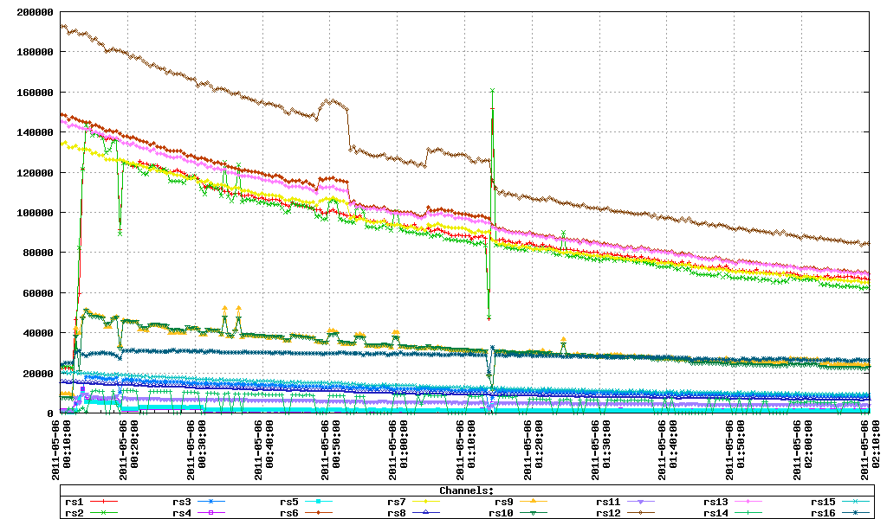
(500 GeV p+p)
(200 GeV Au+Au)
(200 GeV Au+Au)
a)
b)c)
Figure 5 Beam status (richScaler conditions) in STAR at the time of 3 events registered as latchup. The power lines that exhibited latchup conditions were a) MEM1, b) VDD2, c), VDD1.

Based on these measurements we can try to make back-of-the-envelope calculations and predictions for latchup rates in the PXL detector.

Figure 6 and Figure 7 in Appendix A show projected radiation dose at different layers of the HFT detector. The projections are based on the integrated dose measurements with TLD dosimeters in the STAR environment. Data from these figures can be used to establish a relationship between the radiation load at the location of the PXL detector (Z=0, R=2.5 cm) and the location of the test setup (Z=210, R=5.5 cm). Assuming that the test board is aligned with the ~3 o’clock position in Figure 7, the dose at the PXL detector location can be expected to be 2 to 3 times lower than at the end of the TPC (40 krads vs. 14 and 21 krads @ Z=0 for 1/R and 1/R² scaling, respectively).

We also make the following assumptions:
- the latchup rate is proportional to the radiation load,
- all the radiation load profiles scale linearly with the luminosity,
- the luminosity is expected to increase by a factor of 3 with respect to the current value.

The decrease of the radiation load by a factor of 2-3 associated with a different location compensates the expected increase (× 3) from higher luminosity. This indicates that the currently measured latchup rate would be approximately equal to the latchup rate in the same device at the PXL location and in the increased luminosity environment.

Assuming that 2 Mimosa26 sensors correspond to a single PXL sensor, the latchup rate of 3 events per 7 weeks of running for 2 Mimosa26 sensors at 5.5 cm at the current luminosity would translates to 0.0025 latchup per hour in a single PXL sensor located at the radius of 2.5 cm. The latchup rate at the 8 cm radius would be reduced to approximately 0.3 or 0.1 per sensor, depending on the scaling 1/R or 1/R².

The estimated latchup rate in the complete PXL detector is equal to:
0.0025 events/hr/sensor * (100 sensors + 300 sensors* 0.1) ~= 0.3 events/hr
assuming 1/R² scaling, and 0.5 events/hr for 1/R scaling.

The consequence of a latchup event in the PXL detector is that the detector needs to go busy for the time it takes to reset power supplies and reprogram sensors. This time is estimated to be approximately one second. The latchup rate of 1 event/hr will increase the PXL detector dead time by 0.03%, which is a negligible effect.

These back-of-the-envelope calculations should be improved by correcting for the integrated luminosity, sensor layout, and the asymmetry of the radiation load.

UPDATE (7/11/2011)
The STAR run 11 ended on June 30th, which provided the latchup monitoring setup with 11 weeks of operation in the STAR environment. The total number of latchup events did not change in the last four weeks and stayed at three, as discussed above. However, the estimated latchup rate decreased to 0.0016 latchup events per hour in a single PXL sensor. This, in turn, decreases the expected latchup rates in the complete PXL detector to approximately 0.2 events/hr for the1/R² scaling, and 0.3 events/hr for 1/R.

Test plans

Currently, our test plans for latchup and SEU measurements at the 88” cyclotron include:
- completing latchup and SEU measurements on M26 and PXL ICs,
- testing the PXL sensor prototype (Ultimate) for latchup,
- (possibly) testing the PXL sensor prototype for SEU.

We have reserved 3 shifts in August for completing these tests.

In addition, we intend to run our latchup monitoring system, currently installed in the STAR environment, for at least several weeks without any beams. This should allow us to correlate the registered events to the presence of the ion beams and validate the measured latchup rate.

Appendix A
Figure 6 and Figure 7 show radiation dose studies for the HFT detector performed by Howard Matis. The projections shown are based on integrated dose measurements with TLD dosimeters in the STAR environment.

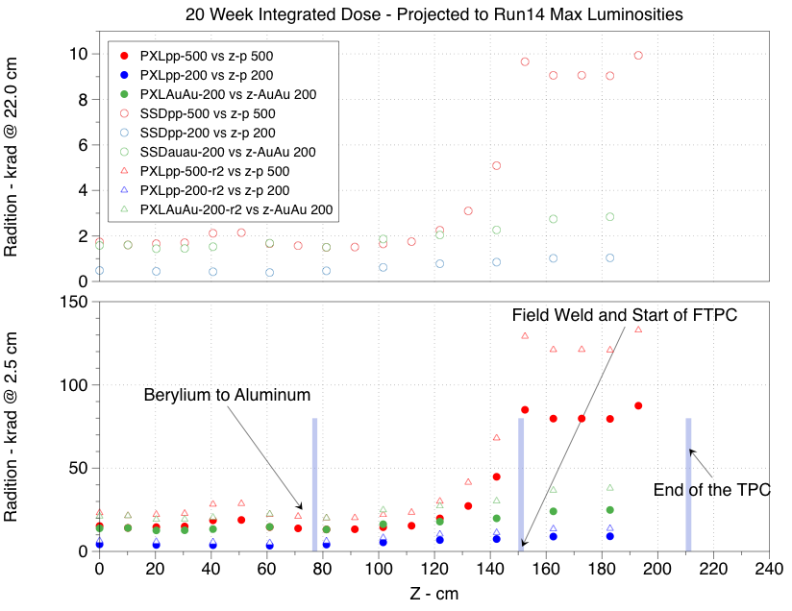

Figure 6 Projected dose in different layers of the HFT detector for 20 weeks of operations with maximum luminosities. The study was performed by Howard Matis and is based on TLD measurements performed along the beam pipe, inside the TPC.

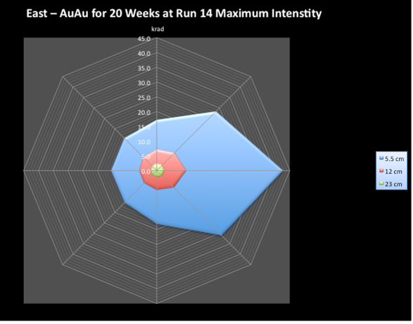
Figure 7 Projected ionizing radiation dose at the end of the TPC wheel. The projection is based on TLD measurements performed at the location of the BLM detector.

Ultimate User Manual V.1.1, January 2011
http://rnc.lbl.gov/hft/hardware/docs/latchup/Latch_up_tests_doc_v2.pdf
http://rnc.lbl.gov/hft/hardware/docs/latchup/Latchup_test_2009_report_v02.pdf
Results from a prototype MAPS sensor telescope and readout system with zero suppression for the heavy flavor tracker at STAR, NIMA, vol 589, 2008, p.167-172.

