|  |  |  |  |
| --- | --- | --- | --- |
| **HFT** | Pixel Services | | |
| HFT Project Document No: | Institute Document No. | Created : Feb. 24, 2010 | Page: **1 of** |
| TBD |  | Modified : **09/13/2011** | Rev. No .: 5 |

|  |  |  |  |  |  |  |
| --- | --- | --- | --- | --- | --- | --- |
| PXL Detector Electrical Connectivity  Prototype Detector  This document describes in a limited way the detector design and modularity as it pertains to the service cabling for the HFT PXL Detector to allow for understanding of the connectivity table. | | | | | | |
| Prepared by:  L. Greiner | | | Checked by: | | Approved by: | |
| Distribution List  HFT Collaboration | | | | | | |
| History of Changes | | | | | |
| Rev. No. | Date | Pages | | Description of changes | |
| 1  4  5 | March 2010  Jaunary 2011  September 2011 | 13 | | FDR original  Updated power supply cabling and fusing section  Updated to current design with VME 9U standard and connectors | |

Table of Contents

1 Introduction 4

2 Structure of the Signal and Power paths 5

3 Pixel Detector Electronic Component Blocks 6

3.1 Control PCs 6

3.2 RDO Boards 7

3.3 Patch Panels 7

3.4 Mass Termination Boards 8

3.5 Ladders 9

4 Signal Path and Cabling 9

4.1.1 Control PCs to RDO boards 9

4.1.2 RDO boards to DAQ receiver PCs 9

4.1.3 Star Trigger to RDO boards 10

4.1.4 RDO Boards to PP (1-2) 10

4.1.5 PP(1-2) to MTBs 10

4.1.6 MTBs to Ladders (Sector) 10

5 Power and Ground and Cabling 10

5.1 Cable Types 10

6 Connectivity 12

6.1 The Connectivity Table 13

6.2 Connectivity Table as Assembly Aid Error! Bookmark not defined.

7 Reference: 14

# Introduction

This document describes the electrical connectivity of the HFT PXL detector. A brief discussion of the structure and modularity of the HFT PXL is included to facilitate understanding of the electrical connection design and the connectivity tables which are presented in the appendix

The structure of the PXL detector is shown schematically in . A basic unit of the PXL detector is the ladder. Each ladder is an linear array of ten ~2 cm x ~2 cm. CMOS sensors. These CMOS sensors are run as a unit with common clock and control lines and constitute the basis of the parallel units that form the complete detector. Ladders are mounted to sector tubes such that there are 3 ladders mounted to the outer side of the sector tube and one ladder mounted to the inner side. Five coupled sector tubes, each with 4 ladders, form one detector half with another 5 coupled sector tubes forming the other half of the detector. This detector geometry and grouping is set by the mechanical design which was derived from the set of positional stability, location and coverage requirements dictated by the physics need. These basic quantities are reflected in

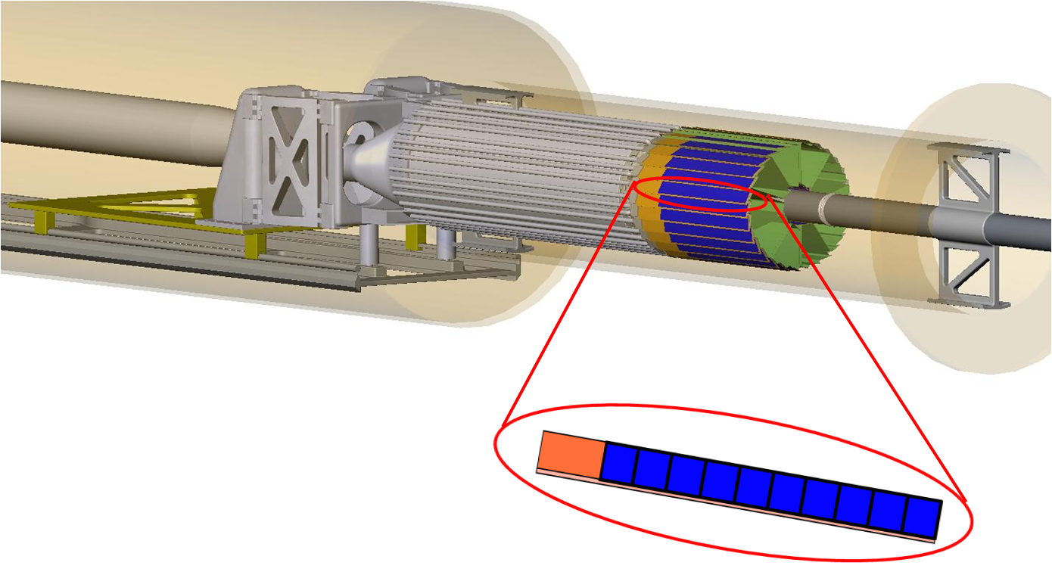

Figure 1. The structure of the HFT Pixel (PXL) detector. The basic unit of the detector is the ladder which contains ten MAPS sensors (shown in Blue). There are four ladders per sector tube (shown in green), three mounted on the outer edges and one on the inner edge. There are five sectors per detector half and a total of ten sectors in the detector.

|  |  |  |
| --- | --- | --- |
| PXL Detector Parameter | Qty. | Total Sensors |
| Signal Outputs per sensor | 4 | NA |
| Sensors per ladder | 10 | 10 |
| Ladders per sector | 4 | 40 |
| Sectors per detector half | 5 | 200 |
| Detector halves per PXL detector | 2 | 400 |

Table Basic PXL detector organization showing number of sensors per detector sub-unit.

The physical layout of the PXL detector readout components is shown in .

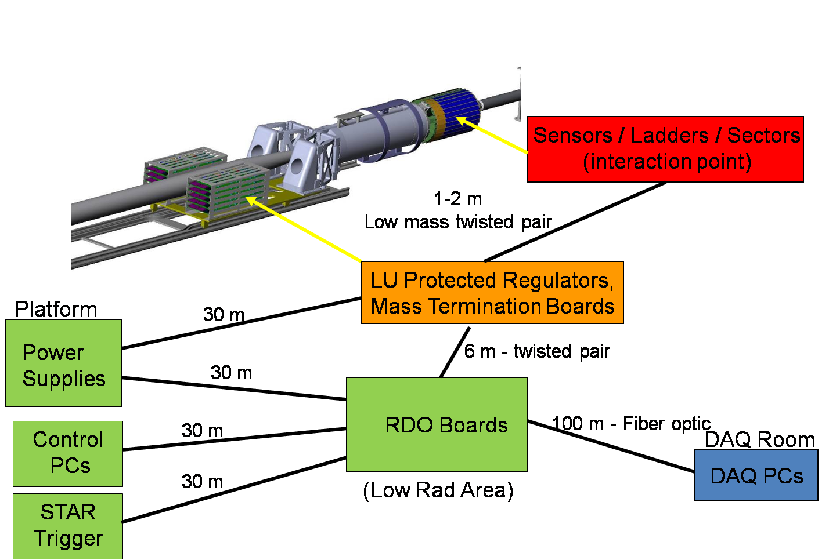

Figure Physical layout of the HFT PXL detector readout components. The distances are indicated between the various RDO components.

The relevant parts of the PXL coordinate definition and numbering convention are shown below in FIGXXX. These definitions are compatible with the existing STAR coordinate and numbering convention

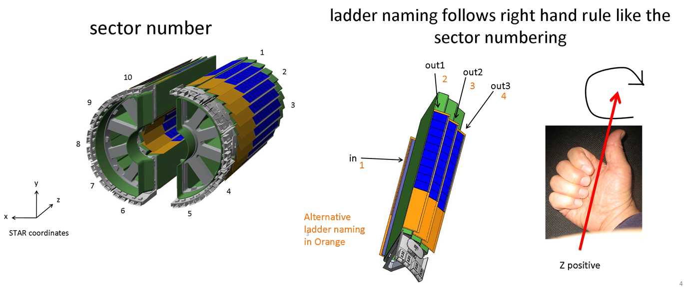

Figure STAR PXL coordinate system and labeling convention.

.

# Structure of the Signal and Power paths

The primary PXL detector data path consists of high speed (160 MHz) LVDS signals carried on twisted pair cables. The sensor control and clock signals move from the RDO boards via twisted pair cable through a patch panel and to the Mass Termination Boards (MTB). The signals are buffered and carried to the ladders over fine twisted pair wire. At the ladder, the clock and control signals are buffered and then distributed to the sensors on a low mass flex PCB. Sensor data follows the reverse path back from the sensors, through buffering on the ladders, through the fine wire to the MTB where the data signals are buffered again, and carried back to the RDO boards through the patch panel on twisted pair cables.

The natural unit of organization for the readout system is the sector. This is shown in . The PXL detector readout architecture is organized as 10 identical parallel units that are comprised of one sector (four ladders) serviced by one MTB which is in turn serviced by one RDO board. This modularity is carried through in the cabling connections.

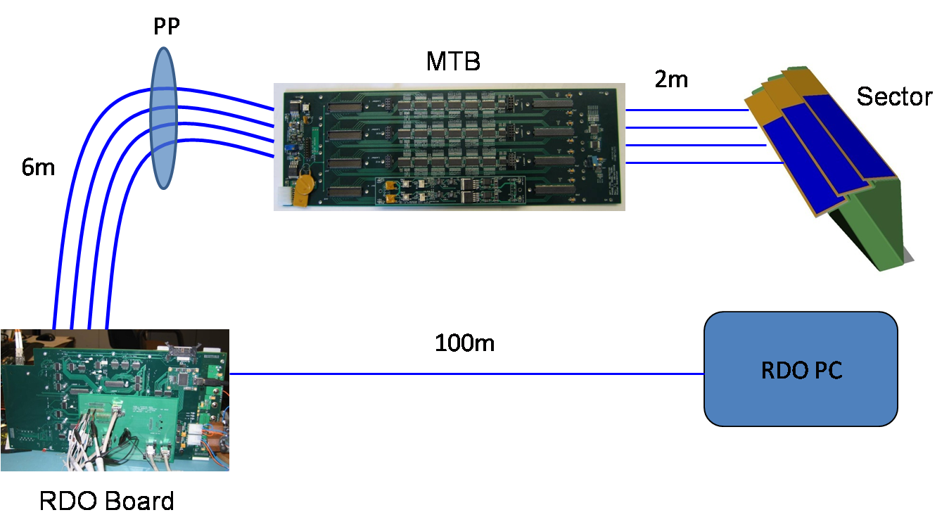

Figure A basic unit of modularity of the PXL RDO system consists of one sector of four sensor ladders serviced by one MTB which is in turn serviced by one RDO board. The complete PXL detector is comprised of ten of the shown units.

Power supplies are located in the STAR racks (location TBD) in the south platform. The power supplies supply low voltage power to the MTBs. The MTBs are equipped with daughter card PCBs which regulate and latch-up protect the power supplied to the ladders. The power supplied is 6 volts to the MTBs. Power supplied to the MTBs is regulated to 5V for running the MTB logic and to 3.3V for the separate latch-up protected analog and digital power supplied to the sensor ladders. The RDO boards will reside in a single 9U VME Crate and use the crate5V power supply which will be regulated to the voltages required on each RDO board.

**It is important to note that the connectivity table described here is specifically for a prototype detector. For the production detector, the connectivity tables will not change. The pin-out tables included in the spreadsheet will be modified to accommodate the use of the final sensors but the basic cable connectivity is identical between the two versions.**

# Pixel Detector Electronic Component Blocks

The PXL detector readout chain is composed of hardware blocks joined by cables. These blocks are listed below. For the purposes of this document, the flex PCB cable that carries the signals to and from the buffers on the ladders to the sensors themselves is considered to be part of the ladder block and is not described separately. The context diagram for the basic unit described may be found at <http://rnc.lbl.gov/hft/hardware/docs/Phase1/Phase-1_RDO_top.pdf>.

## Control PCs

There are two control PCs for the PXL system which reside in the PXL racks (TBD) on the south platform at STAR. These PCs provide control and configuration of the RDO boards and PXL system as well as serving as the slow control link for error condition monitoring. The connection path from these PCs to the RDO boards is via USB carried over RJ-45 cables. The grounds are isolated in this connection. These PCs are remotely controlled via Ethernet. Each PC is expected to occupy 5U of rack space.

|  |  |  |
| --- | --- | --- |
| **External connections / PC** | **Quantity** | **Mode** |
| USB | 5 | Bi-directional |
| Ethernet | 1 | Bi-directional |

## RDO Boards

The RDO boards reside in a 9U VME crate located in a rack on a platform on the east side of the detector. Each RDO board is a custom double wide 9U x 400mm VME board (physical but not connectivity VME standard). A RDO board has connectors to service four ladders by receiving sensor data and providing clock and control signals. In addition, the RDO boards have a USB communication port and PMC slots for the hosting of a ALICE DDL SIU fiber optic communication module A separate 6U VME board has a twisted pair PECL input for STAR Trigger TCD cable and distributes the trigger signals via the VME P1 backplane. A photograph of the RDO motherboard is shown in Figure 4. The context diagram for the Phase-1 RDO board may be found at <http://rnc.lbl.gov/hft/hardware/docs/Phase1/Phase-1_RDO_v5motherboard.pdf>.

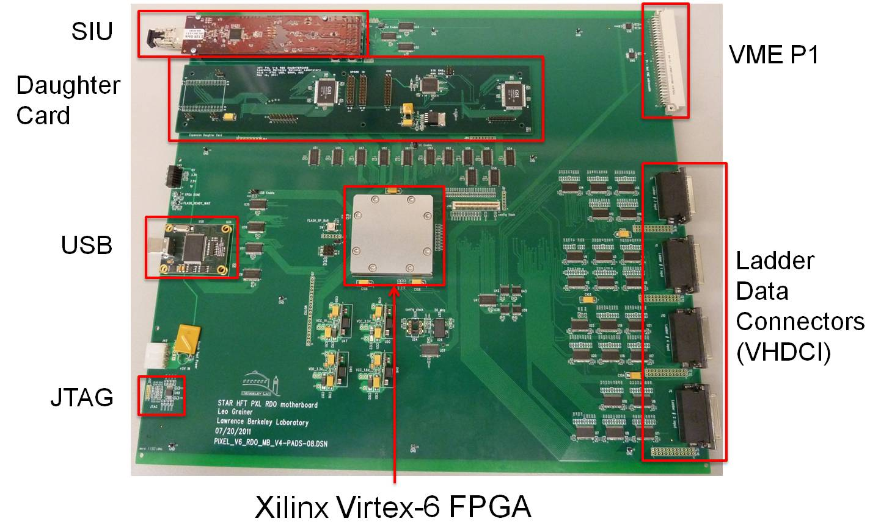

Figure Photograph of a pre production prototype RDO motherboard with the relevant cable attachment points labeled. The RDO motherboard has 4 ladder cable connectors.

|  |  |  |
| --- | --- | --- |
| **External connections / RDO Motherboard** | **Quantity** | **Mode** |
| USB | 1 | Bi-directional |
| VME P1 | 1 | Bi-directional |
| Source Interface Unit (fiber optic connection) | 1 | Bi-directional |
| 68 twisted-pair ladder cable connectors | 4 | Bi-directional |
| JTAG configuration unterface | 1 | Bi-directional |

## Patch Panels

There are two patch panels located at the east end of the cone that lead from the inner detector volume to the exterior of the STAR detector. The function of these patch panels is to allow the data, control and clock signals and power to enter and exit the PXL detector cooling air volume. PP1 is located on the north side of the flange and PP2 is located on the south side of the flange. Each patch panel services one half-detector which consists of 5 sectors. The patch panels are identical and the connectors on the patch panels are arranged as a block of 5 rows of four connectors such that the cable routing to and from the MTBs is simplified.

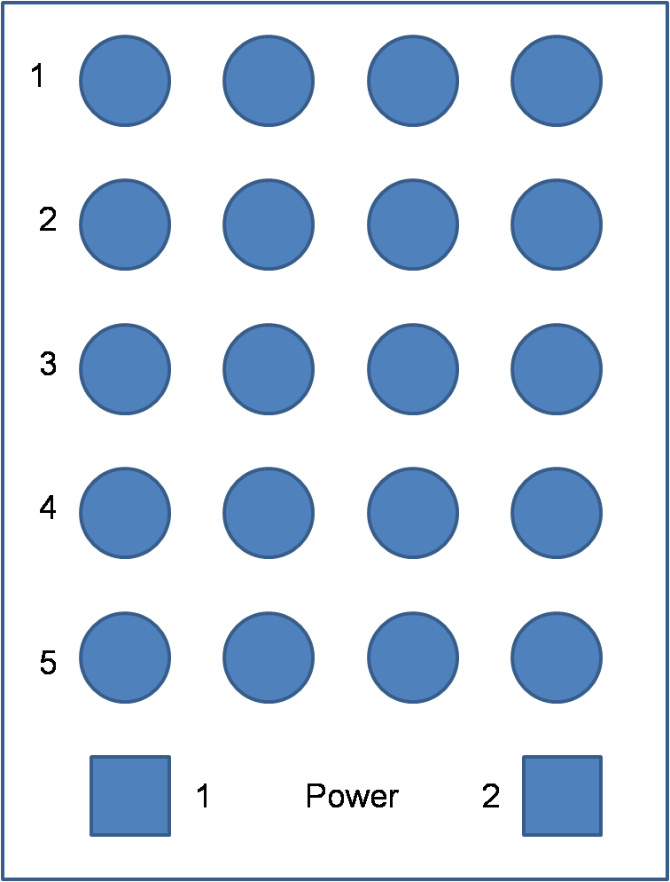

Figure A proposed PXL Patch panel connector layout showing the sector 1-5 ladder cable connectors. The power connectors for the MTBs are also shown.

## Mass Termination Boards

The Mass Termination Boards reside in a card cage located on rails in the inner detector area to the east of the interaction region behind the PXL detector. These boards consist mainly of drivers to buffer the signals to and from the ladders. Each MTB services signals to and from four ladders (one sector). The latch up protected power for each of the four ladders is generated on four daughter-cards which plug into the MTB. The context diagram for the prototype MTB may be found here <http://rnc.lbl.gov/hft/hardware/docs/Phase1/Phase-1_RDO_massterm.pdf>.

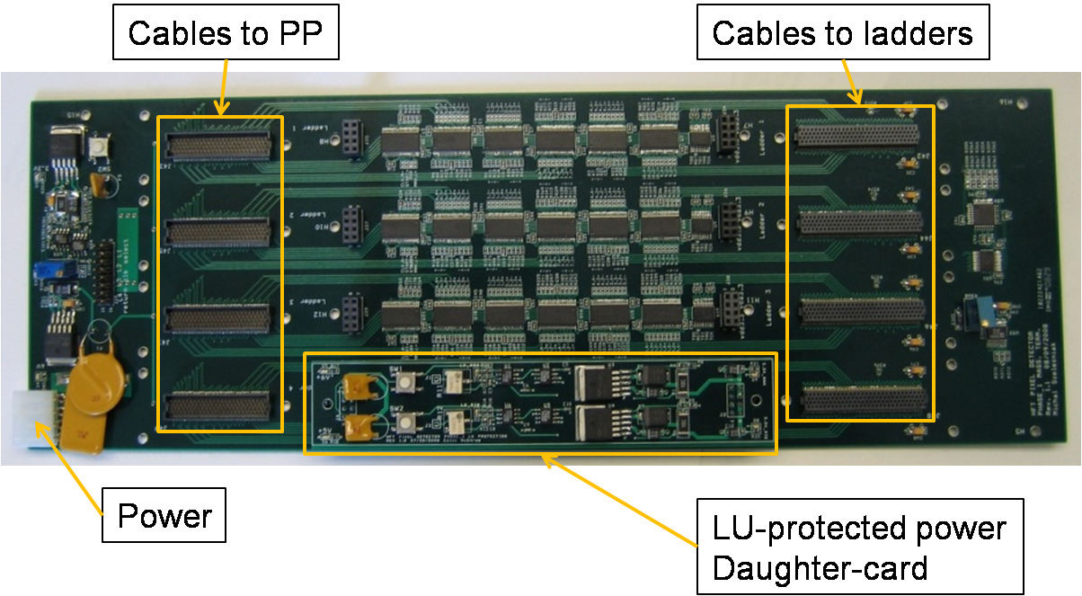

Figure Photograph of a prototype Mass Termination Board. The connections to and from the ladders are shown as is one of the four daughter-cards that produce latch-up protected regulated power for the ladders. Note that the connectors labeled “cables to PP” will be replaced with VHDCI connectors in the updated pre-production PCB version.

|  |  |  |
| --- | --- | --- |
| **External connections / MTB** | **Quantity** | **Mode** |
| 68TP cable to PP | 4 | Bi-directional |
| 60 TP cable to ladder | 4 | Bi-directional |

## Ladders

The ladders are composed of ten MAPS sensors mounted and wire-bonded to a thin flex PCB cable. All signals to and from the sensors are buffered with the buffer chips located at the east end of the ladder. Very thin twisted pair signal wires approximately 2m in length are soldered to pads on the east end of the flex PCB. The other end is soldered to a PCB mount to the Samtec connector that allows for the connection to the MTB. All ladder signals, power and ground are carried through this cable bundle. The context diagram for the ladders may be found here <http://rnc.lbl.gov/hft/hardware/docs/Phase1/Phase-1_RDO_ladder.pdf>.

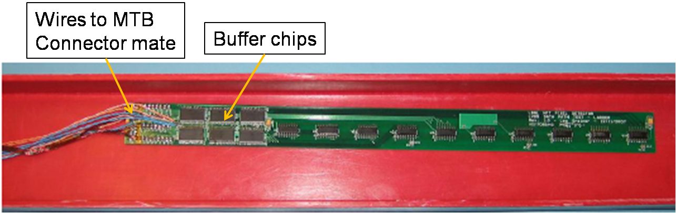

Figure Early Prototype ladder constructed with a thin FR-4 PCB. The buffer chips and wire solder points are indicated.

|  |  |  |
| --- | --- | --- |
| **External connections / Ladder** | **Quantity** | **Mode** |
| 60 TP cable to ladder | 1 | Bi-directional + power, gnd |

# Signal Path and Cabling

The signal path is divided into several signal path segments that are described along with the associated cabling. Please refer to the overall structure in as a reference to the block segments described below. The power and ground paths will be discussed in a later chapter.

### Control PCs to RDO boards

The communication between the control PCs and the RDO boards is via USB. We will be using commercially available USB over fiber USB extender hardware. A standard example may be found here <http://www.sitech-bitdriver.com/products/Datasheets/2181.pdf>. The connection between the control PCs and the RDO boards consists of LC type fiber optic pair cables. This arrangement will electrically isolate the signal connection from the racks to the RDO boards.

### RDO boards to DAQ receiver PCs

*The signal path from the RDO boards to the DAQ PCs is via a multi-mode fiber optic pair cable terminated in LC type connectors. These cables are readily commercially available and are required for use with the ALICE DDL communication link.*

### Star Trigger to RDO boards

The STAR Trigger distributes the STAR clock and trigger information via twisted pair ribbon cable terminated in standard 3M 0.1” spacing dual row 20 pin female connectors. The interface to the STAR TCD may be found here <http://www.star.bnl.gov/public/trg/GeneralTrigger/Interfaces/trig-det.ps>. The signals are transmitted in the PECL standard. We will multi-drop the signal over the VME backplane to the ten RDO. The cable connection between the STAR Trigger and the HFT PXL detector consists of a single 10-twisted pair ribbon cable a female connector that connects to a dedicated 6U VME module at the RDO VME crate and a single female connector at the STAR TCD end.

### RDO Boards to PP (1-2)

The signal connection between the RDO boards and the patch panels is made by shielded twisted pair cable. The cable length is approximately 4 meters. The cable is commercially available VHDCI SCSI-320 cable. An example may be found here <http://www.computercablesource.com/scsi-cable-vhdci-68-male-to-hd68-male-u320-lvdsehvd-010-foot-834.html> The connector on the RDO board end is the complimentary VHDCI female board mount cable. The connector specification sheet may be found here <http://www.molex.com/webdocs/datasheets/pdf/en-us/0743370070_IO_CONNECTORS.pdf>. *The connector is the same female connector that is found on the RDO board.*

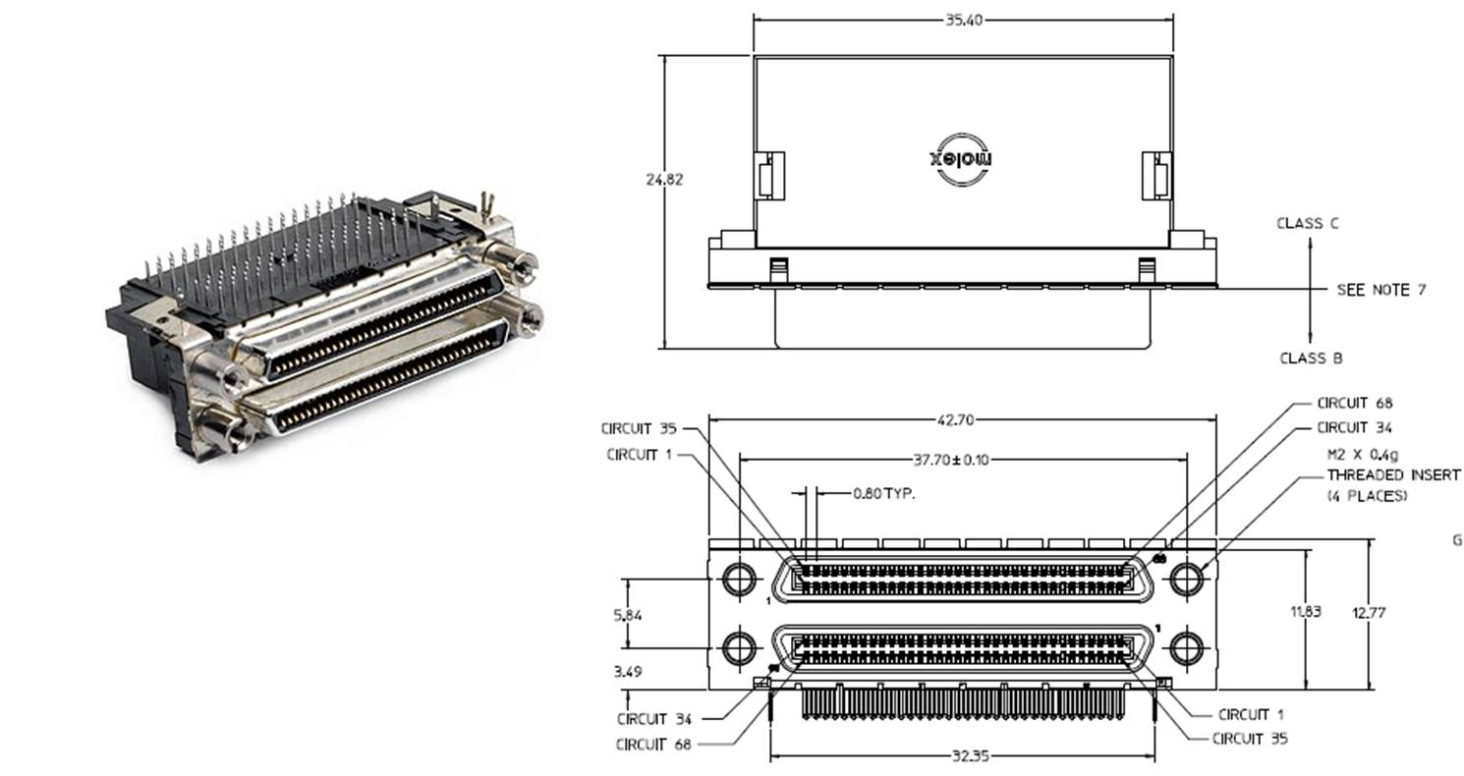

Figure VHDCI signal connector

### PP(1-2) to MTBs

The signal connection between the PP and the MTBs is the same as from the RDO boards to the PP, namely a standard VHDCI cable. The PP to MTB cables are ~2 meters.

### MTBs to Ladders (Sector)

The MTB to ladder signal connection is made with AWG 42 (WireTronic part # 2-42QPN-05) twisted pair copper wires for the signal paths and larger wire for the power and ground. The wire harness is soldered to the ladder PCB at the ladder end. At the MBT cable end, the wires are soldered to a small breakout PCB that interfaces a SAMTEC TOLC 120 pin connector (*samtec part # TOLC-130-02-F-Q*) to the MTB.

# Power and Ground and Cabling

The power and ground connections need to adhere to the grounding scheme adopted for the HFT detector. This requirement mandates single point grounds at the STAR grounding points on the TPC wheel and floating power supplies in the STAR racks. In addition, relevant parts of the mechanical support structure need electrical grounding points that can be carried back to the STAR ground. A diagram of the electrical signal, power and ground paths for the PXL system is shown in and .

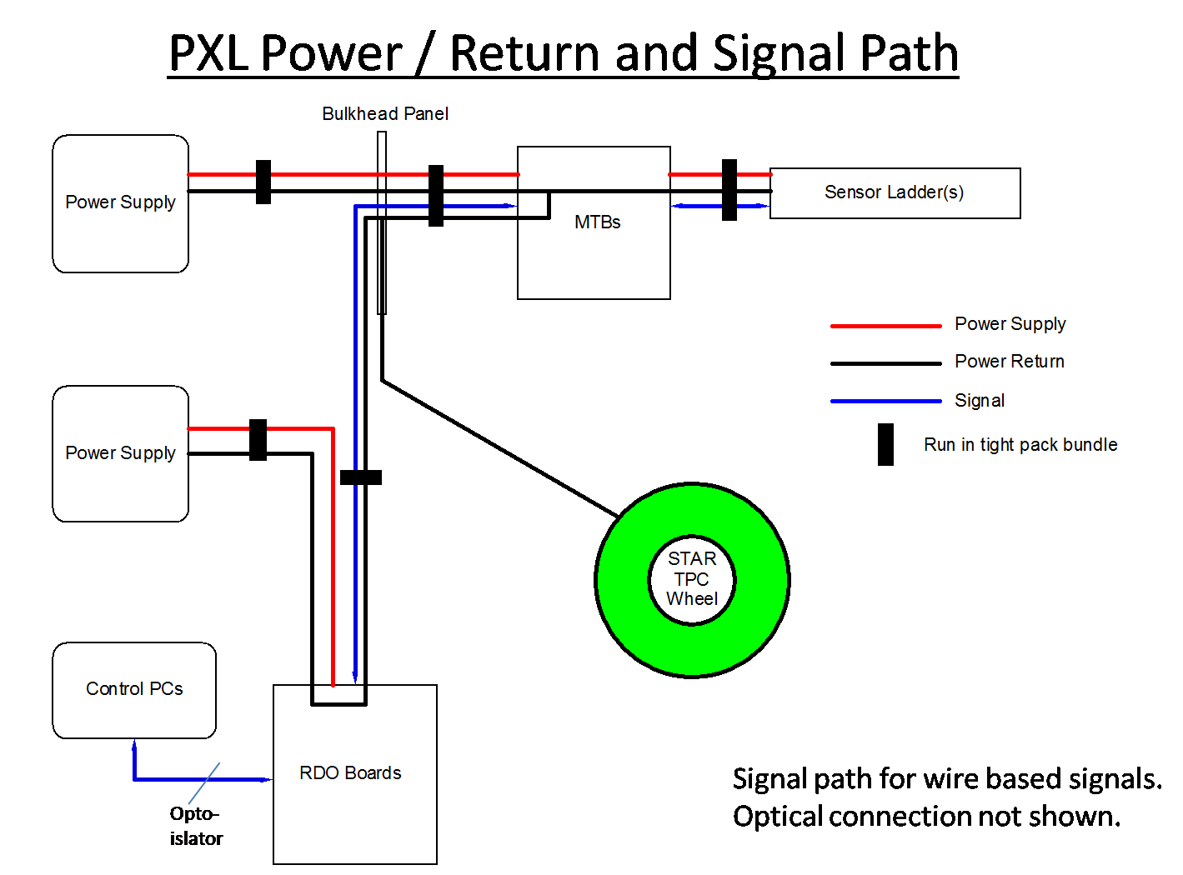

Figure PXL power supply, return and signal path. The main STAR ground is the TPC wheel which is hard grounded to the bulkhead patch panels.



Figure PXL grounding paths.

## Power supply and return paths and cabling

The power supplies for the PXL detector are located in the racks on the south platform at the STAR experiment. Each Power supply is expected to occupy 4U of rack space. The power supplies are configured to be floating with a high impedance resistor providing a soft ground for the power supplies at the rack. Each supply will be rated for ≥ 150A @ 6V. The expected current draw for the MTB/Ladder power supply is ~ 100A. The expected current draw for the RDO boards is ~40A. Power supplies in this range are easily commercially available in rack mount form factor. A compatible power supply is the TDK/Lambda Genesys series. A data sheet may be found here <http://www.testmart.com/webdata/mfr_pdfs/TDKLAI/93507100revB.pdf>*. The other system blocks are shown in the signal connection section. The power and return cable paths are described below.*

### PS to Patch Panel

*The cables from the Power supplies to the MTBs through the PatchPanel are composed of stranded copper in 10/4 configuration. A description may be found here*<http://www.usawire-cable.com/pdfs/TC%20XLP_HYP%2014-12AWG.pdf>*. Each cable run is rated for 50A (25A/conductor with 4 conductors) supply and return. Connections at the RDO board will be via Anderson Power Products SPEC Pack power 4 position power connectors. The data sheet may be found here* [*http://www.andersonpower.com/litlib/files.html/download/556*](http://www.andersonpower.com/litlib/files.html/download/556)*. If circuit breakers are acceptable, we will install a circuit breaker panel (~4U of rack space) in the power supply rack between the power supplies and the power cable connectors. If fusing is required, as we are carrying power over multiple conductors in each cable, we will install fuseholders in the cables at the power supply ends in each conductor of this type* <http://www.fastenal.com/web/products/detail.ex?sku=0703467&ucst=t>.  *Power is distributed to the MTB boards via Molex part number 39-30-3045.*

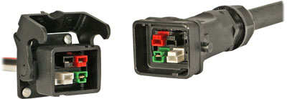

Figure Anderson Power Products SPEC power connectors will be used for the cables powering the PXL MTB

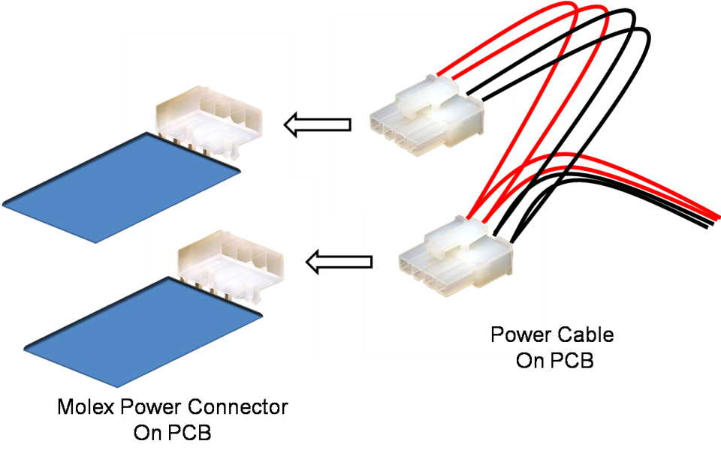

Figure Molex power distribution connectors for the RDO boards and MTB boards. Multi-drop power is shown.

### Patch Panel to Mass Termination Boards

*Inside the inner detector area the conductors from each power cable will be fanned out into five crate, we will fan out the power conductors into five 2x12AWG stranded hookup wire sets for power and ground and multi-drop power to 2 MTB boards / distribution wire set.*

### Mass Termination Boards to Ladders

*The power supplied to the ladders is regulated and latch-up protected by daughter cards (one per ladder) located on the MTBs. The power and ground wires are carried in the wire bundle soldered to each ladder that terminates in a Samtec TOLC MTB connector.* The power connection from the MTBs to the ladders consists of 16 #24 wires to provide the digital power, analog power and return lines. *The composition of these wires is shown in the power cable pin-out table.*

# Connectivity

## The Connectivity Table

The Connectivity tables are presented fully in Appendix A, but components of the tables are presented in parts throughout this section to illustrate how to read the table. The PXL connectivity spreadsheet contains 6 tabs. The tabs are described below:

1. PXL Signal Connectivity – This tab shows the connectivity information and cable identifiers for the signal paths of the PXL system.
2. PXL Power Connectivity – This tab shows the connectivity information for the power supply and return lines of the PXL system.
3. PXL Cable pinout Ladder => MTB – This tab shows the pinout and net names for the cables that connect the Ladders to the MTBs for all four ladders / sector.
4. PXL Cable pinout MTB => PP - This tab shows the pinout and net names for the cables that connect the MTBs to the patch panels for all four ladders / sector.
5. PXL Cable pinout PP => RDO board - This tab shows the pinout and net names for the cables that connect the patch panels to the RDO boards for all four ladders / sector.
6. PXL Cable pinout power – This tab shows the pinout and net names for all of the power connections in the PXL detector.

In the screen capture of the “PXL Signal Connectivity” tab of the Connectivity spreadsheet shown below, one can see the modularity of the PXL detector system reflected in the layout of the spreadsheet. One detector half is shown. It is composed of 5 sectors which are in turn composed of 4 ladders each. The top line indicates that Detector Half #1-sector 1 – Ladder 1 connects via cable “PXL-H1-S1-L1” to MTB # 1 connector J1. The signals from that ladder continue through MTB # 1, out on connector J2, over cable “PXL-MTB1.1-PP1.1.1 and connect to the patch panel connector “PXL-PP1-1-1”.

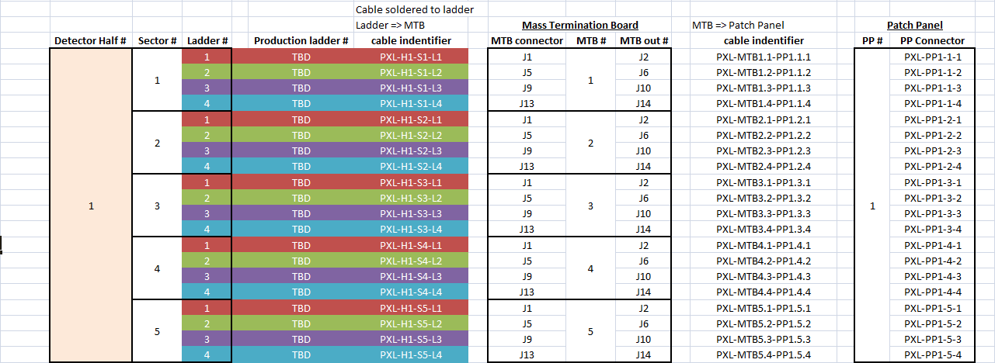

# Reference: