|  |  |  |  |
| --- | --- | --- | --- |
| **HFT** | HFT Grounding Plan | | |
| HFT Project Document No: | Institute Document No. | Created : Apr. 01, 2010 | Page: **1 of** |
| TBD |  | Modified : **20 October 2010** | Rev. No .: 1 |

|  |  |  |  |  |  |  |
| --- | --- | --- | --- | --- | --- | --- |
| HFT Detector Grounding Plan  This document describes in a limited way the detector design and grounding plans as it pertains to the HFT Detector upgrade to the inner detector region at STAR. | | | | | | |
| Prepared by:  L. Greiner, M. Szelezniak | | | Checked by: | | Approved by: | |
| Distribution List  HFT Collaboration | | | | | | |
| History of Changes | | | | | |
| Rev. No. | Date | Pages | | Description of changes | |
| 1 | March 2010  October 2010 |  | | FDR original  Update for whole HFT | |

Table of Contents

1 Grounding Plan for the HFT detector system upgrade 5

2 The PXL Grounding Plan 5

2.1 The signal path and shielding (see Figure 2) 7

2.2 Pixel Power/Return path (see Figure 2) 7

2.3 Ground path (see Figure 3) 7

2.4 Faraday shielding (see Figure 3, Figure 4, Figure 5) 7

3 IST Grounding Plan 11

4 SSD Grounding Plan 11

# Grounding Plan for the HFT detector system upgrade

Electrical integration of the HFT detector system into STAR must provide compatibility with the existing STAR grounding paths, shown in . The south platform is grounded to the STAR magnet. The north platform and the STAR magnet are both grounded to the building ground. The TPC is grounded through the HV power supplies, which are grounded on the south platform.



Figure STAR GND paths. Note high impedance connection between TPC LVPS and platform ground.

The power and ground connections for each of the HFT detector subsystems are required to adhere to the grounding scheme adopted for the HFT detector. These requirements mandate:

* A single point ground at the STAR grounding point on the TPC wheel;
* Floating power supplies in the STAR racks;
* Relevant parts of the mechanical support structure need electrical grounding points that can be carried back to the STAR ground.

# The PXL Grounding Plan

The PXL detector system design is composed of 10 parallel subsystems. Each subsystem is constructed from a detector sector (4 parallel ladders) connected to a mass-termination board (MTB) that is connected to a RDO card with readout/control via a dedicated PC. The signal and power/return paths are presented in for a single subsystem that reflects this architecture.

At the PXL detector level, ten MTBs and RDO cards are grouped together in crates located inside and outside of the TPC volume, respectively. The PXL system utilizes two power supplies with one supplying power for the MTBs and the other supplying power for the RDO cards.

The PXL detector system power supplies and RDO/ control PCs are located in the racks on the south platform. RDO cards are mounted next to the TPC wheel. The MTBs and the PXL detector sectors are located inside the inner detector volume and connect to the rest of the system through a bulkhead patch panel.



Figure Power/Return and signal path in the PXL detector system.

The grounding scheme for the PXL detector has been designed to provide a single grounding point for the PXL detector system at the PXL bulkhead patch panel, which is hard grounded to the east TPC wheel.

The description of the grounding scheme is divided into three sections: the signal path and shielding, power/return path, and ground path.

## The signal path and shielding (see )

* All signals transferred between different blocks are digital signals. All analog signal processing is integrated inside MAPS sensors.
* Signal ground and power ground are common on the system block PCBs (ladder flex cables, MTBs, RDO cards);
* Signal, power and ground to the sensors and RDO are isolated from their support structures (sector tube support, MTB crate, RDO crate);
* Signals transferred between MTB and RDO cards are differential and are independently ground referenced to the patch panel (TPC wheel);
* Signals from the TCD to the RDO cards are differential and are independently ground referenced to the TPC wheel;
* The control/readout PCs are electrically isolated from the RDO boards via an optical connection;
* Signal shielding is currently envisioned for the connection between MTBs and RDO boards. The shield should be grounded at the bulkhead panel and extend to MTBs and RDO boards but is isolated from the ground on these boards;

## Pixel Power/Return path (see )

* The power return path (GND) for the RDO cards is extended to the bulkhead patch panel, the single grounding point of the system;
* Power connection to MTB passes through the patch panel, where the power return path is grounded;
* Power supply (analog and digital) for four ladders per sector is regulated on the MTB and connected to the ladders in parallel. Analog and digital grounds are common;

## Ground path (see )

* The power supplies at the rack are configured to be floating with a high impedance resistor providing a soft ground for the power supplies;
* RDO/control PCs are grounded at the rack;
* The RDO crate is grounded to the magnet iron and is electrically isolated from the RDO cards;
* The MTB crate is grounded through the bulkhead panel to the TPC wheel and is electrically isolated from the MTB cards;
* The sector tube supports are grounded through the bulkhead panel to the TPC wheel and are electrically isolated from the ladder flex cables;
* The PXL insertion tube (PIT) and PXL support tube (PST) are grounded at the bulkhead panel.

## Faraday shielding (see , , )

There are no hard requirements for shielding between detectors. The switching signal load (data, clocks, etc.) are all differential to and from the PXL detector and the radiated “noise” is expected to be quite low. It is prudent to include shielding between the detector layers so we have incorporated a faraday shield around the PXL detector. The faraday enclosure around the PXL detector consists of several conductive carbon fiber tubes electrically connected together and joined electrically to the patch panel that seals the volume. The PIT and PST enclose the PXL sectors and will be joined electrically every ~2 inches along the contact circumference. The PIT to patch panel interface is expected to be an aluminum to aluminum contact made with bolts. While it is not required, the PIT/PST structure may also be electrically connected to the ESC.



Figure PXL ground paths. Note high impedance connections between power supplies and platform/rack ground. RDO boards are isolated from TDO crate GND.

Figure The PXL faraday enclosure consists of the PST, PIT and PXL patch panel.

The above description of the single detector module is extendable to the complete PXL system. The only additions are fan out power connections between the patch panel and MTBs and inside the RDO crate that allow for the distribution of power to 10 cards in each crate. The complete view of the PXL detector grounding paths and signal paths is presented in .



Figure Overview of the PXL detector system grounding and signal paths.

# IST Grounding Plan

The two pictures below show the overal grounding scheme of the IST and the more detailed grounding layout of the Forward GEM Tracker (FGT), respectivily.

The FGT scheme is very similar to the one which will be used for the IST. Both systems make use of the same APV readout chips and, for all practical purposes, identical readout systems. The main difference is the location of the voltage regulators. In the case of the FGT the voltage regulators are located directly on the detectors, while for the FGT they are outside of the field cage.

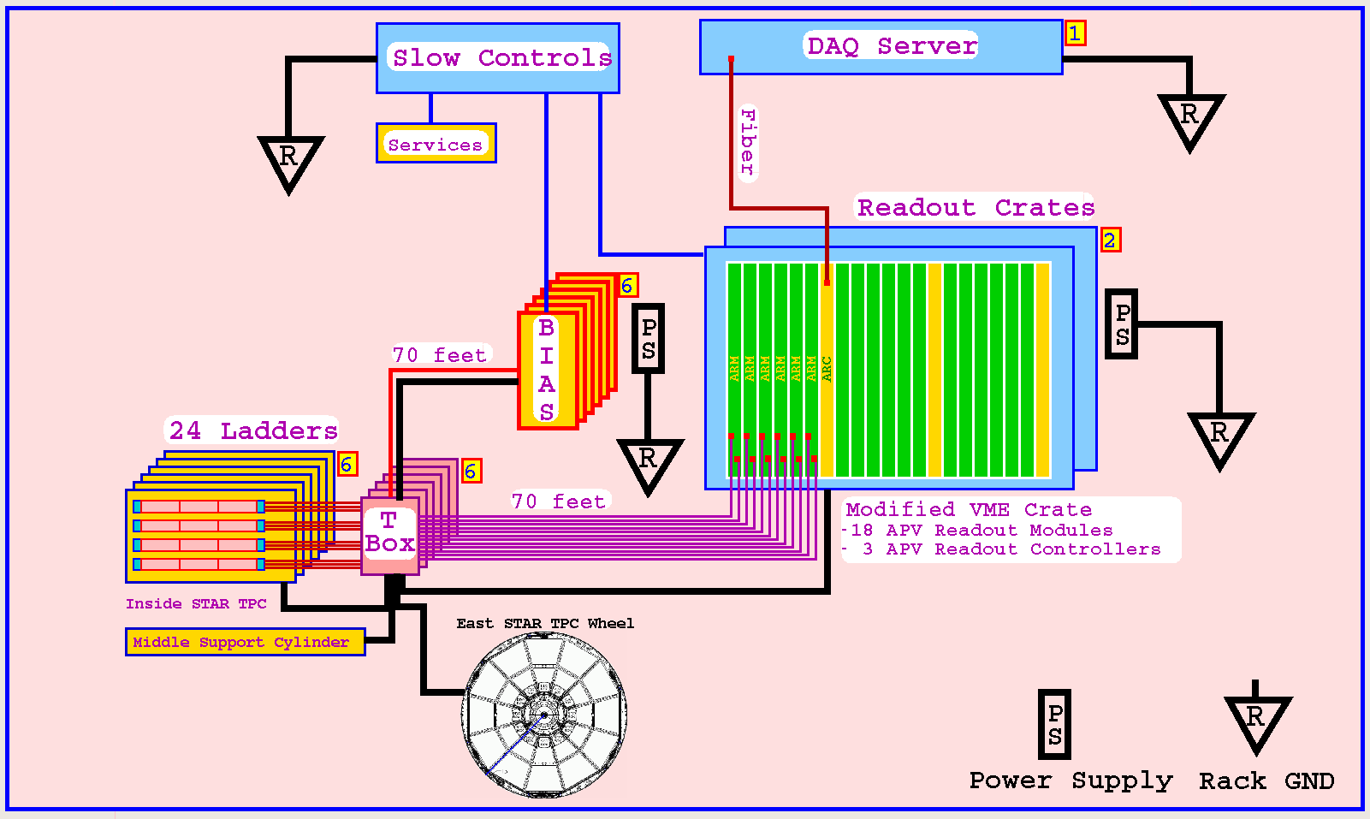

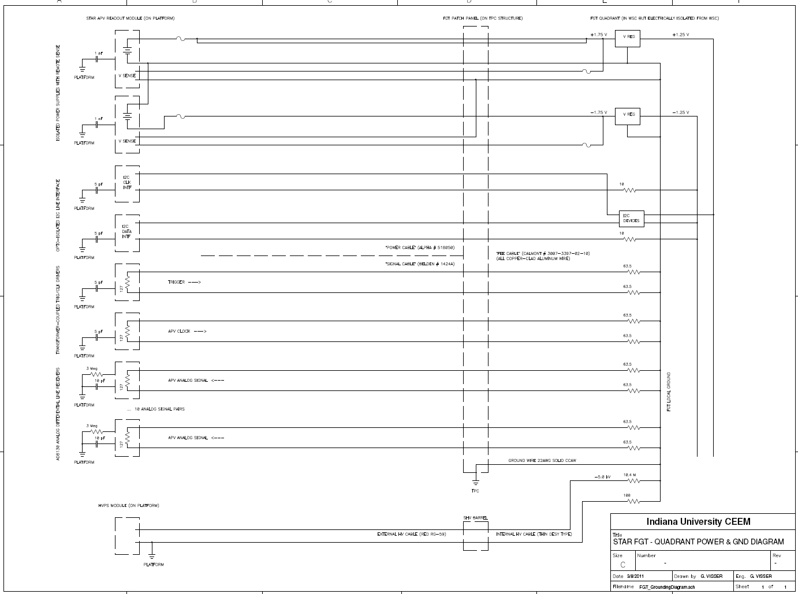

# SSD Grounding Plan

