October 3, 2013
LG
DRAFT

Hand solder component work on the PXL Ladders

There are two types of PXL ladder. Inner and Outer types are based on their position of the sector tubes. Outer ladders have a simple rectangular driver board PCB that fits on the end of the ladder hybrid cable. The inner ladder has the same low mass section but the driver board is a rigid/flex that gives a pigtail for the ladder connector. The handwork on the PXL ladders is the same for both ladder types, but with an additional step needed for the inner ladders.

Hand work on inner ladders
The inner ladders are assembled to the point where the sensors and driver board are attached to the cable and the wire bonds are in place but the encapsulant is not yet applied. At this point

- Take the weight of the cable assembly and note it in the notes section of the follower document with the note “Weight after wire bonding before encapsulant”.
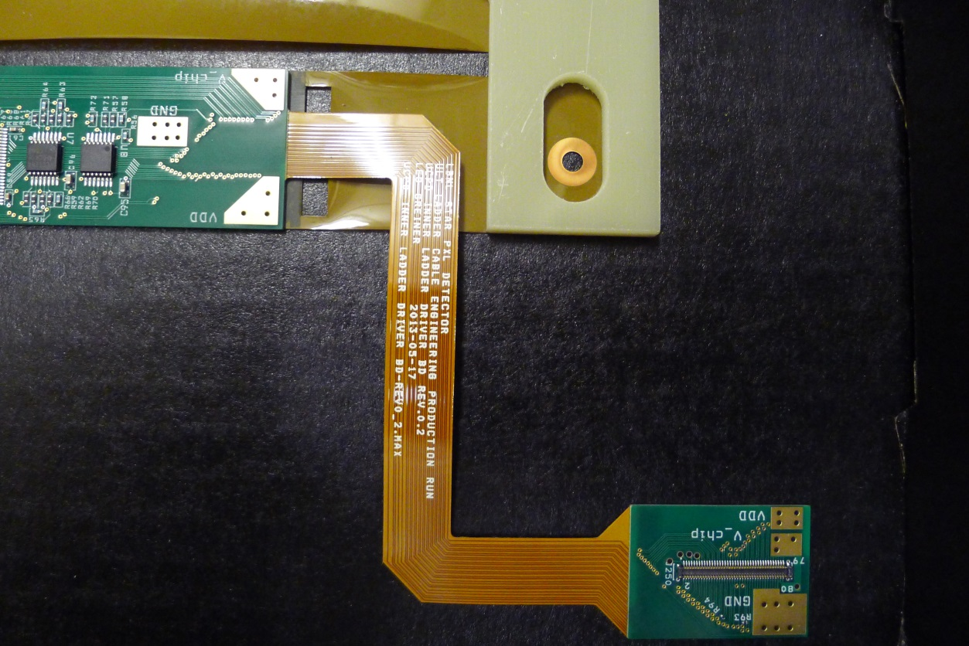
Figure 1 Inner driver board before power wires are attached.
- Using care as there are exposed bond wires use the supplied twisted pair copper wire, attach the driver board VDD solder pad to the connector VDD solder pad, the driver board V_chip solder pad to the connector V_chip solder pad, and the driver board GND solder pad (2 wires) to the connector GND solder pad with the routing following the flex section as shown below
Figure 2 Power wires added to the driver board.
- Take the weight of the cable assembly and note the weight in the follower notes section with the note “weight after power wires added”.
- Place the ladder back into the carrier box and put back into the cabinet. The ladder can now be electrically tested.

Solder components onto the low mass cables and driver boards
After all ladders have been tested and have been encapsulated (inner and outer), the following tasks should be performed on all ladders.
- Be sure that the weight of the cable assembly has been noted into the follower at the end of the encapsulant section. Note that all capacitors used are size 0603, 10uf, 10V supplied
- Install the two capacitors onto the pads at the far end of the cable as shown below:
Figure 3 Capacitors installed on the ladder far end.
- Install two capacitors on the hybrid cable near the driver board as shown below:
Figure 4 Two capacitors installed on the near end of the PXL ladder
- Now install the temperature diode patch as detailed in http://rnc.lbl.gov/hft/hardware/docs/production/PXL_ladder_diode_readout_modification.docx as shown below:
Figure 5 Temperature diode modification.
- Weight the cable assembly and note weight in the follower in the next “components added” section.
The ladder is now ready to be tested and then installed onto a sector.

