01/30/2013
LG

Notes from Meeting with Rui Oliveria in CERN PCB shop.

Problems
There have been two main problems with the fabrication of the PXL low mass aluminum conductor RDO cables to date. These problems are described below.
The first attempt at cable fabrication involved the use aluminum sheet bonded to kapton to give a metal thickness of 30um. This was fabricated, but during heating and air evacuation, bubbles were observed forming between the kapton and the aluminum leading to some de-lamination. Several attempts were made to relieve the large areas of aluminum without penetrations, but, while the number of bubbles was significantly reduced (to one), they were unable to completely stop the formation of bubbles. This method had new been abandoned in favor of completely vacuum deposited aluminum.
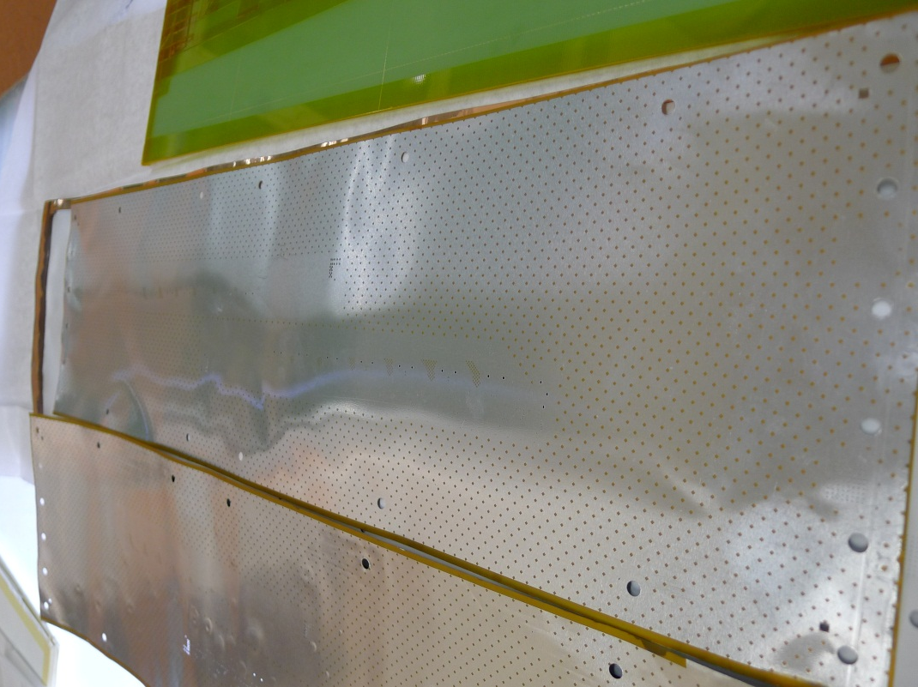
Figure 1 Aluminum cable panels showing bubble formation between the laminated aluminum and the kapton.
The method currently being explored is the vapor deposition onto kapton of the full aluminum thickness of 30 um. In this way, the aluminum bond to the kapton is made in a vacuum deposition process and problems associated with bubbles from outgassing are eliminated. This is more costly and time consuming process than the lamination. Vapor deposition is usually limited to ~10 um thickness and we are requesting 30 um. A set of panels were fabricated in this way and exposed to photoresist with our lithography and etched using the standard etchant mix. The initial results are not yet acceptable for use. During the deposition process, there were areas on aluminum oxidation formed over the various areas of the aluminum overlay. During etching, the areas with oxidation reacted to the etchant used in a way that was not similar to the aluminum and the etching was highly non-uniform.
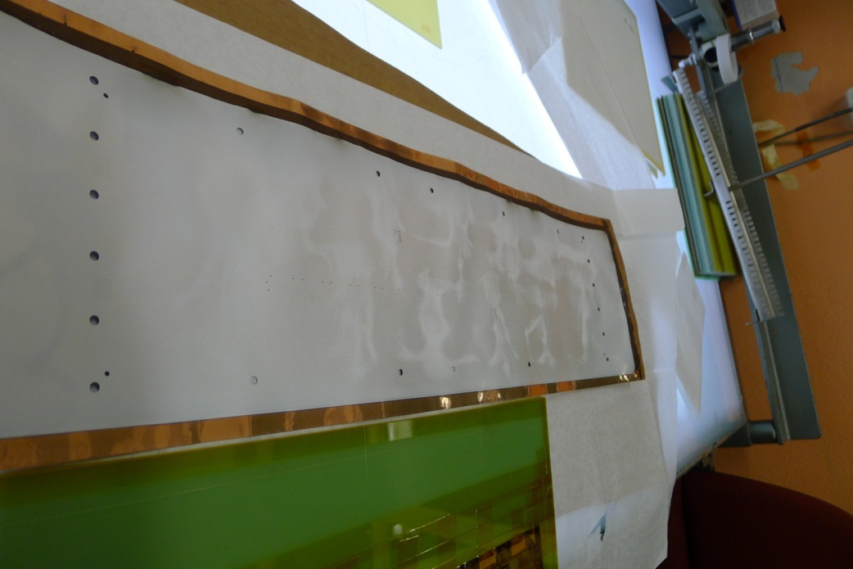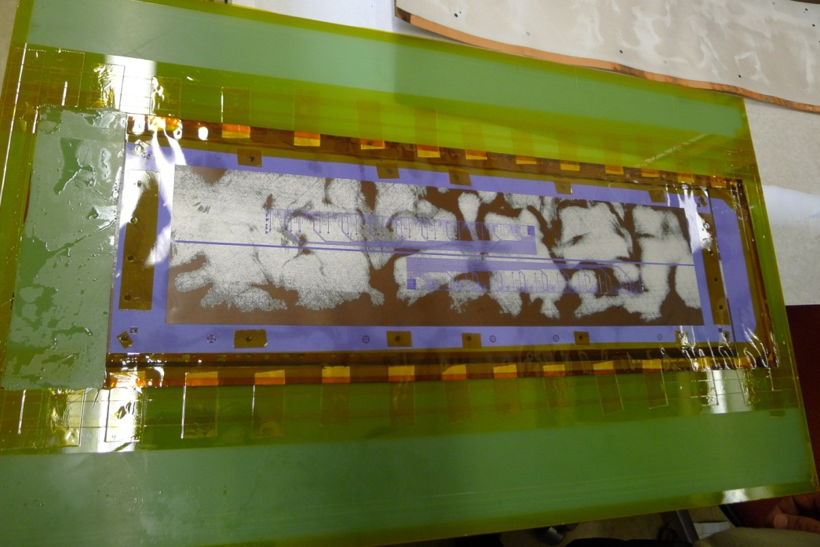
Figure 2 An attempt at etching showing visible oxide layers and etched results.

Way forward
Rui and his personnel have explored the parameter space of etchants and techniques extensively during the development of his processes. There are etching mixes that can be balanced to etch the aluminum and aluminum oxide at the same time. They will now rebalance the etchant mix to fit the condition of the aluminum as it comes from the vapor deposition. They are aware of the problem and already have a plan to fix it. While nothing is guaranteed, he and his shop have done this before and he is confident that he can solve the problem in short order.

Schedule
The current estimate is to have the first two “process validating” prototypes to LBNL by 2nd week of February. This would be followed in mid-March by the shipment of the production fabrication cables at a rate >10 / month. This is acceptable as compatible with PXL construction plans.

Cost
The extra cost of having the cables vacuum deposited with aluminum versus laminating is offset by the fewer number of process steps in the vapor deposition method. According to Rui’s estimates at this time, the cost should not change.

Future plans
Rui is quite interested in working in collaboration with vendors to help produce aluminum conductor PCBs. This is consistent with his mandate from the CERN management that his shop exists to do cutting edge development and fabricate components not available from industry. He would welcome a vendor that can produce aluminum conductor cable with characteristics that can meet the needs of some reasonable fraction of his CERN customers. I have suggested and he has accepted that he and Hughes Circuits should be put in contact to facilitate such an arrangement. If successful, this has the potential to give a second and commercial source for aluminum conductor PCBs.

